Defining “Noncommercial”

A Study of How the Online Population Understands “Noncommercial Use”

September 2009

Report published by:
Creative Commons Corporation
171 Second Street, Suite 300
San Francisco, CA 94105-3811, USA
+1 415 369 8480
www.creativecommons.org

Research conducted by:
Netpop Research, LLC
322 Cortland Avenue
San Francisco, CA 94110, USA
www.netpopresearch.com

This Report, inclusive of the Appendices, is published under the Creative Commons Attribution 3.0 Unported license http://creativecommons.org/licenses/by/3.0/.

The research data collected for this Report are published under CC0 http://creativecommons.org/publicdomain/zero/1.0/, which means Creative Commons has waived all copyright and related rights to the research data worldwide.

Copies of the Report, Appendices and research data are available at http://wiki.creativecommons.org/Defining_Noncommercial, which is also the link to provide for purposes of attribution. See Appendix 5.1 and Appendix 5.2 for suggested citation information.

Questions or Comments?
If you have a question or comment about this Report, contact Creative Commons at info@creativecommons.org.

About Creative Commons
Creative Commons Corporation is a San Francisco-based not-for-profit organization, founded in 2001, that promotes the creative re-use of intellectual and artistic works, whether owned or in the public domain. Through its free copyright licenses, Creative Commons offers authors, artists, scientists and educators the choice of a flexible range of protections and freedoms that build upon the “all rights reserved” concept of traditional copyright to enable a voluntary “some rights reserved” approach. Creative Commons was built with and is sustained by the generous support of organizations including the Center for the Public Domain, Google, the John D. and Catherine T. MacArthur Foundation, the Mozilla Foundation, Omidyar Network, Red Hat, and the William and Flora Hewlett Foundation, as well as members of the public.

About Netpop Research, LLC
Netpop Research, LLC is a San Francisco-based strategic market research firm that specializes in online media, digital entertainment and user-generated content trends. Netpop Research has fielded numerous studies for major profit and not-for-profit entities, and is the creator of the Netpop tracking study of Internet usage among broadband consumers in the United States and China.

Contents
About this Report 6
Executive Summary and Report Presentation 10
Empirical Findings: U.S. Online Population 11
Informal Findings: CCFF 12
Study Impact and Next Steps 13
Report Presentation 13
1 Background 14
1.1 Creative Commons and the CC Licenses 14
1.2 The CC Noncommercial License Term 16
2 Study 19
2.1 Scope of Research 19
2.2 Description and Methodology 20
Research Objectives 21
Qualitative Research 22
Quantitative Research 24
3 Findings 29
3.1 Qualitative Research 29
Phase 2: Creators 29
Phase 3: Users 36
3.2 Quantitative Research: U.S. Online Population 41
Creators and Users: Profiles 41
What Is Noncommercial Use? Unaided Understandings and Beliefs 48
Gatekeeping Factors 51
Anchor Point Exercise and Reactions to Specific Use Scenarios 54
Summary of Anchor Point Exercise 65
Changes to Unaided Understandings 66
3.3 Quantitative Research: Creative Commons Friends and Family 68
Comparison to U.S. Online Population 69
Perception of Creative Commons and Reaction to the NC Term 71
3.4 Summary of Principal Findings 72
Empirical Study 72
CCFF Survey 75
4 Next 77
4.1 Import for Creative Commons Noncommercial Licenses 77
4.2 Recommendations on Using CC Noncommercial Licenses 78
4.3 Further Research 80
4.4 How to Participate in the Discussion 82
5 Appendix 83
5.1 Using and Citing the Report and Appendix 83
5.2 Using and Citing the Data 83
5.3 Creative Commons BY-NC License and Commons Deed 84
Creative Commons Attribution-Noncommercial 3.0 Unported Commons Deed 90
5.4 Defining “Noncommercial” Study Questionnaire for Creators 91
5.5 Defining “Noncommercial” Study Questionnaire for Users 112
5.6 Defining “Noncommercial” Study Data Graphs 136

Figures
Figure 1: Phase 2 – Content Creators [Appendix 5.6, Slide 2] 26
Figure 2: Phase 3 – Content Users [Appendix 5.6, Slide 3] 26
Figure 3: Photos are the most common type of online content created, accessed, shared or used [Appendix 5.6, Slide 4] 43
Figure 4: Profile of U.S. Content Creators and Users [Appendix 5.6, Slide 6] 43
Figure 5: Profile of U.S. Content Creators and Users [Appendix 5.6, Slide 17] 45
Figure 6: Profile of U.S. Content Creators and Users [Appendix 5.6, Slide 29] 47
Figure 7: Unaided Definitions and Reactions to the CC NC Term [Appendix 5.6, Slide 36] 49
Figure 8: Unaided Definitions and Reactions to the CC NC Term [Appendix 5.6, Slide 39] 50
Figure 9: Unaided Definitions and Reactions to the CC NC Term [Appendix 5.6, Slide 43] 51
Figure 10: Ratings of Commercial Use by Creators and Users (Gatekeeping Exercise) [Appendix 5.6, Slide 44] 53
Figure 11: Initial Anchor Point Ratings by Creators and Users [Appendix 5.6, Slide 45] 55
Figure 12: Ratings of Commercial Use by Creators and Users: Scenarios Related to Uses by Individual [Appendix 5.6, Slide 46] 57
Figure 13: Ratings of Commercial Use by Creators and Users: Scenarios Related to Uses Involving Money [Appendix 5.6, Slide 51] 59
Figure 14: Ratings of Commercial Use by Creators and Users: Scenarios Related to Uses Involving Advertisements [Appendix 5.6, Slide 54] 60
Figure 15: Ratings of Commercial Use by Creators and Users: Scenarios Related to Uses by Organization [Appendix 5.6, Slide 59] 62
Figure 16: Ratings of Commercial Use by Creators and Users: Scenarios Related to Uses with Charitable Purposes [Appendix 5.6, Slide 61] 64
Figure 17: Ratings of Commercial Use by Creators and Users (Anchor Point Exercise) [Appendix 5.6, Slide 62] 65
Figure 18: Changes in Definitions and Reactions to CC NC Term [Appendix 5.6, Slide 71] 68

Tables
Table 1: Creative Commons License Elements. 15
Table 2: Content Creators and Content Users Dataset. 27
Table 3: Qualitative Research Consideration Factors. 31
Table 4: Gatekeeping Factors. 52

About this Report

Confidentiality

The identities of interviewees and focus group participants are confidential. All findings are reported either anonymously or in aggregated fashion. Quotation marks used in connection with the reporting of research findings indicate verbatim quotes, unless it is clear from the context that the quotation marks are used to set off a word or phrase.

Data and Word Usage Conventions

For ease of reading, this Report and the data graphs reproduced here and in the Appendix sometimes shorten the questions asked of survey respondents. Very similar questions from different phases of research are also sometimes combined and condensed when data from those phases are reported together. The study questionnaires are available at the end of this Report.

Below are some terms frequently used in connection with representation of the data, and explanations of what those terms are intended to convey:

“definitely” when used in connection with the gatekeeping factor exercise, refers to a specific answer choice in the questionnaires; when used in connection with the anchor point exercise, refers to a score of 1 or 100 on a 100 point scale;

“generally” denotes a common pattern seen in data across multiple variables;

“significant” refers to statistical significance testing (differences are noted at a 95% confidence level unless otherwise indicated);

“majority” means over 50%, while “vast majority” means over 70%;

“most” used in connection with qualitative findings indicates when an opinion is shared by substantially more than half of respondents;

“many” used in connection with qualitative findings indicates when an opinion is shared by approximately half or more respondents; and
“some” used in connection with qualitative findings indicates when an opinion is shared by less than half, but more than a few respondents.

With regard to representation of numbers, specifically, percentages are rounded to the nearest whole number, while means are reported with a single decimal place. When indications such as “1 in 10” are provided, they are based on actual percentages, and rounded to the nearest integer under 10.
Acknowledgements
This study was made possible by the generous support of the Andrew W. Mellon Foundation. At the Mellon Foundation, Creative Commons owes particular thanks to Donald J. Waters, Program Officer for Scholarly Communications. Thanks as well to Helen Cullyer, Associate Program Officer, and Paula Muir, Program Associate.

Creative Commons is honored to have been able to work with a stellar group of legal, public policy, and information technology experts, who advised on research methodology and data analysis. For their generosity and invaluable guidance, CC is grateful to these distinguished academicians:

Christine L. Borgman, Ph.D., Professor and Presidential Chair in Information Studies, Graduate School of Education and Information Studies, University of California, Los Angeles;

William H. Dutton, Ph.D., Director of the Oxford Internet Institute, Professor of Internet Studies, University of Oxford, Fellow of Balliol College;

Deborah R. Hensler, Ph.D., Judge John W. Ford Professor of Dispute Resolution and Associate Dean, Graduate Studies, Stanford Law School; and

Daniel E. Ho, Ph.D., Assistant Professor of Law and Robert E. Paradise Faculty Fellow for Excellence in Teaching and Research, Stanford Law School.

Other experts helped by reviewing drafts of this Report. For their thoughtful comments, Creative Commons is grateful to Mia Garlick, its former General Counsel who was a leader within CC for many years on defining “noncommercial,” as well as Molly Kleinman, Special Assistant to the Dean of Libraries at the University of Michigan Library. CC is indebted also to Wilson Sonsini Goodrich & Rosati for their valuable research assistance, and appreciative of the help given by the many people who engaged in discussion, introduced useful contacts, or answered a survey.

Creative Commons owes a particular debt of gratitude to Netpop Research, LLC. Josh Crandall, President and Co-founder, and Cate Riegner, Vice President, Research Director and Co-founder, were instrumental in shaping this project and seeing the research through its iterations to completion. They were aided by Jean Durall, Ph.D., Director, Research Services, and Netpop staff members Rudy Hernandez, Grace Han Yao and Ev Penev. Netpop extends thanks as well to Greenfield Online, Inc. and Decipher, Inc.

Creative Commons is fortunate to have a dedicated board and staff, as well as a remarkable and extensive network of international affiliates and volunteers, many of whom participated as members of the NC Study Working Group and helped steer this project: Hal Abelson, Renata Avila, Ahrash Bissell, Carolina Botero, Mike Carroll, Andrés Felipe Umaña Chaux, Giorgos Cheliotis, Jessica Coates, Wen-Yin Chou, Tyng-Ruey Chuang, Melanie Dulong de Rosnay, Brian Fitzgerald, Syb Groeneveld, Gisle Hannemyr, Chi-Chang Huang, Joichi Ito, Paul Keller, Ronaldo Lemos, Lawrence Lessig, Catharina Maracke, Yuko Noguchi, Eric Steuer, Alek Tarkowski, Prodromos Tsiavios, Chunyan Wang, John Wilbanks, Jongsoo Yoon, and Zafka Zhang.

Finally, CC thanks for their contributions Virginia Rutledge, Creative Commons Special Counsel, who served as project director; Mike Linksvayer, Creative Commons Vice President, who served as Principal Investigator; and Diane Peters, Creative Commons General Counsel. Thanks also to Creative Commons staff members Lila Bailey, Fred Benenson, Kevin Birtchnell, Diane Cabell, Nathan Kinkade, Thinh Nguyen, Jane Park, Cameron Parkins, Melissa Reeder, Alex Roberts, Ani Sittig, Michelle Thorne and Jennifer Yip for their assistance.

Executive Summary and Report Presentation

In 2008-09, Creative Commons commissioned a study from a professional market research firm to explore understandings of the terms “commercial use” and “noncommercial use” among Internet users when used in the context of content found online. The study was comprised of two components – an empirical study of understandings of Internet users in the United States, and an informal study for comparison purposes of a broader, worldwide group of Internet users consisting of those generally more familiar with CC but not taking part in the empirical survey (dubbed “Creative Commons Friends and Family” or “CCFF”). The primary objectives of the study were two-fold:

- to survey variations in the general online population’s understanding of the terms “commercial use” and “noncommercial use,” when used in the context of the wide variety of copyrighted works and content made available on the Internet; and

- to provide information and analysis that would be useful to Creative Commons and to others in understanding the points of connection and potential disconnection between creators and users of works licensed under Creative Commons noncommercial, or “NC,” licenses or other public copyright licenses prohibiting commercial use.

The study involved three phases:

Phase 1 comprised background research, identifying research objectives, and preparation for the subsequent phases;

Phase 2 consisted of qualitative and quantitative research to understand meanings given those terms by creators of copyrighted materials found on the Internet; and

Phase 3 involved qualitative and quantitative research designed primarily to understand meanings given those same terms by users of copyrighted content found on the Internet.

Empirical Findings: U.S. Online Population
The empirical findings suggest that creators and users approach the question of noncommercial use similarly and that overall, online U.S. creators and users are more alike than different in their understanding of noncommercial use. Both creators and users generally consider uses that earn users money or involve online advertising to be commercial, while uses by organizations, by individuals, or for charitable purposes are less commercial but not decidedly noncommercial. Similarly, uses by for-profit companies are typically considered more commercial. Perceptions of the many use cases studied suggest that with the exception of uses that earn users money or involve advertising – at least until specific case scenarios are presented that disrupt those generalized views of commerciality – there is more uncertainty than clarity around whether specific uses of online content are commercial or noncommercial.

Uses that are more difficult to classify as either commercial or noncommercial also show greater (and often statistically significant) differences between creators and users. As a general rule, creators consider the uses studied to be more noncommercial (less commercial) than users. For example, uses by a not-for-profit organization are generally thought less commercial than uses by a for-profit organization, and even less so by creators than users. The one exception to this pattern is in relation to uses by individuals that are personal or private in nature. Here, it is users (not creators) who believe such uses are less commercial.

The most notable differences among subgroups within each sample of creators and users are between creators who make money from their works, and those who do not, and between users who make money from their uses of others’ works, and those who do not. In both cases, those who make money generally rate the uses studied less commercial than those who do not make money. The one exception is, again, with respect to personal or private uses by individuals: users who make money consider these uses more commercial than those who do not make money.

When presented with the language of the Creative Commons noncommercial license term (abbreviated at times in this Report as the “NC term”), the vast majority believe it is “essentially the same as” or “compatible with” their definition of noncommercial use. The Creative Commons NC prohibition on use of a work “in any manner that is primarily intended for or directed toward commercial advantage or private monetary compensation” presumably resonates with a large majority of creators and users because most believe that no money can be made if a use is to be considered noncommercial. Given that the NC term does not refer to any particular uses, such as use in connection with online advertising that a large majority of respondents considers commercial in several instances before more specific use cases are presented, creators and users appear to have read this meaning into the NC term. Furthermore, the appeal of the NC term may reflect a desire among creators and users to simplify (possibly over-simplify) a complex issue, anchoring the definition around a restriction that is most “easy to think,” that is, one in which “no money is made.”

Finally, the empirical findings suggest that the vast majority of both U.S. creators and users do not know the basics of copyright law, adding to other studies that show public interest in and need for more copyright law and, specifically, fair use education.

Informal Findings: CCFF
Although not empirical due to the open access nature of the polls, the CCFF survey results provide valuable information about CCFF’s familiarity with copyright licensing and use of public copyright licenses. The survey reveals that both the U.S. online population and CCFF define “commercial use” primarily as a use that makes money. However, CCFF identify some use scenarios where at least some money may be made without those uses being decidedly “commercial.”

In particular, CCFF consider uses in connection with online advertising and uses involving cost recovery less commercial than the U.S. online population, and are much less likely to think that use in connection with online advertising from which the user makes money is “definitely” commercial. Fewer CCFF think it is “definitely” commercial if a work is used on a website that is supported by advertising than the U.S online population. Yet CCFF are much more likely to consider use in connection with splog advertising “definitely” commercial. As well, a lower percentage of CCFF creators and users say that making money by unspecified means from use of a work to cover cost distribution is “definitely” commercial.

Other interesting differences exist between CCFF and the U.S. online population. Like the U.S. online population, CCFF rate personal and private use the least commercial of all scenarios studied, and CCFF ratings are even lower than U.S. ratings for both creators and users. Further, unlike the U.S. online population, CCFF creators and users are equally certain that personal or private use is “definitely” noncommercial.

Additional data sought from CCFF specific to Creative Commons and its NC licenses show that the Creative Commons BY-NC-SA license is the most popular of all CC licenses among both CCFF creators and CCFF users. Survey results show that the BY-NC-SA license is chosen by CCFF creators because it allows them to control their right to make money and retain a commercial advantage. Both CCFF creators and users say they trust that Creative Commons licenses are legally enforceable. Finally, CCFF creators and users are divided on whether they would support an effort to potentially refine or redefine the Creative Commons NC term.

Study Impact and Next Steps
The results of the survey provide a starting point for future research. In the specific context of the Creative Commons licenses, the findings suggest some reasons for the ongoing success of Creative Commons NC licenses, rules of thumb for licensors releasing works under NC licenses and licensees using works released under NC licenses, and serve as a reminder to would-be users of the NC licenses to consider carefully the potential societal costs of a decision to restrict commercial use. They also highlight the need for caution when considering whether to modify the CC NC licenses in the course of a license versioning process or otherwise, so that expectations of those using NC licenses are preserved, not broken.

Report Presentation
In Section 1 of this Report, Creative Commons provides the background for this study, including an overview of Creative Commons and its licenses. Section 2 and Section 3 contain information, data analysis and results compiled from Netpop Research, LLC, a professional market firm that conducted the study survey. Section 2 describes the study’s scope of research and methodology. Section 3 reports the findings of the research – the qualitative research findings are reported in Section 3.1, the empirical findings for the U.S. general online population are reported in Section 3.2, and the informal worldwide CCFF findings are reported in Section 3.3. Finally, Section 4 outlines a preliminary analysis of what the study results mean for Creative Commons’ noncommercial licenses, recommendations on use of these licenses informed in part by the study results, and suggestions for further contributions to discussion of “noncommercial use” by academic researchers and community members alike. Section 5 is an Appendix that includes attribution and citation information for the Report and its various components, the creator and user study questionnaires, and a slide deck containing the data graphs created for this study that are reproduced or referenced in this Report.

1 Background

1.1 Creative Commons and the CC Licenses
Creative Commons (“CC”) is a 501(c)(3) not-for-profit corporation founded in 2001 to address both an opportunity and a challenge. Thanks to the Internet, it is possible to more easily, quickly and cheaply distribute content than ever before. Increasingly, the Internet also provides both source material and a platform for the creation of new works. Yet the very technology upon which the Internet is built presents a challenge because a copy of any content or work must be made in order to use it, even if “use” only means accessing the work online.

Copyright legal systems around the world generally provide that copyright is acquired the moment a work is fixed in a tangible means of expression, and that owners are not required to place any notice claiming copyright on their works. In the absence of any other information, those who wish to use content found online must assume that it is “all rights reserved,” and that for any use beyond fair use (or other exceptions and limitations to copyright applicable outside of the United States) permission must be sought. The costs of obtaining – and granting – permissions, however, can be very high.

Creative Commons’ core mission is to facilitate the legal use and reuse of content, by offering creators and other copyright holders free and easy-to-use legal and technical tools that help them publish and distribute their works under flexible copyright terms. By promoting a “some rights reserved” approach to copyright and reducing the transactional costs associated with sharing, CC provides the legal and technical infrastructure necessary to realize the full potential of creativity and innovation in a digital age.

Creative Commons provides a standardized set of copyright licenses containing terms and conditions that creators and other owners of copyrighted materials (referred to interchangeably at times in this Report as “creators” or “licensors”) can associate with works they want to share with the public, without requiring users of that content to ask them for specific permission in advance. As with every “public license,” the creator who chooses to release a work under a CC copyright license is choosing to allow any user (or licensee), without discrimination, to take advantage of the offer to use the work. The four basic CC license terms are described in the following table, underneath the visual icons that represent each term.

BY | SA | NC | ND
You let others copy, distribute, display, and perform your copyrighted work – and derivative works based upon it – but only if they give credit the way you request. | You allow others to distribute derivative works only under a license identical to the license that governs your work. | You let others copy, distribute, display, and perform your work – and derivative works based upon it – but for noncommercial purposes only. | You let others copy, distribute, display, and perform only verbatim copies of your work, not derivative works based upon it.
Table 1: Creative Commons License Elements.

All Creative Commons licenses include the “BY” or attribution requirement, ensuring that the creator of the work is credited for any use unless the creator indicates otherwise through notice to licensees. BY and the three other terms, Share Alike (“SA”), Noncommercial (“NC”) and No Derivative Works (“ND”), may be variously combined to compose the six different licenses that make up the core CC license portfolio. For example, a BY-NC-ND license, the CC license granting the fewest permissions in advance, requires attribution and prohibits both commercial use and the making of derivative works based on the licensed original.

Since their introduction in December 2002, CC licenses have been enthusiastically adopted by creators and enthusiastically employed by users, not only in the United States but also around the world. To date, the licenses have been “ported” – that is, linguistically translated and legally adapted – to 52 international legal jurisdictions. Currently, CC estimates that its licenses are attached to over 250 million web pages and other creative works. Those works reflect the full spectrum of cultural production, not only in established forms such as literary and scientific texts, music, images, photographs, film and video, but in web-native media such as blogs, podcasts and wikis. This wealth of pre-cleared material is discoverable through many online content providers and services, including Google and Yahoo!.

1.2 The CC Noncommercial License Term
Copyright consists of a set of exclusive rights that enables the owner to control a variety of uses of her copyrighted work. Many copyright owners understand a core premise of copyright to be the right to exclude all commercial (but not necessarily noncommercial) uses of their work unless they grant a license permitting otherwise. This belief finds some basis in the law itself.

In the United States, for example, the Copyright Act does not define a copyright owner’s rights in terms of commercial or noncommercial use. Instead, copyright law sometimes attaches legal significance to whether a use is “commercial” or “noncommercial” or whether a user is deemed to be a commercial or noncommercial entity, However, rarely are the terms defined, and the law offers no specific guidance on how to differentiate between commercial and noncommercial uses or users of copyrighted works. Even if copyright law were specific about the commercial/noncommercial use divide, that fact would be of limited significance in the Creative Commons context because there is no necessary connection, at least in the United States, between the definition of the rights given to authors by copyright law and the rights that users enjoy under a license given by the copyright owner.

The Creative Commons licenses were drafted with the understanding that one size does not fit all in the field of copyright and that some creators and other owners of copyright may want to reserve the right to control commercial uses of their work while broadly enabling noncommercial sharing. Currently, the noncommercial option only permits use of the work in any manner that is not “primarily intended for or directed towards commercial advantage or private monetary compensation.” Specifically excluded from the prohibition against noncommercial use in the NC licenses is the exchange of a CC-licensed work for any other copyrighted work, whether by means of peer-to-peer digital file-sharing or otherwise, provided no monetary compensation is involved.

The noncommercial option has proven popular with those who choose Creative Commons licenses for their works. Approximately two-thirds of all Creative Commons licenses associated with works available on the Internet include the NC term. This study was prompted in part by the desire to better understand expectations of users of Creative Commons licenses across a wide variety of content types, particularly given the dynamic evolution of Internet business models that enable or encourage free sharing of copyrighted works while also relying on indirect means for their financing, such as advertising.

Creative Commons is committed to making its licenses as clear as possible for both creators and users, and to communicating about its licenses in a manner that is easily understandable. A sharing culture that is grounded in respect for copyright cannot reach its fullest potential if creators and users have different expectations and understandings regarding permissible uses of noncommercially-licensed works. For these reasons and others, Creative Commons seeks to better understand the points of connection and disconnection between creators and users with respect to noncommercial use.

In December 2007, the Andrew W. Mellon Foundation awarded Creative Commons a grant to commission the study reported here. Defining “Noncommercial” had two main goals:

    - to undertake an empirical study that would survey variations in the online U.S. general population’s understanding of the terms “commercial use” and “noncommercial use,” when used in the context of the wide variety of copyrighted works and content made available on the Internet; and

    - to provide information and analysis that would be useful to Creative Commons and to others in understanding the points of connection and potential disconnection between creators and users of works licensed under Creative Commons “NC” or other public copyright licenses prohibiting commercial use.

The scope of research and methodology are described below, in Section 2.

2 Study

2.1 Scope of Research
Creative Commons licenses are available to all would-be licensors, and CC-licensed works are available to all would-be licensees, worldwide. Because it is the right of the creator to choose whether and how to license a work, the study was designed to focus first on exploring “noncommercial use” from the viewpoint of creators, as broadly and as deeply as practicable. Logistical and cost restraints mandated that empirical research be confined to the United States, however international perspectives were solicited during the qualitative research stages as well as during the open access polls made available worldwide during the quantitative research stages. The research was conducted solely in English.

At early stages of the study, two decisions were made that refocused the initial research plan. The first decision resulted in limiting the research conducted on different content communities. When the study was originally proposed, Creative Commons was aware from its experience that certain “content communities” shared some understandings about various kinds of content. To give two examples, CC was aware that the print publishing industry distinguishes between “commercial” and academic presses, and that magazine and newspaper publishers refer routinely to “editorial” or “feature” content as opposed to “advertising” or “commercial” content. Exploring specific usages thus seemed a good direction for research. However, almost as soon as qualitative research began it was determined that individual studies devoted to particular communities and industries would be required in order to collect anything more than generalities.

Consequently, a decision was made to focus resources looking for patterns that might be found across high-level content communities and types of content, since identification of any “universal” cross-community factors relevant to understanding noncommercial use would be an important step in understanding public noncommercial copyright licensing solutions. As a result, the quantitative research on content communities and types of content was limited to a few very general questions. The high-level communities that were ultimately sampled were informed by the qualitative research – in particular, education, science, music, visual art, film-making/video, entertainment, literature, journalism and marketing. Common types of content based on qualitative research were identified as well.

The second decision was made during the first phase of quantitative research, and resulted in adjusting the last phase of the study to probe understandings of “noncommercial” among users of such content, including creators who also identify as users of content. As the project progressed, it became clear that before turning to the CC noncommercial license term itself, it was important to test with users what was learned from creators about their basic understandings of commercial and noncommercial use. As a consequence, the second phase of empirical research (called Phase 3 in this Report) was designed to mirror the subject areas of the first as closely as possible. However, it was soon obvious that creators are also users of others’ works, and users of others’ content also create their own works; indeed, much original creativity – “original” in both copyright law and aesthetic or critical usage – historically is based on reuse. Thus, a decision was made to collect information from users who also identify as creators. A few questions were added to the final phase of research to assist in determining whether there are significant differences in understanding among users who also see themselves as creators.

2.2 Description and Methodology
A three-phased study program was launched in 2008 and concluded in June 2009. The research was conducted by Netpop Research, LLC, a market research firm chosen for its experience with online content development, expertise with online technologies and knowledge of online consumer attitudes and behaviors, including in connection with user-generated content. A distinguished group of legal, public policy, and information technology experts advised on research methodology and data analysis.

Phase 1 consisted of project planning, formulation of research objectives, consideration of relevant law, and review of materials Creative Commons had already created or collected in connection with its NC licenses. These materials included a list of almost 100 actual use cases in which the meaning of the NC license term or “noncommercial use” had been raised on Creative Commons mailing lists and web-based fora, as well as in other discussions within the Creative Commons community.

Phase 2 (creators) and Phase 3 (users) involved research, and ran from late summer 2008 through mid-winter 2009, and mid-winter through late spring 2009, respectively. As indicated, Phase 2 focused on content creators (licensors or potential licensors); Phase 3 on content users (licensees or potential licensees). Phase 2 and Phase 3 began with collection of qualitative data, primarily via focus groups held both in-person and online. Phase 2 and Phase 3 each culminated in two online surveys conducted simultaneously: an empirical survey of Internet users in the United States (going forward, referred to sometimes in this Report as the “online population” or “general population”), and an open access poll of Creative Commons Friends and Family (meaning, those persons who participated in the poll because they follow news of the organization or are interested in the question of noncommercial use or copyright generally) (again, sometimes referred to in this Report as “CCFF”). Both the Phase 2 (creators) and Phase 3 (users) surveys were fielded in the English language only. Due to budget limitations, the general population empirical survey was conducted in the United States only. The CCFF open access poll included completed surveys from respondents from around the world.

Research Objectives
During Phase 1, the primary objectives of the research were formulated. These objectives were fairly simple.

First, the research sought to understand whether people believe that there existed a real and meaningful distinction between commercial and noncommercial use. Based on the previous five years of successful Creative Commons license adoption and use, CC wanted to understand whether the most common understanding of “noncommercial use” across the online population (not confined to CC licensors or licensees) involves some formulation of the idea that the use should not be made in order to make money. Creative Commons also wanted to know whether there is consensus around the idea that an individual’s personal or private use of content is not considered a commercial use.

Dialogue within the organization and other communities and interest groups suggested substantial differences of opinion might exist on a few points, perhaps most visibly in connection with online advertising. Whether NC-licensed content is appropriately used on websites or blogs supported by advertising is a question that CC is asked with some frequency. Some believe that because the web-advertising model is based on traffic, any use of content that helps increase visits to a particular web page containing advertising is commercial. Others believe that the ad-supported model is an innocuous reality of web-based content distribution. Some also question whether use of content by a for-profit organization can ever be anything but commercial, while others believe that use by a not-for-profit should always be considered noncommercial regardless of the particular use. Further, some have questions about whether costs in connection with the use and further distribution of NC-licensed content may be recovered, and if so, how much (for example, may a school charge students for NC-licensed educational materials, and if so, may cost recovery include staff salaries?).

Finally, it was expected that even among those who create and use a lot of content, the U.S. online population is largely unfamiliar with copyright law or licensing.

Qualitative Research
Interviews

Testing the research objectives started as soon as qualitative research began, with 30-90 minute telephone interviews of persons identified as experts in some aspect of online content production and/or distribution, primarily in the United States but also elsewhere. Interviewees included representatives from some Creative Commons license adopters, as well as organizations interested in adopting CC licensing. The objective was to add detail to the range of issues surrounding definitions of noncommercial use, understanding and adoption of public copyright licenses generally, and reception of the noncommercial licenses specifically.

A basic outline was created that served as a topic guide for the interviews, which covered subjects ranging from online distribution models for music and video, academic and scientific publishing, search and content-linked advertising, access to curricular materials in developing countries, and the popularity of photo-sharing and user-generated content websites, to online consumer behaviors and marketing, copyright education, and copyright policy in the United States and internationally. Over the course of the project, more than 20 interviews were conducted by the market research consultant and/or the project director.

Focus Groups

The focus groups for both Phase 2 (creators) and Phase 3 (users) were a mix of in-person sessions convened in major American cities, and online bulletin board-type discussions, which allowed the inclusion of people who live in other cities and countries. In Phase 2 (creators), six in-person focus groups (each two hours in length) were conducted with a total of 35 participants in San Francisco, New York and Los Angeles, and one online focus group (with postings over a period of 3 days) was conducted with 12 participants from around the world. In Phase 3 (users), the total number of in-person groups was reduced in order to hold more online discussions, resulting in four groups in San Francisco and New York with a total of 26 participants, and two online groups with a total of 20 participants from around the world. In all, over 90 people participated in focus groups. Every group, whether in-person or online, was moderated by principals of the firm serving as market research consultant and observed by other project personnel. The format of the in-person groups allowed for free-flowing discussion. The online groups by necessity proceeded asynchronously, though participants were highly responsive to questions posted by the moderator, and sometimes commented on other participants’ replies in a threaded discussion format.

Recruiting for the focus groups aimed at gathering participants from a cross-section of communities and industries. Because as an organization Creative Commons has had extensive experience with a passionate amateur base of creators, Phase 2 (creators) deliberately included mostly professional creators with whom CC has had relatively less experience. For Phase 3 (users), in addition to tapping persons and organizations known to be deeply engaged in using and curating content, an open call for participation was made via the Creative Commons website. This was done in order both to bring more amateurs into the mix and to provide a way for anyone interested enough to volunteer to participate.

The focus groups were composed differently. Some included participants drawn primarily from a particular community or industry or two (however generally described, such as “educators” and “publishing”). Others were a deliberate mix of participants coming from very different contexts (for example, technology and ecommerce experts with artists and cultural organization administrators). Different types of people were brought together during the focus groups: persons making and using content of all types; those with a range of cultural and economic values; amateurs and professionals; persons who “grew up digital” with persons who already had long experience in the media and content industries before the Internet existed; individuals with others representing both for-profit and not-for-profit corporate creators, users and curators; and people from across the copyright policy spectrum with people who had little knowledge of copyright beyond the fact that it exists. For the most part, lawyers were excluded except when they had substantial experience in a more purely “business” aspect of content production or distribution. Although groups in Phase 2 were asked to focus on the perspective of creators, and groups in Phase 3 were asked to focus on the perspective of users, many participants in each Phase were “cross-overs,” able to speak from both perspectives.

Key findings from the qualitative research are described in Section 3.1.

Quantitative Research
Sample Methodology

The target population was U.S. Internet users who created (Phase 2) or used (Phase 3) copyrightable online material in the past 12 months. Respondents for this study were selected to represent the U.S. Internet population 18+, in age and gender using a best practices online consumer market research panel as the sampling frame.

Greenfield Online provided the sample for both phases of quantitative research. Greenfield Online maintains quality standards for respondent recruitment and management by recruiting respondents from multiple websites via banner advertising and text links. The Greenfield Online panel had an active member base (members who have taken a survey within the last six months or registered within the last two months) of 253,878 panelists in June 2009. While samples for these studies were selected using best practices for selecting and managing online panel respondents, online panels comprise volunteer or opt-in participants who receive various rewards for their survey participation. The decision to use an online consumer market research panel was based on consideration of the target population – the U.S. online population, not the general population – and a cost/benefit analysis of using telephone sampling techniques. Furthermore, Creative Commons desire to field the survey via an open access poll to the Creative Commons community added to the benefits of hosting the study online.

Netpop Research further managed respondent selection by using stratified random sampling based on a joint distribution of age/gender categories throughout the duration of data collection. Benchmarks for the stratification were based on reliable market data obtained from Pew Internet Project, the U.S. Census Bureau (The National Data Book) and internal historical information. Data collection was controlled through a combination of sending reminders to active invitees and releasing fresh invitations through the data collection period. The actual compositions of all age/gender categories are within +/- 2 percentage points of the benchmarks. Releasing survey invitations in controlled waves reduces the potential bias from including too many rapid responders in the final sample. This procedure – introducing controlled waves of invitees matched to Internet population benchmarks – ensures that all respondents reaching the actual screening questions are proportionately representative of the U.S. Internet population based on age/gender benchmarks. The procedure may be reproduced in other markets for future research.

For Phase 2 (creators), respondents were screened for eligibility by being asked:

“In the last 12 months, have you created any of the following types of works or content? Please select all that apply.”

Respondents who selected “None” or only “Other,” rather than any one of a randomized list of 10 types of content (videos, songs, photos, etc.) were not permitted to proceed with the survey. The objective here was to screen for respondents who view themselves as creators, and who likely create some content that is copyrightable (even if they are not themselves aware that copyright may exist).

For Phase 3 (users), respondents were screened for eligibility by being asked:

“In the last 12 months, have you used any online content in any of the following ways?”

Respondents who selected “None” or only “Other,” rather than any one of a randomized list of seven types of activity involving use of content online (accessing, downloading, posting, etc.), were not permitted to proceed with the survey.

The composition of the resulting set of completes was allowed to fall-out naturally and no weighting of the data was applied during analysis. Content creators and content users who are members of the online population in the United States tend to be younger and skew slightly male (3%) than the online population in general. Graphs illustrating the Internet Population benchmarks used, the composition of qualified starts (sample composition) and the composition of completed surveys are presented below.

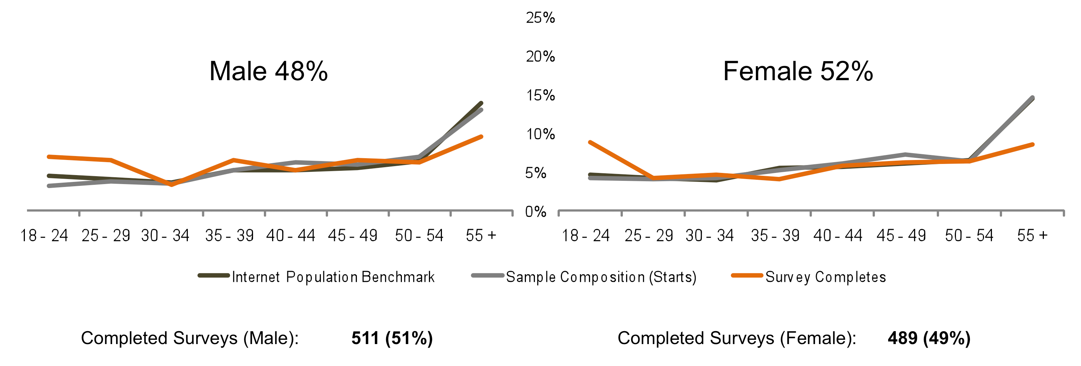Figure 1: Phase 2 – Content Creators [Appendix 5.6, Slide 2]
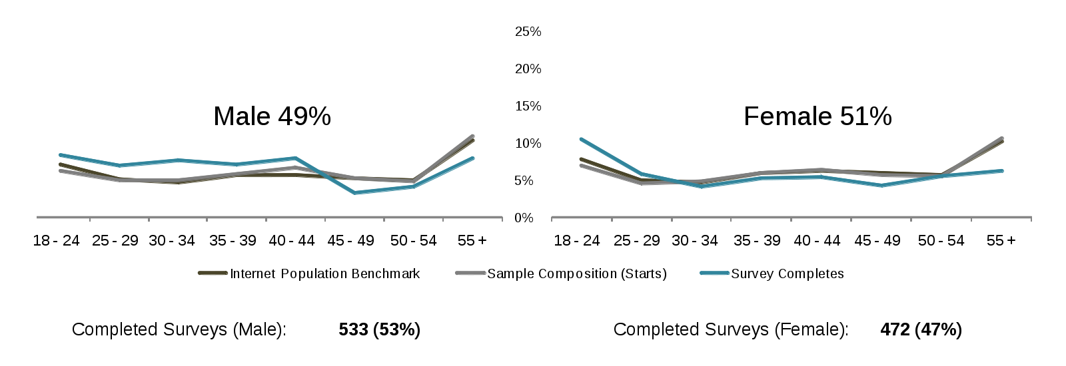Figure 2: Phase 3 – Content Users [Appendix 5.6, Slide 3]

Finally, post-field data cleansing was implemented to remove “speeders” from the data set. Respondents who completed the study in less than 7.5 minutes were removed from each phase of quantitative research. It is possible for respondents to pause their participation in a survey and return to it at a later time. Thus, several outliers from each phase were not included in the mean time calculations: For Phase 2 (creators), 5 respondents who took between 1085 minutes – 1760 minutes were excluded, and 2 respondents from Phase 3 (users) who took 715 minutes and 1016 minutes were excluded.

 | Phase 2 – Content Creators | Phase 3 – Content Users
Response rate | 5% | 6.00%
Abandon rate | 18% | 17.00%
Incidence rate | 31% | 53.00%
Avg. time to complete survey | 21 minutes | 20 minutes
Sample size | 1000 | 1005
Collection Period | 2008-11-25 to 2008-12-12 | 2009-04-19 to 2009-04-29
Table 2: Content Creators and Content Users Dataset.

Surveys

The core of the questionnaire consisted of questions designed to elicit unaided definitions of commercial use and noncommercial use, followed by a “gatekeeping” exercise intended to identify uses that respondents believe to be “definitely” commercial or noncommercial, and an “anchor point” allocation exercise that measured response to five unqualified use scenarios suggested as basic starting points, then compared that response to more detailed and nuanced scenarios. A question testing reaction to the language of the Creative Commons NC term was also included. The questionnaire for Phase 3 (users) was based on the questionnaire developed for Phase 2 (creators), but was tailored for users. It also omitted several questions on online sharing behaviors, in order to include others exploring users’ activities and attitudes as creators.

Open Access Polls

In both Phase 2 (creators) and Phase 3 (users), an open access poll targeted at Creative Commons Friends and Family was fielded simultaneously with the U.S. sample survey. The CCFF polls were based on the general population survey questionnaires, but included additional questions specifically about Creative Commons and the NC license term. After launch, each poll remained open for approximately three weeks. The polls were announced on the Creative Commons blog and promoted via Twitter, Identi.ca and Creative Commons international affiliate websites. The announcement of the Phase 2 (creators) poll was picked up by several other widely read blogs. For Phase 2 (creators), CCFF completed 3,337 questionnaires; 437 completed questionnaires during Phase 3 (users).

The goal of the CCFF polls was to collect more information relevant to understanding global interpretations of noncommercial use, although as noted above the polls were fielded in English only and could not be considered scientific because of the self-selected nature of the CCFF sample. The polls were intended to allow those interested in the subject to express their opinions. It was expected that the CCFF audience would include more respondents knowledgeable about copyright and copyright licensing and have views about the Creative Commons NC term itself.

Copies of the quantitative research questionnaires, indicating the programming instructions that determined how they were presented to individual respondents, are included at the end of this Report.

The results of the quantitative research are described in Section 3.2.

3 Findings

The findings for Phase 2 (creators) and Phase 3 (users) are reported comparatively, rather than in the chronological sequence in which the data were collected. Section 3.1 reports the findings of qualitative research, which informed the design of the questionnaires used to collect quantitative data. For those readers who wish to go directly to the data collected from the U.S. online population, Section 3.2 reports those survey results. Section 3.3 reports the results of the polls of Creative Commons Friends and Family, in comparison to U.S. content creators and users. Section 3.4 provides a summary of research findings.

3.1 Qualitative Research

Phase 2: Creators
Participants in the Phase 2 focus groups were asked to consider the question of noncommercial use from their point of view as creators. The primary objectives of Phase 2 of research were to:

- explore how content creators decide whether a particular use of content is commercial or noncommercial; and

- determine whether creators could be grouped based on a shared definition of noncommercial use.

Qualitative research revealed variations of understanding even among creators who identify with communities that may appear to share certain vocabulary, contexts, norms or general values. To give two examples, within “the education community” there are differences in understanding of and approach to the question of commercial versus noncommercial use, in part because of efforts to define “open access” and the growth of the open educational resources movement. Within “the arts community,” an increasing number of artists and cultural organizations are experimenting with newer models both for content distribution and revenue generation, resulting somewhat paradoxically in greater interest in exploring the return on “giving away” content, and greater interest in exploiting control of access to content that might have untapped commercial value. In each case, previous understandings of commercial and noncommercial use are destabilized. Other examples of developing and shifting understandings of “what can be done with content” are available from every sector of “the content industry.”

However, no matter which content community or communities participants in Phase 2 (creators) were willing to identify with, no matter how traditional or innovative their creative and/or business models, or where they stood with respect to debates about the need for more or less copyright protection, virtually all agreed that there was an important distinction between commercial and noncommercial use. Yet, they could articulate no single common definition. So how do creators approach the question of deciding what counts as commercial use, what noncommercial?

Many participants in the Phase 2 (creators) groups were familiar with at least the basics of copyright. Most participants thought that “noncommercial use” had no legal definition, or were not sure. Many U.S. creators were aware that the doctrine of fair use allows some use of others’ content without their permission, as were creators outside the United States who were aware of a similar law in their legal jurisdictions. Some participants believed noncommercial use to be more likely a fair use than not, and some conflated noncommercial use and fair use. Some participants also mentioned personal or private use as being both legally and pragmatically a noncommercial use, though they were not certain of any law defining “personal use.” During these discussions the moderator was careful to keep participants focused on their understandings of what a license for noncommercial use would permit, and how any law would be relevant to that. There was no consensus on this point, and in some cases, there was misinformation and misunderstanding even on settled points of law. Some participants expressed the belief that more law would be helpful; others disagreed, viewing the question as one that creators are able and should be able to decide.

Internet technology professionals and those focusing primarily on the creation and distribution of web-based content typically take a more liberal stance. Orienting around open source software licensing standards, some (though not all) embrace a “copyleft” philosophy and theorize the implications of abolishing the noncommercial distinction altogether. Many are more concerned with proper attribution than commercial gain, hoping the use will be fair and equitable. Some use technology to license low fidelity versions of the work for noncommercial use and reserve the high fidelity versions for commercial gain.

When asked to share their understandings of noncommercial use, no participant could provide a definition of noncommercial use that worked for everyone in their particular group, although there was much agreement on elements of many of the definitions. Through discussion, it emerged that creators take a variety of factors into account when determining what constitutes noncommercial use. These factors are often considered on a case-by-case basis, although some creators were comfortable with the idea of categories of cases, for example, “educational use” – even though those categories are not consistently defined. However, participants across communities were able to articulate a list of factors they generally agreed as a group were relevant to creators’ understanding of whether a use of a work is commercial or noncommercial. After the first couple of in-person groups during which these factors had begun to emerge, the group moderator began moving more quickly and openly to the collaborative creation of such a list, probing for nuances, qualifiers, and outliers.

The lists created were not identical, and there was no unanimity of opinion on any hierarchy of the factors other than a strong tendency to put the question of money-making at or very near the top. Uses in connection with advertising also featured prominently. Overall, there was a remarkable degree of consensus around the relevance of each of the “consideration factors” on the list ultimately synthesized (below, in no known order of priority, particularly at the time). Most importantly, these factors were relevant to creators across a breadth of content communities and industries. In addition, at least at that this level of research, there were no significant differences of opinion between participants in the United States and those elsewhere.

Qualitative Research Consideration Factors
Perceived economic value of the content
The status of the user as an individual, an amateur or professional, a for-profit or not-for-profit organization, etc.
Whether the use makes money (and if so, whether revenues are profit or recovery of costs associated with use)
Whether the use generates promotional value for the creator or the user
Whether the use is personal or private
Whether the use is for a charitable purpose or other social or public good
Whether the use is supported by advertising or not
Whether the content is used in part or in whole
Whether the use has an impact on the market or is by a competitor
Table 3: Qualitative Research Consideration Factors.

In general, creators did not consider the media in which content is created or potentially used relevant in and of itself to the question of whether a use is commercial or noncommercial. However, some raised the fact that some content in digital form has greater potential economic value than other types of content – music and movies were frequently cited examples.

It was recognized that a list of consideration factors alone could not define noncommercial use. Most participants insisted that any definition would have to include expressed rules and limits for most of the factors. Further, participants were deeply skeptical that even with the aid of such a list, any single definition could be formulated.

Creators in the groups recognized that they consider some factors more important than others, and they also weigh the factors differently. Some consider certain factors to be “gatekeeping” questions, the answer to which settles the matter. Some creators consider a use commercial if there is any advertising in connection with it, for example. Others consider certain factors to be questions of degree. For example, some creators consider recovery of costs to distribute a work a noncommercial use, but not if salaries or other overhead are calculated as part of cost recovery. Rather than constituting a simple checklist, for many creators the factors exist within a matrix in which the type of use (for example, promotional or advertising use) and the context or community-based nature of the use (for example, charitable use, or use in a public school) are important vectors. In sum, the decision-making process is not clear-cut.

However, virtually all creators agree that a noncommercial use is one in which “no money changes hands.” Many then add that for a use to be truly noncommercial, there should also be no indirect commercial gain. Yet everyone recognizes that indirect commercial gain may be impossible to avoid – and may accrue to the creator as well as (or instead of) the user. Many group participants noted that there are promotional and thus potentially economic or commercial advantages to creators in connection with releasing content freely for noncommercial use. For these creators, “credit” for permitting noncommercial use is very important, and the question of attribution is something that gets factored into their consideration of when a use is acceptable. For example, attribution is often more important to artists and programmers than protecting particular content that might have some economic value, sometimes but not always on the theory that attribution may ultimately lead to overall greater commercial gain. This suggests that the CC license attribution requirement may be an important factor in at least some creators’ understanding/perception of the NC license term. At the same time, some participants noted that users can derive promotional advantage from use of others’ works, and wondered when “promotional” becomes “commercial” advantage. As a practical matter, many seem to consider noncommercial use as having minimal or indirect commercial impact, rather than absolutely no commercial impact.

Many creators are also more inclined to let their evaluation of a use shift toward “noncommercial” when the use is made for some charitable purpose, or to promote some social or public good. For example, a creator may usually consider advertising a commercial use, but not if the advertising is for a charitable organization. Yet that same creator also may want to distinguish between charitable organizations with more or fewer resources, or charitable purposes or social causes that align with the creator’s values, or not. Thus the decision-making process is further complicated by subjective or personal views; that is, what may be a social good to the user may be objectionable to the creator. While some content creators are aware that some consideration factors may have a legal dimension beyond the licensor’s control, at least in the United States (for example, “whether the use is morally objectionable” would be irrelevant if a use of content was otherwise fair and legal), others are not.

In the absence of contractual or licensing terms for noncommercial use, many creators rely on formulations that are unique to their particular situations, or which may be used by similar creators (even though these formulations may not rise to the level of a shared community or industry standard). Often these formulations cannot be made easily known to users (for a variety of reasons, including that the distribution of the content may not be entirely under the creator’s control); sometimes the creator does not bother to make them known, at least not unless the would-be user contacts the creator, or the creator discovers an unacceptable use. Many of these formulations are also open to interpretation, as is demonstrated by these verbatim examples of what “noncommercial use” means in practice for some creators:

- “if I have nothing to gain, then it’s noncommercial”

- “if you can afford it, please pay; if not, that’s okay”

- “what we consider to be ‘truly’ educational use”

Many creators also establish different standards for release of content for noncommercial as opposed to commercial use. For example, creators release low fidelity or low resolution versions of a work for noncommercial use, but reserve high fidelity or high resolution versions for commercial exploitation.

Internet technology professionals and those focusing primarily on the creation and distribution of web-based content typically take the most liberal stance with respect to permissible uses, particularly those who describe themselves as sympathetic to the principles of the open source software movement and/or who espouse a “copyleft” philosophy. On the most extreme end of this scale, a few respondents advocated the free circulation and distribution of content as an absolute good, and thus opposed any restrictions on use, including restrictions on commercial use.

While Creative Commons openly convened the focus groups, the emphasis of research was on creators’ own understanding of noncommercial use. Many participants in the groups had only minimal familiarity with Creative Commons. However, when time and the flow of discussion allowed, some groups were presented with the language of the Creative Commons NC term as a possible definition of noncommercial use. This was done without identifying the source, but many participants guessed, and a few knew the term before coming to the group. Many participants felt the definition captured their basic understanding of noncommercial use, but was too general to be useful for application to many specific situations. Others deemed the ability of the definition to apply to a range of otherwise unspecified situations a strength. Many participants, including some of those who felt the definition was compatible with or close to theirs, criticized the language as vague or unclear, focusing particularly on the meaning of “primarily intended” and “commercial advantage,” and the import of the adjective “private” as applied to “monetary compensation.” Some criticized the definition as tautological, because it includes the word “commercial.” Virtually all agreed that more explanation and/or examples of specific noncommercial uses presented in connection with the definition would be helpful – and some put it more strongly than that.

Many participants disagreed with the idea that a single definition of noncommercial use could be workable. Some raised the possibility of developing a range of public copyright noncommercial use licensing solutions, in different “flavors” for different uses and/or contexts. Others emphasized the advantages of a single standardized license term that might work for a majority of creators and users. When pressed to express a percentage, however speculative, a few agreed that such a solution might be found for maybe 80% of cases.

Finally, although the focus in Phase 2 was on content creators, a lot was heard about and from content users. Many group participants introduced their own experiences using content created by others into the discussion, sometimes to describe a situation involving a creator with a different perspective, sometimes to make a point about how their own views as creators were formed. These discussions informed the decision to focus Phase 3 of the research on content users, in order to learn more about how understandings of noncommercial use may differ from one side of the licensing equation or the other.

The generation of a “consideration factors” list in Phase 2 (creators) focus groups inspired an approach and much of the content for the questionnaire developed for quantitative research, described below.

Phase 3: Users
Mirroring Phase 2, the primary objectives of Phase 3 qualitative research were to:

- explore how content users decide whether a particular use of content is commercial or noncommercial; and

- determine whether users could be grouped based on a shared definition of noncommercial use.

Additionally, this Phase of research investigated users’ identification and experience as creators.

In order to define “user,” participants were asked to think of all the various “use” activities in which they might engage: copying and downloading content, sharing and further distributing a copy of content, incorporating content into some other work, or manipulating or altering content. In discussion of these uses, immediate similarities appeared between the perspectives of those using content and the perspective of creators explored in Phase 2 (creators) focus groups. Like creators, users do not share a single definition of noncommercial use, and there are significant differences in understanding even within particular communities or industries. The majority of both groups tends to think that “noncommercial use” has no legal definition, or is not sure. Users are also uncertain (and sometimes misinformed) about the relation of noncommercial use to fair use or personal use.

However, many of the participants in Phase 3 (users) groups would not classify themselves strictly as “users,” explaining that the categories of pure creator (someone who creates “something from nothing”) and pure user (passive consumer) are increasingly rare and/or inadequate. Rather than “user,” many of these participants from across content communities prefer terms such as “re-user” or “re-purposer,” terms that express strong beliefs that their use of content is itself creative. These participants in particular acknowledge remixing and sampling as vital cultural phenomena, although it has to be said that the definitions or legality of these activities were not established in the groups. Just as the moderator remained careful to curtail discussion of the scope of fair use to its relevance to the definition of noncommercial use, the group moderator also asked respondents to focus on situations in which a creator’s willingness to license was not in question, only the understanding of what a license for noncommercial use would permit beyond fair use.

Other participants found different ways of describing “value-added” user activity. Those who work in libraries, museums and other cultural repositories and institutions often refer to themselves as “curators” of content, or “mediators,” “facilitators” or “intermediaries” between creators and users of content. These participants are typically involved as well in creating content such as text for the organization’s records, blog or other publications. Some participants working in web-based content contexts refer to themselves as “guardians” or “shepherds” of the metadata associated with digitally created or hosted works, and explain that their roles in organizing metadata schemas and aggregating content have a creative dimension that may add value to the content itself.

Those who identified as both users and creators seemed to agree that their experience had influenced their perspectives on the question of what constitutes noncommercial use, making them more aware of the issues and their implications. Yet, despite being better able to articulate the complexities and nuances of the issues, user-creators did not express differences in opinion from other users, or from other creators for that matter.

When asked to evaluate the list of commercial/noncommercial use consideration factors developed in Phase 2 (creators) qualitative research, participants in Phase 3 (users) agreed with their relevance. Even after much discussion, no new factor was added although, as mentioned below, two were proposed. Reaction to the utility of the list also was the same: participants in both Phases 2 and 3 agree that a positive definition of “noncommercial use” would have to establish rules or limits for most of the factors. Furthermore, users are as skeptical as creators that a single definition of noncommercial use can be formulated.

Users added more color and depth to many of the possible use cases explored with creators, but no completely new scenarios. Overall, users did seem to view uses involving cost recovery as somewhat more commercial than creators, and they did express some concerns that had not been raised or had not fully surfaced in Phase 2 (creators).

A few individual users voiced some feelings of guilt for taking advantage of the ambiguity regarding the distinction between commercial and noncommercial use, and what they judge to be the low risk of being discovered or pursued for infringement. Interestingly, for some this guilt appears exacerbated by their mostly untested belief that creators define noncommercial more narrowly than they do, especially when the creators are trying to make a living from their works. One participant said that in the current environment, many users are essentially creating new “pies,” that is, new products and/or markets based at least in part on use of others’ content without giving anything back to the creators of the original pies. Some users make a point of giving attribution to the creator as a way of giving back, even when not requested.

Indeed, some Phase 3 (users) participants assert a “new orientation around creating” is the primary cause of confusion or ambiguity regarding the commercial/noncommercial distinction. They point to the fact that some creators feel that the recognition made possible by the Internet is reward enough for creating content, and suggest that the implications of this new reality are two-fold: creators who earn a living from their work experience greater competition and pressure to find new ways of making money, and attribution is increasingly perceived by some creators and some users as sufficient compensation for producing content and making it available to others. These participants emphasize the need for standards and/or rules regarding credit that should be given to the source of content used; in the words of one participant, “to think of noncommercial [use] without attribution is faulty.”

Among users who are not interested in making money from their uses of others’ work, or who work for not-for-profits, many present themselves as conscientious experimenters who want to do new, interesting and socially useful things with content, ideally using ethical guidelines that have been endorsed by the community. For these users, lack of clarity around the meaning of noncommercial use is particularly frustrating.

Participants representing not-for-profit cultural and educational institutions expressed not only frustration but also some real worry about possible litigation, particularly as they strive to take advantage of new possibilities for content collection and distribution enabled by developing technologies and meet the corresponding new expectations from their audience or “clients.” For example, users who work for archives and educational say they have to “play all sides” in an attempt to reconcile what often seem to be opposing interests in content. These users struggle to find ways of making more content available to the public while negotiating the demands of some creators and content providers (or their in-house counsel or administrators) to restrict access.

In general, the lack of accurate knowledge and the abundance of misinformation about copyright law and fair use revealed in qualitative research are notable, particularly among professionals working with content. Many users are aware of this problem. Even accomplished professionals openly question their own understanding and judgments about the distinction between commercial and noncommercial use. Educators in particular seem to feel they are in a difficult position because they see a need for greater understanding of copyright law and fair use among students at all levels, but are also grappling with their own lack of knowledge. Many participants from a range of cultural organizations report a high degree of internal confusion and risk aversion, as well as lack of any internal resources to increase understanding of the legalities concerning much use of content.

Participants representing corporations or who deal with corporations, especially those with more traditional business models, say the ambiguity around noncommercial use often prevents much content from being used. They assert big corporations “won’t touch” works licensed for noncommercial use because of uncertainty over the term, and that the noncommercial label may even have a chilling effect on uses that creators may not intend to restrict. For example, technology industry representatives explain that working with noncommercial use-licensed databases would mean the loss of ability to partner with large companies, because “even a whiff of noncommercial and companies will not use it.”

A few Phase 3 (users) participants in the in-person groups also raised as potential additional consideration factors the notions of “community support,” and “promotion of public discourse.” The rationale for the first proposed additional factor was that if a particular use serves the “authentic” needs of a community, it should be considered a permitted use (at least within that community); the rationale for the second was that if the intention of the use is to enter something into public discourse, it too should be permitted. The format of the focus groups did not permit in-depth discussion of these points, but the feeling generally among participants seemed to be that were these proposals to find broad support, as noncommercial use “consideration factors” at least they were already captured by the factor recognizing “promotion of a public or social good.”

As do creators, users often approach the question of noncommercial use on a case-by-case basis. Paralleling many creators’ approach to deciding when to allow or license a noncommercial use, many users also explained they use content guided by their own principles or personal rules of thumb, or in accord with practices followed by other users, which they hope creators are more likely to accept, on a “safety in numbers” theory. Verbatim examples of how some users articulate their understanding of when a use is noncommercial include:

- “if it’s for education or personal use”

- “if it does not compete – noncommercial is really non-compete”

- “if the creator is getting promotional value”

When Phase 3 (users) groups were presented with the language of the Creative Commons NC term as a possible definition of “noncommercial use” (again, without identifying its source), their reactions were similar to those of participants in Phase 2 (creators). Most participants said the description is vague, specifically criticizing the phrases “primarily intended” and “commercial advantage.” Some also questioned the meaning of “private monetary compensation,” and pointed out the tautology of using the word “commercial” in a definition of noncommercial use.

Participants made various suggestions for improving the Creative Commons NC term, but none seemed certain the result would yield a truly effective solution. While many suggested that examples of use cases would be helpful, as did participants in Phase 2 (creators), there seemed to be pessimism that this would solve the problem since new use cases could always arise. Several Phase 3 (users) respondents specifically suggested including attribution in the term as a way of striking some balance or ensuring some equity between user and creator.

Ultimately many Phase 3 (users) participants engaged in a more general debate around the pros and cons of having a definition that is more broadly, or narrowly, defined. Some recommended a broader definition, suggesting that would best serve the purpose of accommodating developing understandings of noncommercial use, as social practices and business models change in response to new technologies. Others recommended a more narrow definition, believing it more important to counter the chilling effect caused by uncertainty around understandings of noncommercial uses. Some further recommended avoiding trying to “define the gray,” and specifically suggested that a definition of noncommercial use that at least establishes any non-controversial use cases would be helpful. Examples offered were personal uses at home, or uses by students for school projects.

Speaking as users, some Phase 3 participants expressed a certain amount of anxiety that examination of uncertainties around the commercial/noncommercial divide could in the short term “spoil the party” by causing some creators to rethink licensing content for noncommercial use. At the same time, they are concerned that the sense of opportunity and expansiveness that characterizes legitimate online content-sharing will be dampened if creators lose confidence that users understand and respect their intentions in licensing content for noncommercial use.

3.2 Quantitative Research: U.S. Online Population
The primary objectives of the quantitative research were to:

- empirically validate the qualitative research finding that content users do not share a single definition of noncommercial use;

- identify and compare content creators’ and content users’ understandings of noncommercial use; and

- confirm and measure the relative importance of the factors identified in the qualitative research that creators and users consider when determining whether a use should be considered commercial or noncommercial.

Additionally, the second phase of quantitative research explored users’ identification and behaviors as creators. Findings from both phases of research – Phase 2 (creators) quantitative research and Phase 3 (users) quantitative research – are presented in comparison below.

Creators and Users: Profiles
This section provides highlights of the profiling data collected, which overall reveal that online U.S. creators and users are in many significant respects more alike than different. Analysis of the data further reveals that with respect to their understanding of the difference between commercial and noncommercial use, there are few statistically significant differences between creators and users across a number of key variables and between subgroups within each sample.

Overall, creators and users are more similar than different in profile and their understandings of commercial and noncommercial use. Within each sample of creators and users, creators and users younger than 30 tend to consider more uses of content less commercial than do older users. But as noted throughout discussion of the findings below, the most significant differences among subgroups are those between creators who make money from their works and those who do not, and users who make money from their uses of others’ works, as opposed to those who do not.

Creating and Using

Over 8 in 10 of all creators and users generally consider themselves amateurs. Photos are by far the most common type of content created and used by each group, among a wide variety of media including web-native content in the form of blogs and podcasts. There are far more users of different types of content, particularly images, videos, music and games, than there are creators of these types of content.

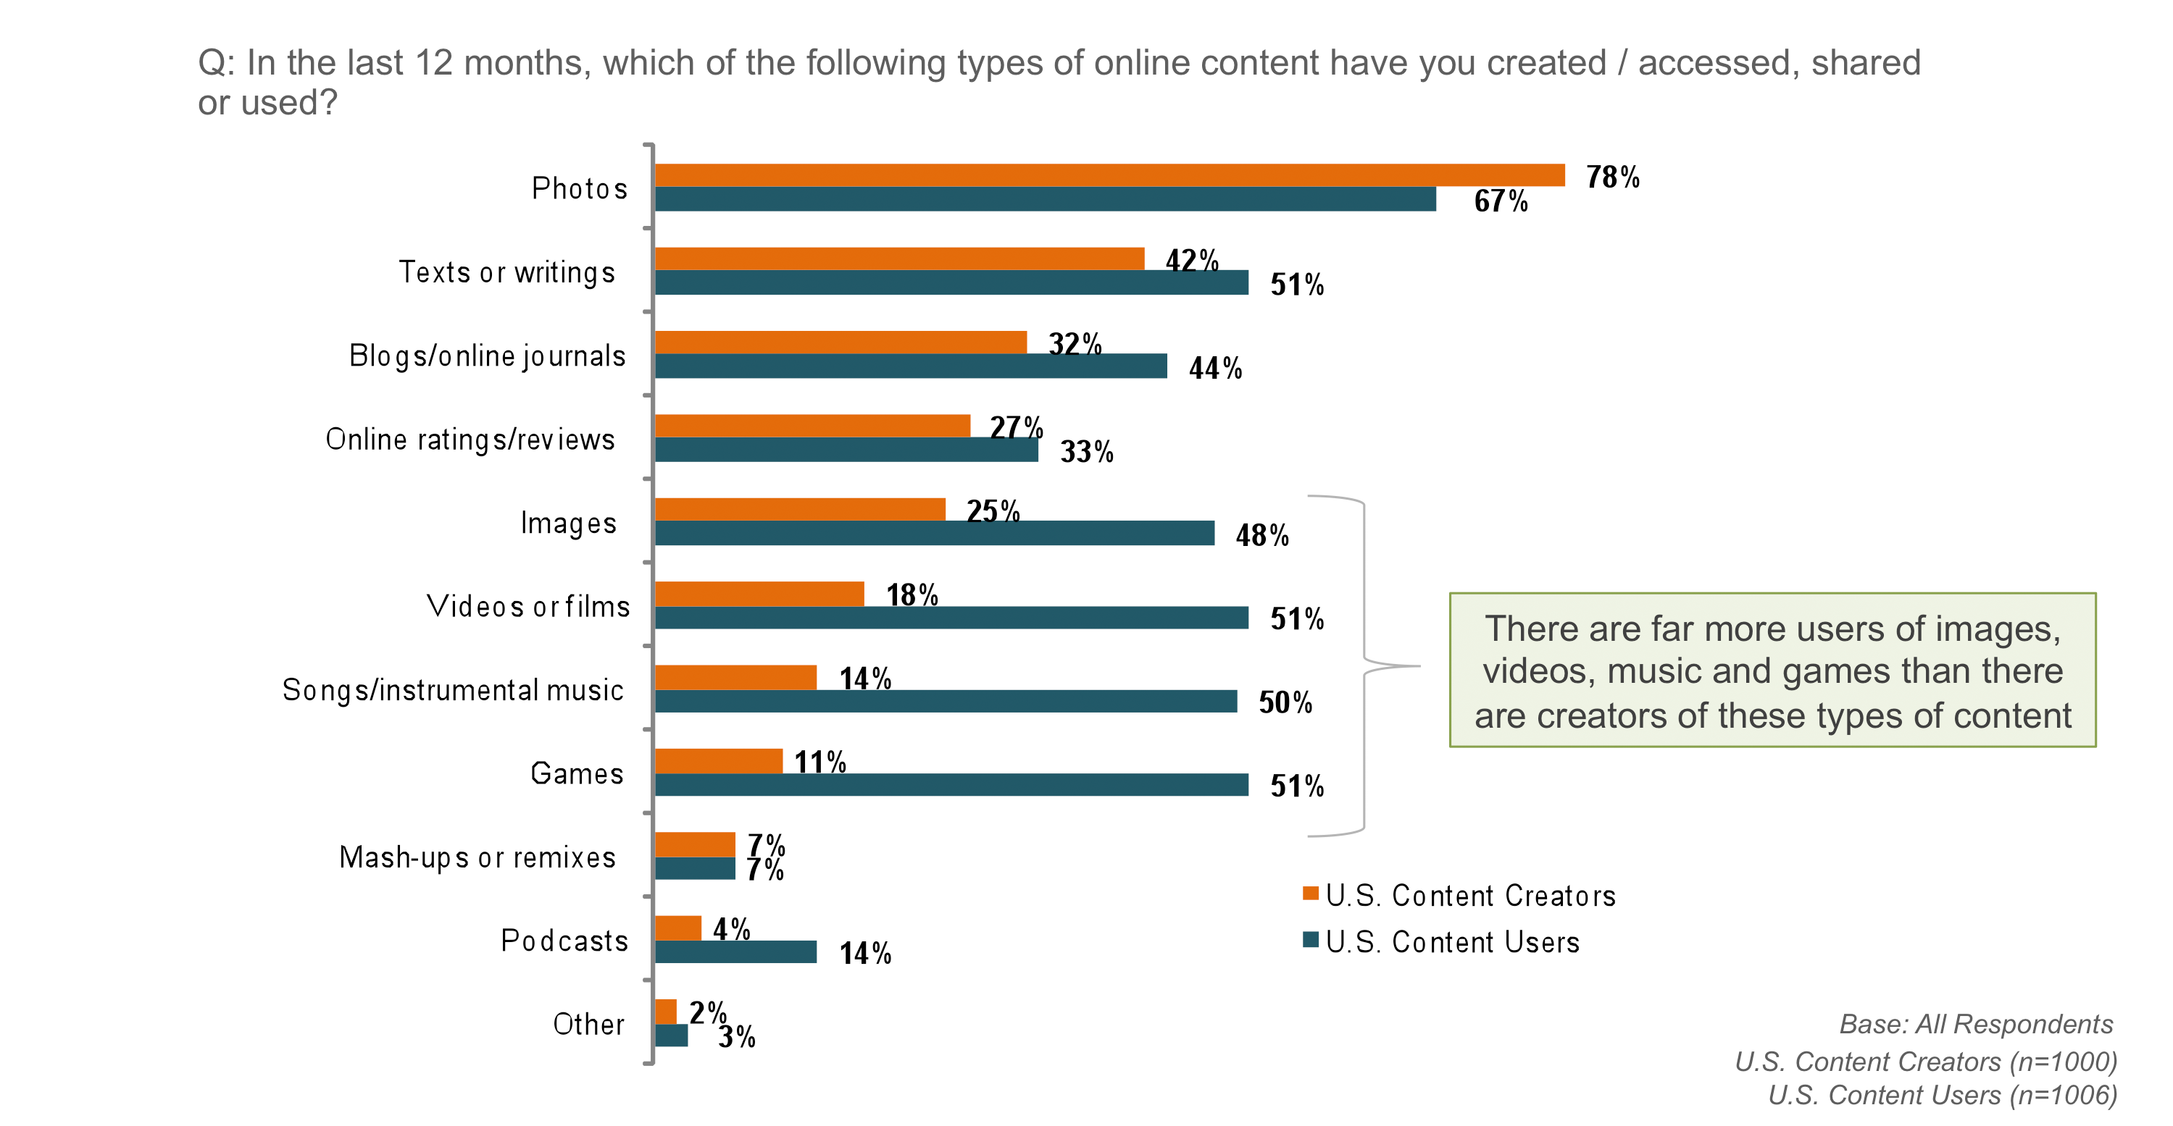Figure 3: Photos are the most common type of online content created, accessed, shared or used [Appendix 5.6, Slide 4]

Creators and users also relate to a broad range of community or industry categories. “Entertainment” is chosen by most as the category that best describes the majority of the works they create or use. The next most common categories selected by creators are visual art, literature and education; users select music, and education.

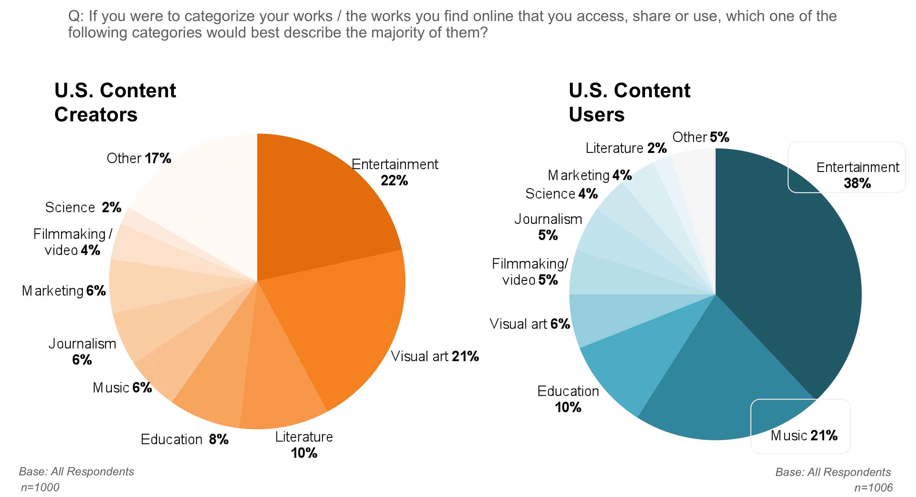Figure 4: Profile of U.S. Content Creators and Users [Appendix 5.6, Slide 6]

Online Behaviors

Over 8 in 10 creators have shared their works online. Games and podcasts are shared most frequently, followed by blogs, songs and music, images, and other texts and writings. 60% of creators have shared their photos, the most common type of non-web-native content shared. Creators use a variety of means to share their works online. Email is the most common (66%), but over half also post to social networking websites, and about a third post to their own or someone else’s blog, post to a website that hosts user-generated content, use an email group or listserv, or share content via instant message or “chat” message. 6% of creators use microblogging services such as Twitter to share works. Only 12% of creators share their works on peer-to-peer networks. 6 in 10 creators “always” or “usually” control who can access the content they share online.

Photos are the most common type of work used, but almost half of all users have also used video or film, texts or writing, games, songs or music, and images. Over one-third have used blogs and online ratings or reviews.

Content users also use online content in a variety of ways. 70% have downloaded content just for themselves, while 46% have shared what they downloaded with others. 49% have posted or uploaded content created by others to a blog or website. Others say they have made new works using others’ content by incorporating it (13%), or changing or altering it (8%). 8% say they have remixed or mashed up content.

Familiarity with Copyright and Licensing

Among profiling variables, only 1 in 5 creators say that any of the works they have created in the last 12 months are copyrighted. As noted above, respondents for Phase 2 (creators) were screened for entry into the study based on their having selected one or more types of copyrightable content from a list that was presented. Because U.S. law grants copyright upon creation in fixed tangible form and no formalities are required to obtain copyright, the study assumed that most content creators in fact do own copyrighted works, although the study results show that many do not realize it. Meanwhile, nearly 8 in 10 content users say that none of the works they have used in the last 12 months are copyrighted, or they are “not sure.” Here, the corollary assumption was made that these users are unaware that they are using copyrighted works. These findings suggest that the vast majority of both creators and users do not understand the basics of copyright law.

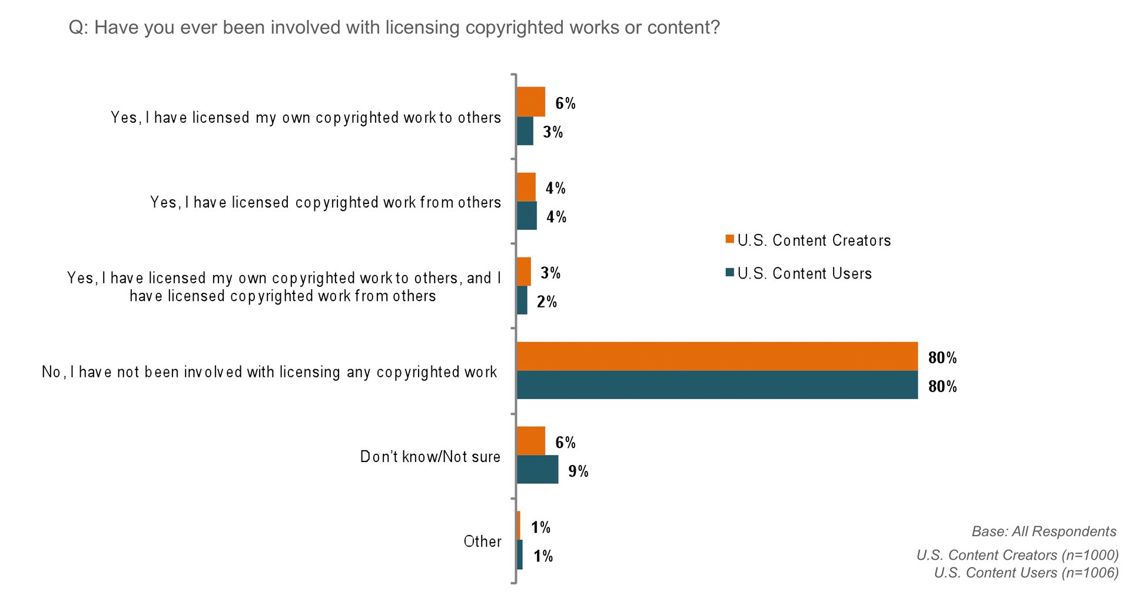Figure 5: Profile of U.S. Content Creators and Users [Appendix 5.6, Slide 17]

Only a few creators (about 1 in 10) have licensed their own work to others. Of creators who share their works online, about 2 in 10 say they license their works – 44% of them using a free public license available online, and 40% using a license written specifically for the work.

Nearly 7 in 10 users who say they have used copyrighted works in the past year are able to state how the works were licensed, while the others either do not know or are not sure, or say the works were not licensed or they did not seek or acquire a license. 37% of the works they used were licensed under a free public license available online.

Because of its importance to the development of public copyright licensing, the study sought to determine whether there was awareness of the open source software movement within the general population. While 56% of creators say they are not at all familiar with the principles associated with the open source software movement, 44% are at least “somewhat familiar,” with18% saying they embrace them. Awareness of the open source software movement among users is almost identical, with most (59%) saying they are not at all familiar with the principles and 18% saying they embrace them.

Revenue Generation

Although most of the online population generally consider themselves amateurs, creators say 14% of their works earn them money, and users say that 14% of the uses they make of others’ works earn them money, as well. Among those who earn money from works they create or use, creators earn an annual average of $12,600, while users earn on average $19,600. Typically, however, creators and users who earn money earn less than $500 a year.

Users as Creators

As mentioned above, the Phase 3 (users) survey included additional questions exploring users’ experience as creators. Only 29% of respondents in Phase 3 (users) of the survey identify themselves as “exclusively a user of works.” Over 4 in 10 users say they have created one or more types of content in the past year. Approximately half of these “user-creators” say they have created photos, approximately one-third have created text, blogs or images; approximately one-quarter have created videos, films, songs or music. User-creators also categorize their works in a variety of ways, primarily however as “entertainment,” as did creators in Phase 2.

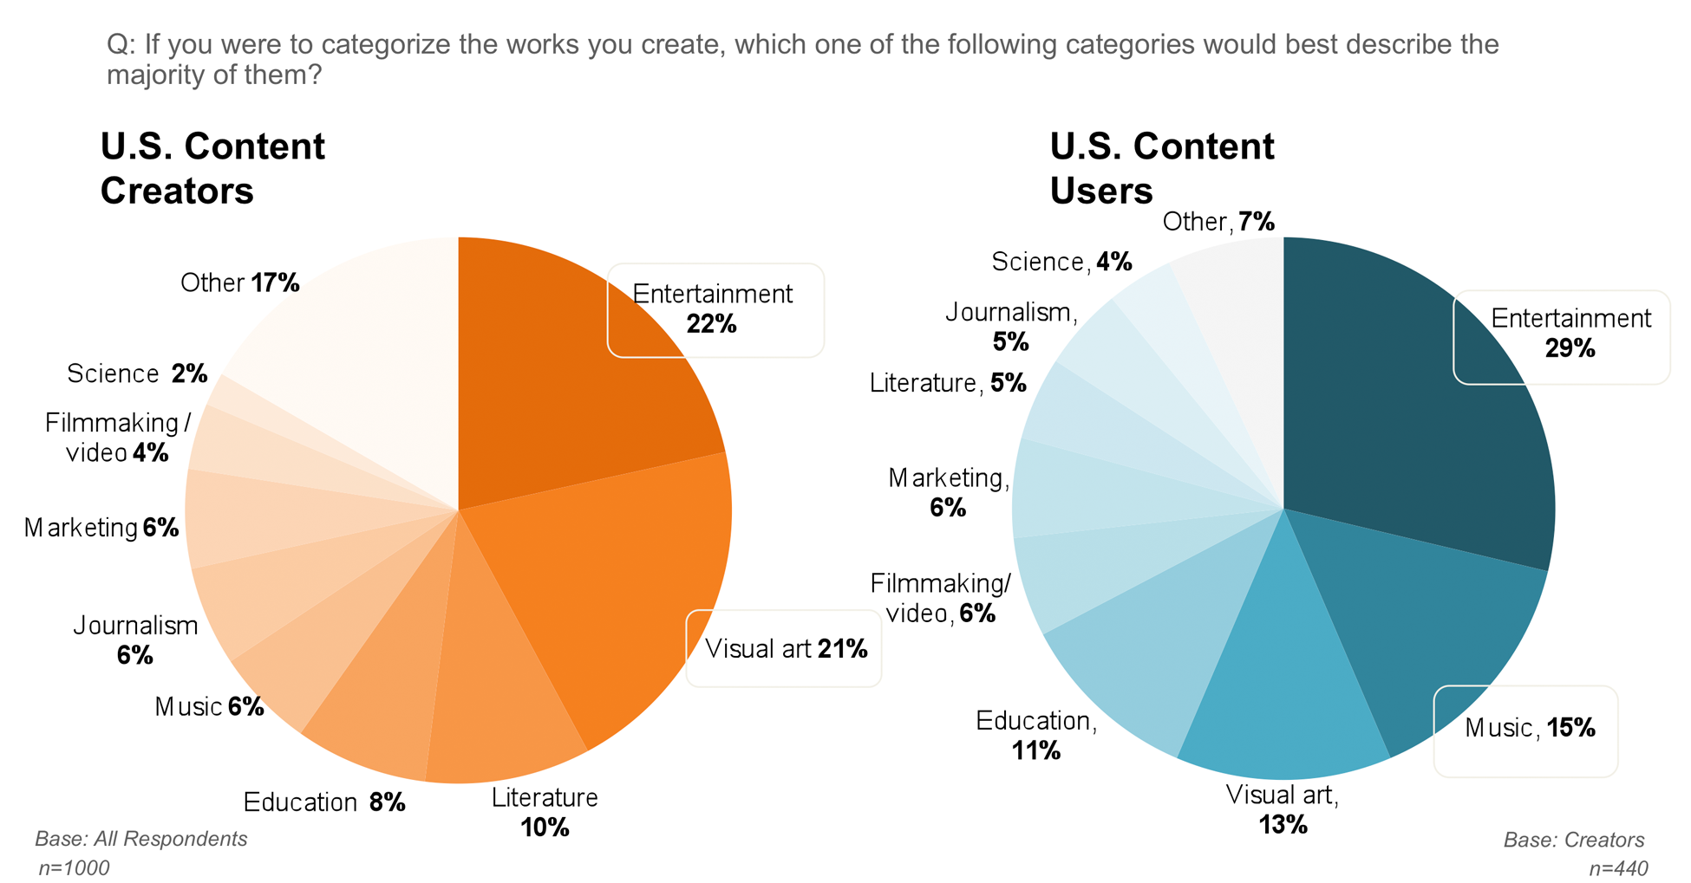
Figure 6: Profile of U.S. Content Creators and Users [Appendix 5.6, Slide 29]

Phase 3 (users) respondents were asked if they would use any of a number of terms that had emerged during qualitative research to help describe their involvement with the content they use and/or create. From the list of terms presented, approximately one-third of respondents selected “sampler,” and 22% selected “contributor.” The terms ”intermediary,” “remixer,” “mediator,” “repurposer” and “curator” were each selected by 5-10% of respondents. This finding further supports the view, expressed strongly during qualitative research, that for many, there is not a strict dichotomy between creators and users.

Overall, the survey data reveal very little difference between the perspectives users generally bring to the question of the distinction between commercial and noncommercial use, and the way that user-creators see the question. There are virtually no statistically significant responses between those who identify exclusively or primarily as users, and users who also identify as creators.

Attribution

Because the importance of giving attribution or credit for use of content was raised repeatedly in Phase 3 (users) focus groups, some questions on this subject were presented in the Phase 3 (users) survey. The findings suggest users are very supportive of giving attribution to the creators of the works they use. Over one-third (39%) say they "always" give attribution, even when not required or requested, and more than a quarter (26%) say they “usually” do. Only 15% say they “rarely” or “never” give attribution. Furthermore, 61% say attribution should “always” be given even if not requested or required, with another 30% saying it should be given when requested or required. Thus, fully 91% of users support attribution for creators. By contrast, a only 3% say attribution should never be required and only 6% say they “don’t know.”

What Is Noncommercial Use? Unaided Understandings and Beliefs
Survey responses reveal that creators and users take a similar approach when asked to define the difference between commercial use and noncommercial use. As discussed below, both groups believe that they can define the difference on the basis of their existing knowledge, both groups believe that others understand the difference the same way they do, and both groups are similarly divided as to awareness of any law that may define the difference.

Commercial v. Noncommercial

In the quantitative surveys for both Phase 2 (creators) and Phase 3 (users), the first mention of “noncommercial use” appears in an open-ended question asking respondents how they would define the difference between a commercial use and a noncommercial use of a work, in their own words and without consulting other sources. Creators and users provided an answer in the same ratio – approximately 7 in 10 from each group.

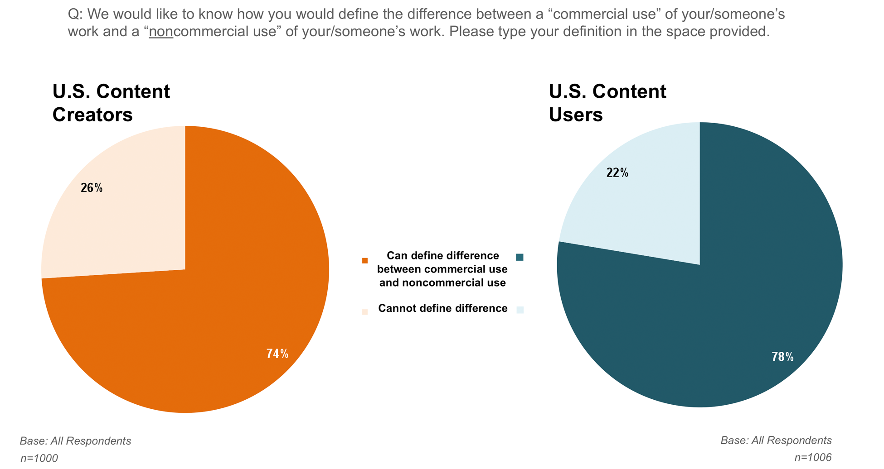
Figure 7: Unaided Definitions and Reactions to the CC NC Term [Appendix 5.6, Slide 36]

Responses to this open-ended request for a definition of the difference between commercial and noncommercial use were coded in order to quantify them. A large majority of both creators and users define a commercial use as one in which money is made (73% of creators, 76% of users). Both also mention uses in connection with advertising and uses in which the work would be distributed publicly or widely. Neither group expresses a majority consensus on an understanding of noncommercial use. However, the most common mention of a noncommercial use by both creators and users is some use by an individual (19% of creators, 33% of users), including personal and private uses. Those who provided an answer were then asked whether they think other people understand the difference between commercial use and noncommercial use in the same way they do. More than 7 in 10 creators and users said “yes.”
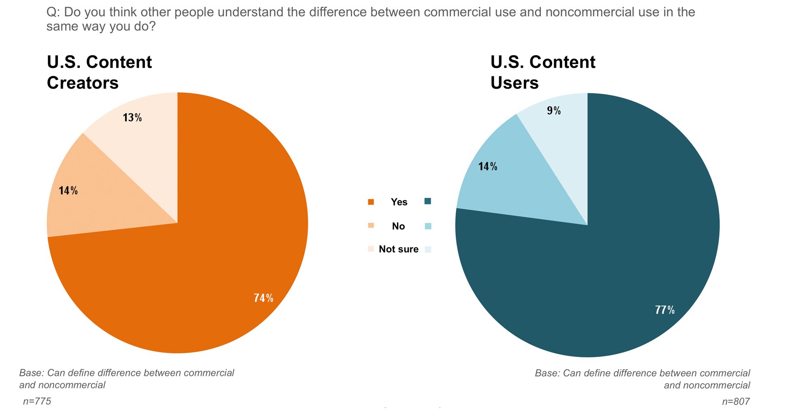
Figure 8: Unaided Definitions and Reactions to the CC NC Term [Appendix 5.6, Slide 39]

Awareness of Law

Creators and users who provided an answer in response to the request for a definition of the difference between commercial and noncommercial use are similarly divided on their awareness of any law that defines such a difference. Roughly one-third of each group said “yes,” another third said “no,” and a final one-third replied “not sure.” When asked to describe it in their own words, of creators who believe relevant law exists, “copyright law” was mentioned most often, far fewer mentioned fair use, and fewer still referred to other law such as the “Uniform Commercial Code.” Users replied similarly.

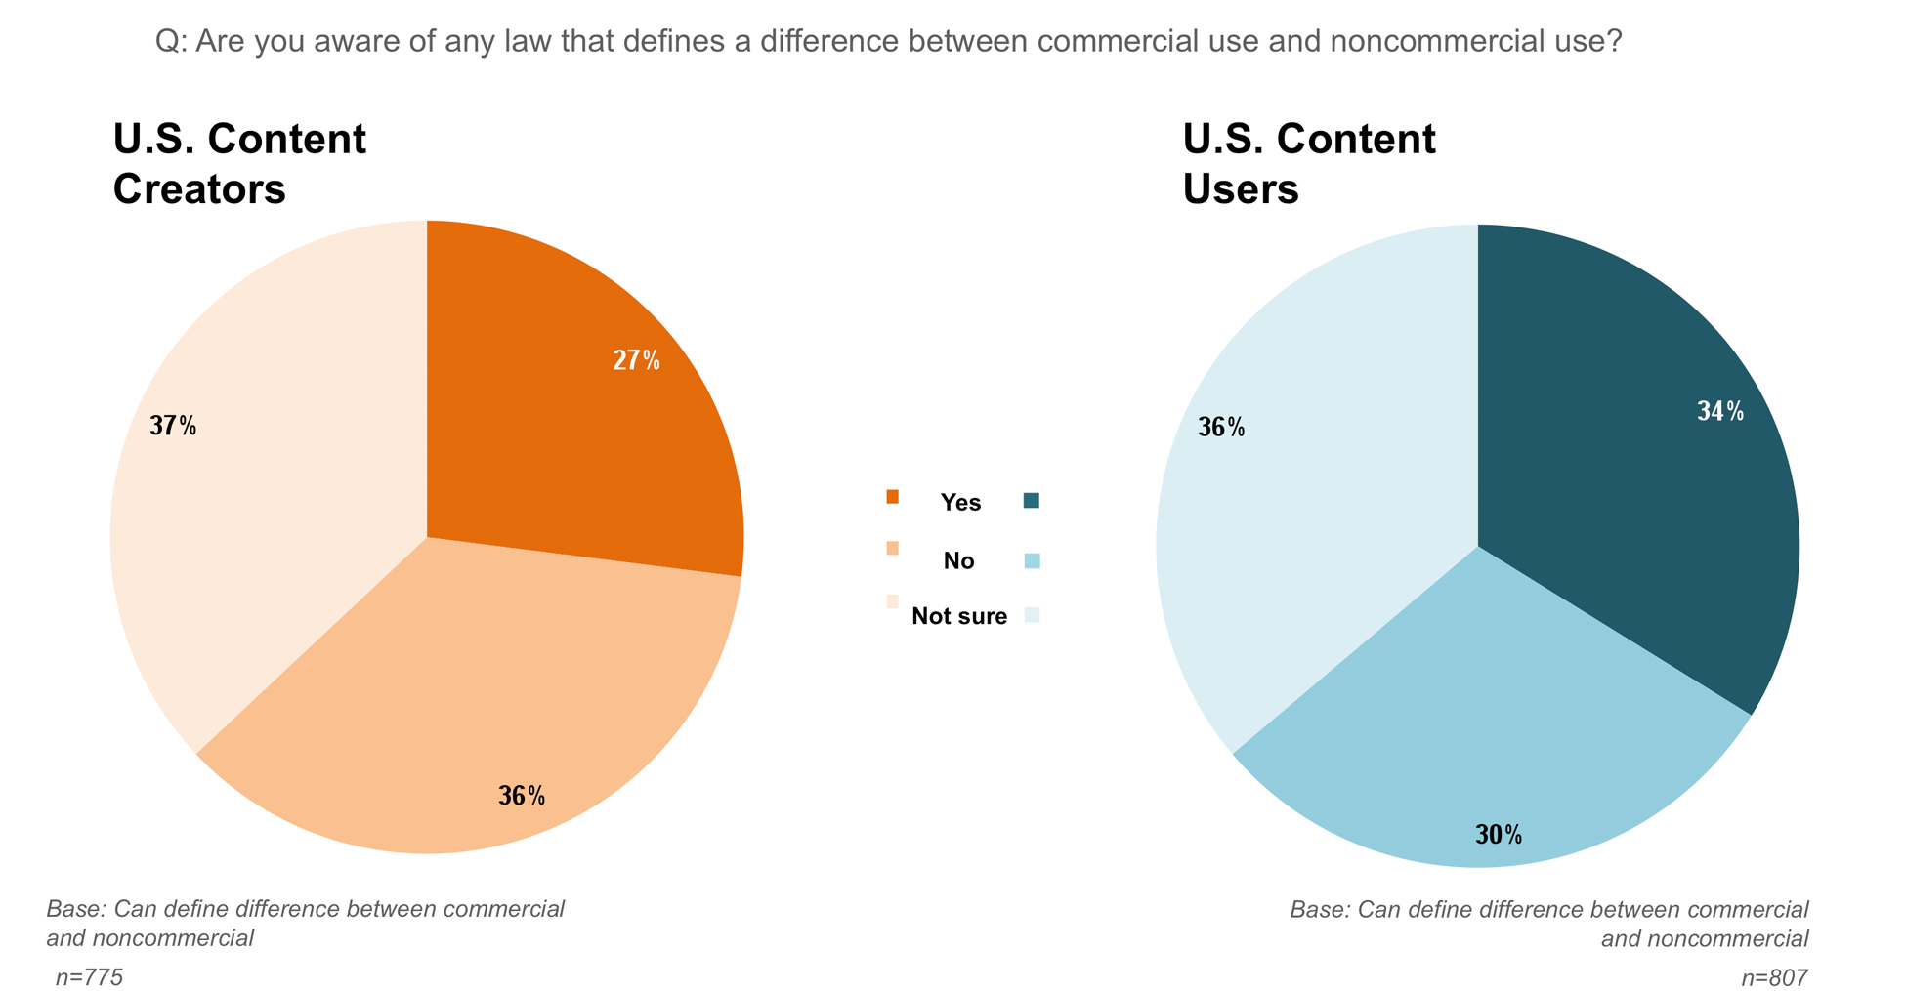
Figure 9: Unaided Definitions and Reactions to the CC NC Term [Appendix 5.6, Slide 43]

Gatekeeping Factors
Following the series of questions designed to elicit unaided definitions of noncommercial use, creators and users were presented with a set of statements describing certain distinct use scenarios, some of which were deliberately more generic than others. These statements were randomly generated from the list of 16 scenarios below, which analysis of qualitative research suggested might involve possible “gatekeeping factors,” that is, factors that some creators and users might consider definitive for their determination of whether a use is commercial or noncommercial. Only eight statements were provided to each respondent in hope of partially mitigating survey fatigue.

Possible Gatekeeping Factors
Money would be made directly from sale of a copy of the work
Money would be made from use of the work in some way
Money would be made from use of the work, but only enough to cover costs of copying and distributing the work
No money would be made from use of the work
The work would be used online and advertising would appear around or in connection with it – and money would be made from the ads
The work would be used online and advertising would appear around or in connection with it – and enough money would be made from the ads to cover the cost of website hosting
The work would be used on a splog or “zombie website” that exists only to artificially generate traffic and revenues from pay-per-click advertising
The work would be used by an individual
The work would be used by a not-for-profit organization
The work would be used by a for-profit company
The work would be used by the government or a state-run entity
The work would be used by a for-profit company, but no money would be made from use of your work
The work would be used for a charitable purpose, or to promote a public or social good
The work would be used for a purpose you find objectionable
Only a small part of the work would be used
The entire work or “the heart” of the work would be used
Table 4: Gatekeeping Factors.

Respondents were not presented with the notion of “gatekeeping” per se, but were asked to consider the statements and indicate whether they thought the proposed use would be “definitely a commercial use,” “definitely a noncommercial use,” whether “it would depend,” or if they “don’t know.”

Findings from the gatekeeping exercise reveal that creators and users share some strong opinions, as well as some uncertainties. The findings also demonstrate that there are significant differences of opinion both within the groups and between the groups.

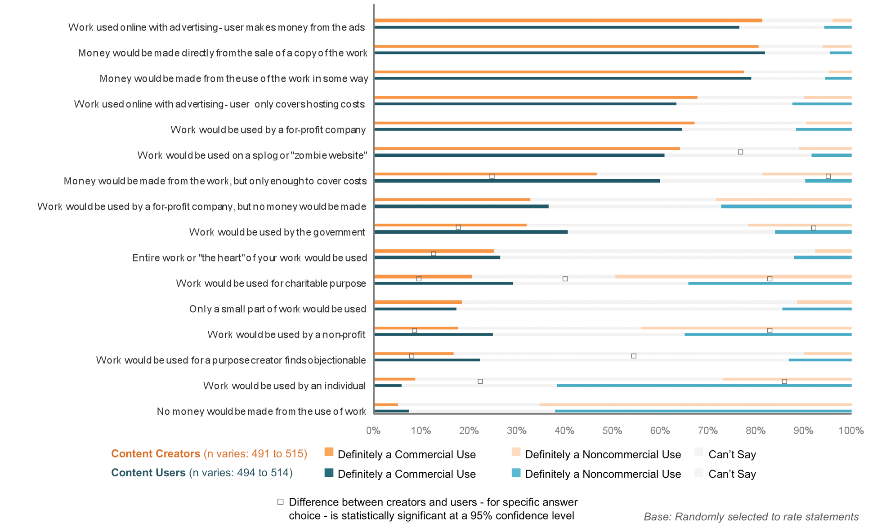
Figure 10: Ratings of Commercial Use by Creators and Users (Gatekeeping Exercise) [Appendix 5.6, Slide 44]

Over 3 in 4 of both creators and users consider uses in connection with online advertising, and uses from which money is made (either directly from a sale or copy of the work or some other way), to be “definitely” commercial. More than 6 in 10 of both creators and users also consider uses in connection with online advertising to be “definitely” commercial even if money made from the ads only covers the cost of website hosting. Creators and users also share a similar view of uses by a for-profit company and use of works on splogs or “zombie” websites, with approximately 6 in 10 users and creators considering these uses “definitely commercial.” A similar majority of creators and users (6 in 10) share the view that uses where no money is made to be “definitely noncommercial.”

Users and creators show differences of opinion, however, around uses for cost recovery, uses that are objectionable, uses for charitable purposes, and uses by the government, by not-for-profit organizations, or by individuals. For all but one of these “gatekeeping” factors, users are more inclined to consider these uses “definitely” commercial, while creators express uncertainty or consider them “definitely” noncommercial. One exception relates to uses by an individual. Here, a majority of users (6 in 10) rate uses by an individual “definitely noncommercial” while a similar percentage of creators express uncertainty, indicating they “can’t say.”

Overall, users and creators share similar views for over half of the 16 gatekeeping factors measured. There is generally a greater level of consensus among creators and users around uses considered “definitely” commercial. The greater the uncertainty around a factor, the more likely differences of opinion among creators and users are seen.

Anchor Point Exercise and Reactions to Specific Use Scenarios
Following the gatekeeping exercise, respondents were presented with an allocation exercise designed to measure reaction to five basic use scenarios or “anchor points” that qualitative research suggested would be useful starting points for evaluation.

Respondents were told to assume this was all the information available for each proposed use, and were alerted they would be presented with more specific use scenarios to evaluate in subsequent questions. Each respondent was asked to rate each of the five anchor points on a scale of 1 to 100, where 1 means “definitely a noncommercial use” and 100 means “definitely a commercial use.” While any number between 1 and 100 represents some hesitancy to rate a particular anchor point as “definitely” a noncommercial or commercial use, very low and very high scores represent a strong opinion by the respondent.

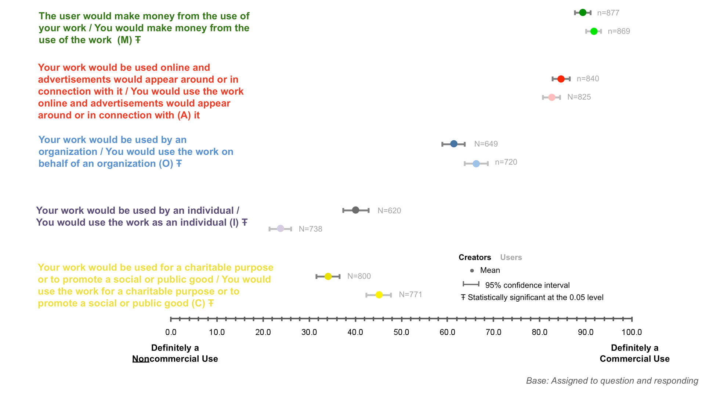Figure 11: Initial Anchor Point Ratings by Creators and Users [Appendix 5.6, Slide 45]

The dots represent users’ mean score estimates for the initial five anchor points. Confidence intervals (CI) for each mean rating were also analyzed to show the reliability of the mean estimates. All other things being equal, a result with a smaller CI is more reliable (representing more consensus of the mean estimate) than a result with a larger CI. The CI for each mean estimate is presented in the graph as the horizontal line bisecting the mean for every scenario.

Both creators and users gave very high mean scores to Anchor Point M (91.7 and 89.4, respectively) and Anchor Point A (82.6 and 84.6), indicating that they evaluate as strongly commercial those uses where the user “makes money” or the use is “in connection with online advertising,” respectively. Both creators and users rate uses “for a charitable purpose to promote a social or public good” (Anchor Point C) and “by an individual” (Anchor Point I) more noncommercial, as well as rate uses by or on behalf of an organization (Anchor Point O) in the midpoint. The only score under 25 was given by users to Anchor Point I (23.8 mean), indicating users evaluate “use by an individual” as more noncommercial.

Findings from the anchor point exercise reinforce findings from the previous gatekeeping exercise. Specifically, both exercises show that uses that involve making money and uses in connection with advertising are considered “definitely” commercial by a high majority of both creators and users, whereas uses by individuals, organizations and for charitable purposes are less commercial, but not decidedly “noncommercial.” Also evident in the anchor point exercise is the pattern seen in the gatekeeping exercise where there is greater agreement between creators and users around uses that are more commercial, less agreement around uses that are less commercial.

After rating the five anchor points, each respondent was presented with two randomized sets of more specific use scenarios, each set containing a number of variations on one anchor point. Specifically, respondents were told, “Below is another group of statements, each of which includes some additional information describing the proposed use of the work.” Respondents were also shown their rating of the initial anchor point, and then asked to rate each scenario, again using a scale of 1 to 100, where 1 means “definitely a noncommercial use” and 100 means “definitely a commercial use.” Half the respondents were presented with the scenarios for Anchor Point M (use makes money), and the other half were served the scenarios for Anchor Point A (use with advertising). The scenarios for Anchor Point O (use by organization), Anchor Point I (use by individual) and Anchor Point C (use for charitable purpose) were distributed randomly.

The goal of this exercise was to collect data that would allow visibility into how respondents changed their initial anchor point ratings as they encountered more specific or nuanced use scenarios, some of them designed to overlap with other anchor points. Breaks, if any, with the initial anchor rating and patterns across the anchor points were sought.

Results for Anchor Point I (use by an individual) are reported first, and described in some detail by way of explanation of how to read the data graphs prepared for all the anchor point exercises. Highlights of those results are summarized in turn below.

Use by an Individual

The figure below graphs the eight scenarios related to uses by individuals.

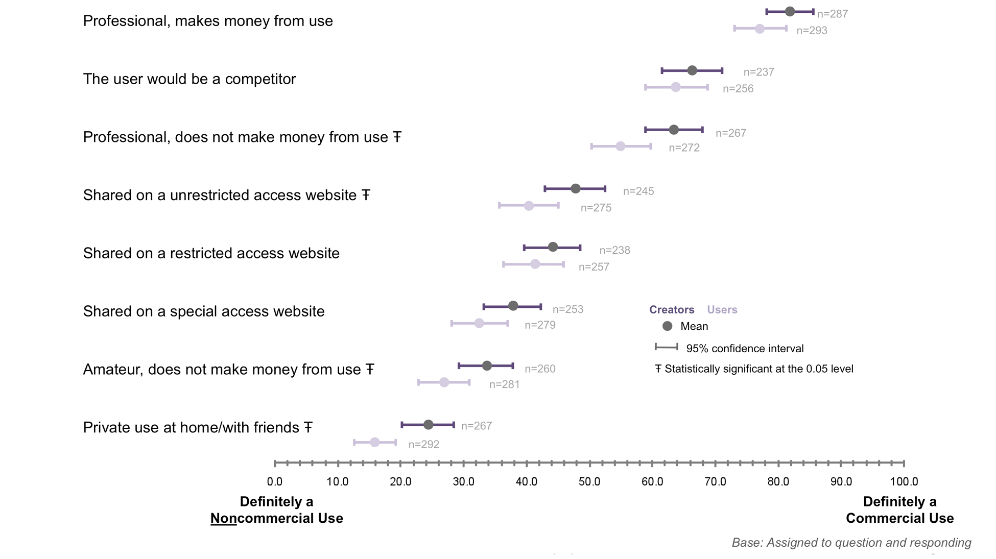
Figure 12: Ratings of Commercial Use by Creators and Users: Scenarios Related to Uses by Individual [Appendix 5.6, Slide 46]

This graph shows that users rate uses by individuals that are private at home/with friends most noncommercial of all the specific uses studied. Compared to the initial anchor point rating, the mean score for this use is lower. Also rated quite low, and very near the initial rating, is use by an amateur who does not make a living from such uses. Looking at the rest of the data graphed on this figure and the next figure below, however, when respondents receive more information about other specific uses, the fact that the user is an individual becomes less determinative of the rating for that specific use – all the other scores are at least slightly higher and some are dramatically higher, meaning that all other specific uses sampled are rated more commercial than the simple unqualified “use by an individual” with which the exercise began.

For example, if the individual in question is a competitor, or a professional using the work in her/his professional context, users rate the use as strongly commercial. However, if users know the professional makes no money from the use, then the rating is significantly lower, though still more commercial than noncommercial. Ratings also shift when money is not at issue, or at least not obviously or certainly at issue: users rate a use slightly more commercial if an individual shares a work on a website with restricted access, rather than on a website that anyone can access, and sharing on a website with anyone the user specifically allows is rated least commercial of all three uses. Although the assumptions respondents made about these three types of access are unknown, respondents respond differently to different fact patterns of use.

Users with different profiles also respond somewhat differently. For example, users who earn money from use of others’ works rate both personal or private uses by individuals and uses by amateurs as considerably more commercial (that is, less noncommercial) than do users who do not earn money. Users who earn money also rate uses by professionals less commercial.

Creators agree that personal or private uses are the least commercial of all scenarios measured. Creators also agree that use by an amateur rates more noncommercial.

Like users who make money from their use of works, creators who make money from their works rate personal or private uses by individuals considerably more commercial than do other creators. However, also like users who make money from their use of works, creators who make money from their works generally rate uses by professionals as less commercial than do creators who make less money or no money from their works.

Creators who make money also rate uses in which their work is shared online more commercial than creators who make no money from their works. In this regard, users who make money show no strong difference from other users.

Many more points could be drawn out of the graphs that accompany this Report, and the data itself could be worked and mined for still more. However, this Report focuses only on the highlights that, with respect to “use by an individual,” are clear: although the ratings are not identical, creators and users are in general agreement about the specific uses studied. The one major exception is personal or private use: while both groups rate it noncommercial, users do more strongly.

Making Money

The figure below provides a visual summary of the anchor point exercise measuring responses to uses that make money.

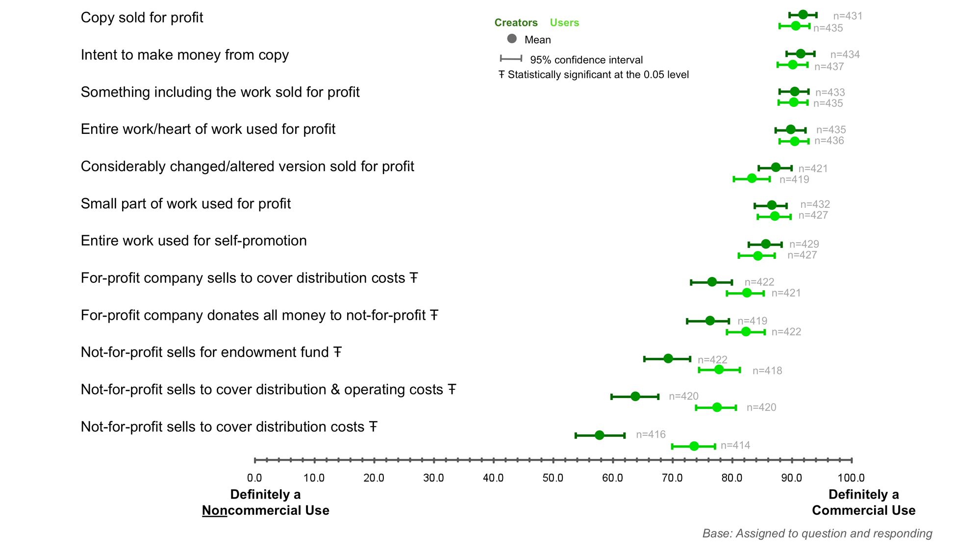
Figure 13: Ratings of Commercial Use by Creators and Users: Scenarios Related to Uses Involving Money [Appendix 5.6, Slide 51]

Compared to the initial anchor point rating, respondents’ scores for specific uses remain essentially unchanged: all scenarios are still rated “definitely commercial” by the vast majority of creators and users. However, both groups rate uses less commercial if the recipient of the money is a not-for-profit organization.

The scenario rated most commercial by all respondents is one in which the user makes money from selling a copy of the work. Further, the scenario is rated almost identically if the user only intends to make money from the sale. Both creators and users also see very little difference between use of an entire work or only a small part of a work in a profit-making venture.

On the question of making money for cost recovery, creators think covering distribution costs only is slightly more commercial than covering operating costs, or raising money for an endowment fund. Users tend to agree, but overall see these uses as rather more commercial than creators. Note, however, that no mention of advertising revenues was included in these scenarios (as discussed below, even where uses in connection with advertising are for cost recovery they are generally rated commercial).

Generally, uses that make money also are rated as less commercial both by creators who make money from their works, compared to those who do not, and users who make money from their use of works, compared to those who do not. This may parallel the finding noted above, that both creators and users who make money rate uses by professionals less commercial than creators and users who do not make money. Interestingly, creators and users rate also rate uses that promote the user or user’s work as highly commercial.

Online Advertising

The figure below shows that creators and users generally share the same opinion of uses in connection with online advertising.

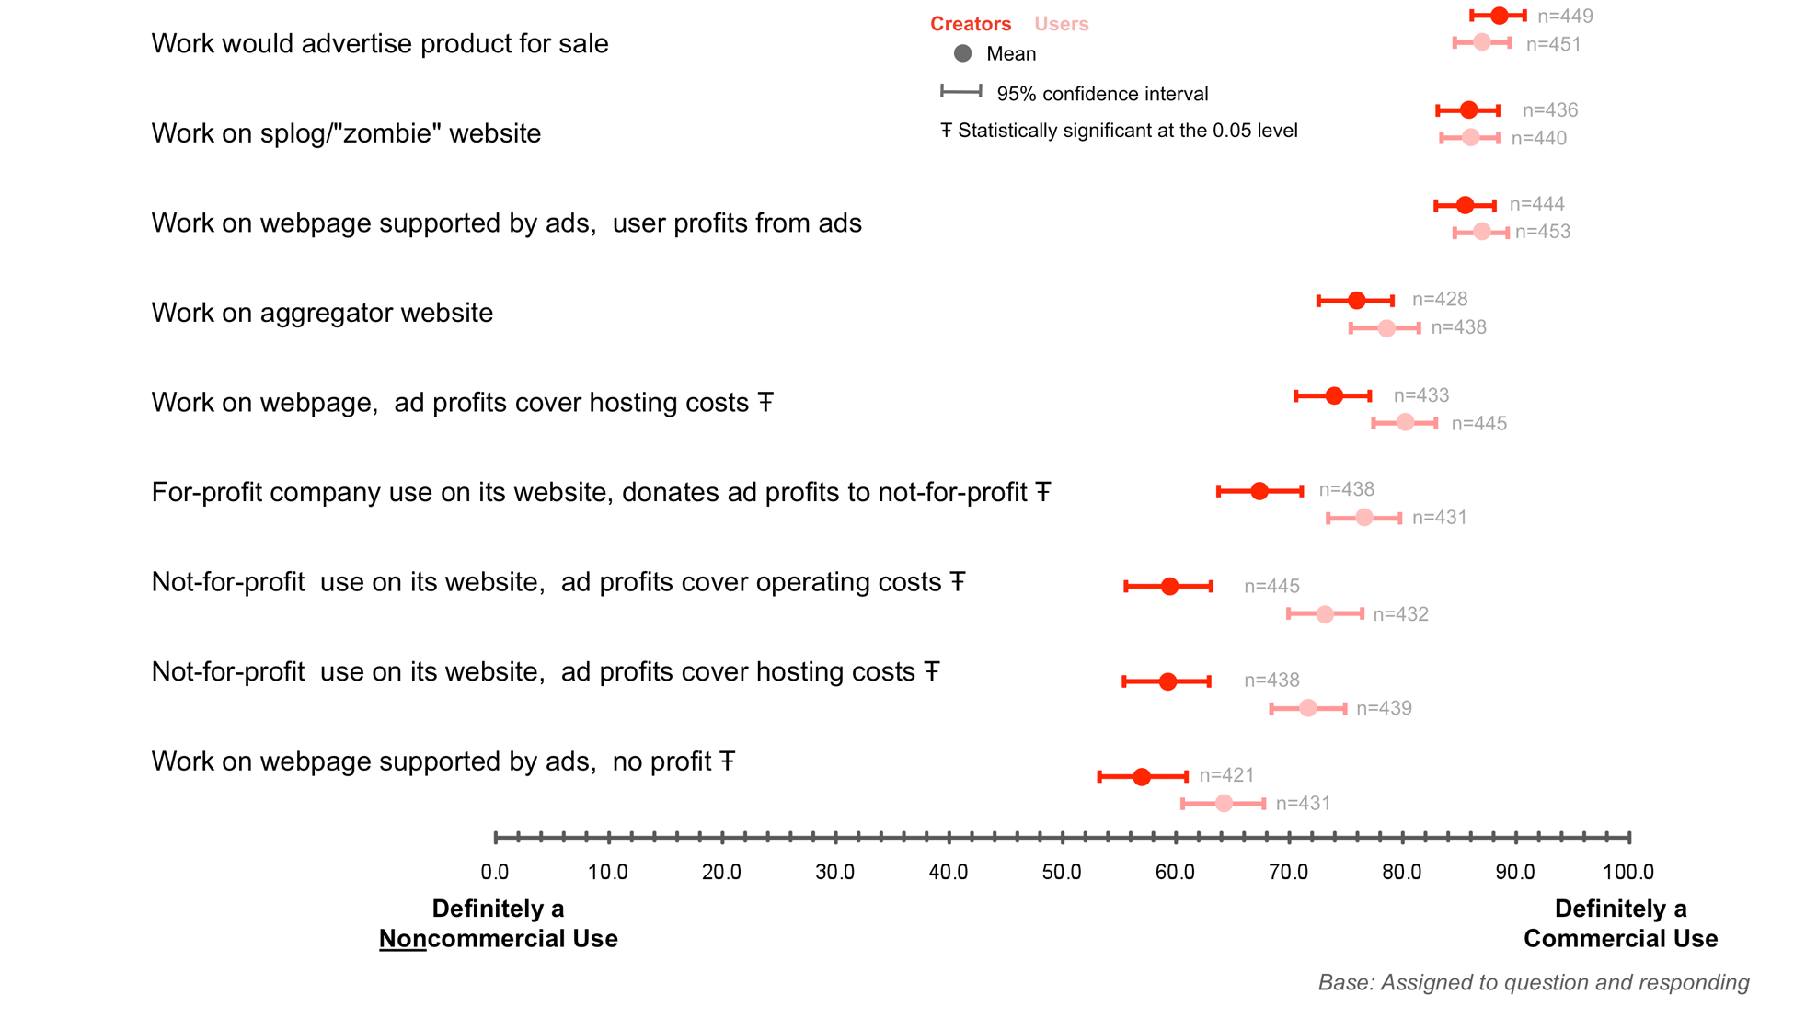
Figure 14: Ratings of Commercial Use by Creators and Users: Scenarios Related to Uses Involving Advertisements [Appendix 5.6, Slide 54]

As with Anchor Point M, compared to the initial anchor point rating, respondents’ scores for specific uses in connection with online advertising remain essentially unchanged: all scenarios are still rated “definitely commercial” by the vast majority of creators and users, although users tend to view more uses as more commercial than creators. Both groups rate use in connection with advertising less commercial if the money generated goes to a not-for-profit organization – though creators view this as much less commercial than users do.

Creators and users rate use in connection with advertising on a splog or on a blog or web page where the user profits from the advertising virtually the same, and as only slightly less commercial than the highest rated use, use as advertising for another product (88.5 for creators, 87.1 for users). However, when it is specified that the user would only make enough money from the advertising to cover the costs of hosting the website, users rate the use as less commercial (80.2), and creators rate it even lower (74.0) – but over half still rate the use “definitely” commercial. Uses where the user does not make money from the advertising are rated least commercial of all (57.2 and 64.2, for creators and users, respectively).

Creators see use by posting on an aggregator website supported by advertising as slightly less commercial than users do (75.9 for creators, 78.5 for users), but again, over half of all respondents still rate this use as “definitely” commercial.

Creators and users each rate use of advertising revenue by a not-for-profit organization to cover website hosting costs and operating costs almost the same, though as stated above, creators find uses to support not-for-profits rather less commercial than users do. Both groups also evaluate advertising by a for-profit that then donates the money to a not-for-profit as being more commercial than use by the not-for-profit on its own behalf.

Continuing a pattern noted above with respect to uses that make money (Anchor Point M), uses involving advertising are generally rated less commercial by creators who make money from their works and users who make money from their use of works.

Use by an Organization

As illustrated by the graph below, creators and users are in general agreement about uses by an organization.

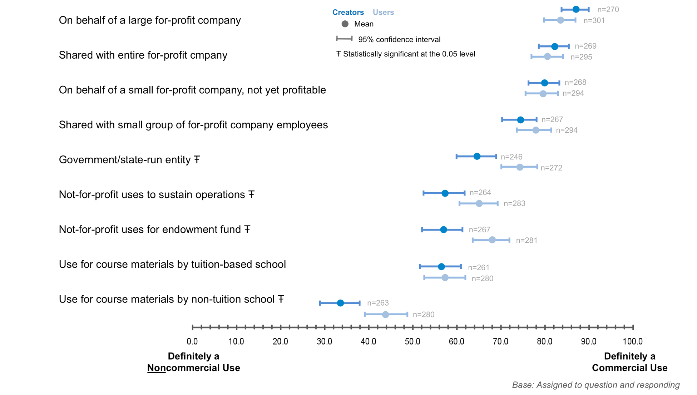
Figure 15: Ratings of Commercial Use by Creators and Users: Scenarios Related to Uses by Organization [Appendix 5.6, Slide 59]

Compared to the initial anchor point ratings, both creators and users rate the specific uses studied more commercial if they are by for-profit organizations, with high consensus. By contrast, if the use is by a not-for-profit, ratings are generally the same, but consensus is lower. Notably, while many more respondents rate all the studied uses by for-profits “definitely” commercial, some respondents rate many uses by not-for-profits “definitely” commercial, as well: there is no “pass” for not-for-profit organizations. This is confirmed by the findings of the Anchor Point C exercise, discussed below, which show that even a use for an express charitable purpose by a not-for-profit organization is rated “definitely” noncommercial by only 13% of creators and 23% of users.

Creators view uses by specified not-for-profits as less commercial than users do (ratings in the mid/high 50s and mid/high 60s, respectively). However, whether the work is used to raise money for a not-for-profit’s operating expenses or its endowment is of little consequence to either group.

The only ratings for use by an organization that are seen as more noncommercial than commercial are specific to a use that suggests no money is exchanged: if a school that does not charge tuition uses a work in its course materials then both creators and users rate the use noncommercial, especially creators, although consensus for both groups is low. By contrast, if a school charges tuition then both groups increase their ratings, and creators do so significantly (from 33.5 to 56.3, as compared to a rise from 44.0 to 57.4 for users).

Note that the profit status of the school was not specified in these two uses. However, when the school charges tuition creators rate the use almost exactly the same as the specified not-for-profit uses (approximately 57); users rate the use lower than for specified not-for-profits (67/57). As previously noted, the gatekeeping factor exercise that appeared just before this one in the survey defined a “not-for-profit organization” as “any organization that exists primarily to make a profit,” and included a school as a possible example. It is likely that respondents here assumed “school” to be a not-for-profit. As the next exercise shows, use by for-profit and not-for-profit schools is rated differently in at least one other context.

In this exercise both creators and users regard use by the government or a state-run entity as commercial (ratings of 64.4 and 74.3, respectively), with only a few respondents in each group rating such use as “definitely” noncommercial (4% of creators, 9% of users). However, when this same scenario was presented to respondents rating uses for a charitable purpose or to promote a social or public good (discussed below), ratings by creators were somewhat lower (57.8), and ratings by users were lower still (61.6).

Use for a Charitable Purpose or Social Good

Of all the anchor points, respondents demonstrate lowest consensus on the question of uses for a charitable purpose as is illustrated by the graph below.

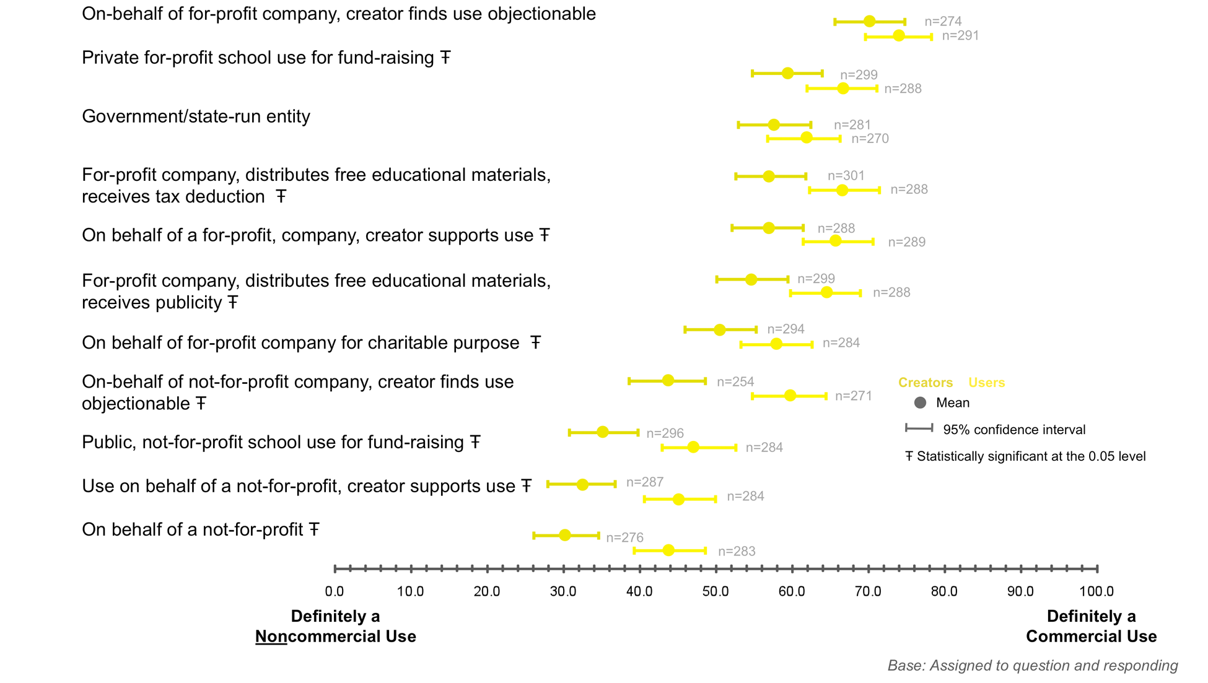
Figure 16: Ratings of Commercial Use by Creators and Users: Scenarios Related to Uses with Charitable Purposes [Appendix 5.6, Slide 61]

Respondents who were asked to rate specific uses for a charitable purpose or to promote a social or public good generally rate uses by a not-for-profit organization the same as their initial anchor point ratings. An exception, however, is use by a not-for-profit for a purpose that the creator of the work finds objectionable: both creators and users rate these uses as more commercial than their initial anchor point ratings (43.7/34.1 creators, 59.6/45.0 for users) – highest of all uses studied for not-for-profits. Further, both groups rate uses by a for-profit company for a purpose the creator of the work finds objectionable the most commercial of all scenarios (70.2 for creators, 73.9 for users). These findings suggest that the question of “commerciality” may be complicated by other considerations, but they appear to be considerations shared by creators and users alike.

Scores greatly increase from the initial anchor point ratings, and more respondents rate specific scenarios “definitely” commercial if the use is by a for-profit company. This is true even in the case of use by schools, clearly positioned for this exercise as use to promote a social good. Both creators and users rate use for a fundraiser by a public not-for-profit school almost the same as the initial anchor point rating, while both rate use for a fundraiser by a private for-profit school much higher (59.4 for creators, 66.6 for users).

However, some uses by for-profits are rated as “definitely” noncommercial by 12-20% of users and a smaller number of creators (4-8%). This finding, combined with the finding already noted above that even use for an express charitable purpose by a not-for-profit organization is rated “definitely” noncommercial by only 13% of creators and 23% of users, reveals that this category of use is the most difficult of those studied for both creators and users to sort out.

Summary of Anchor Point Exercise
The graph below plots the results for all specific use scenarios tested in the anchor point exercise.

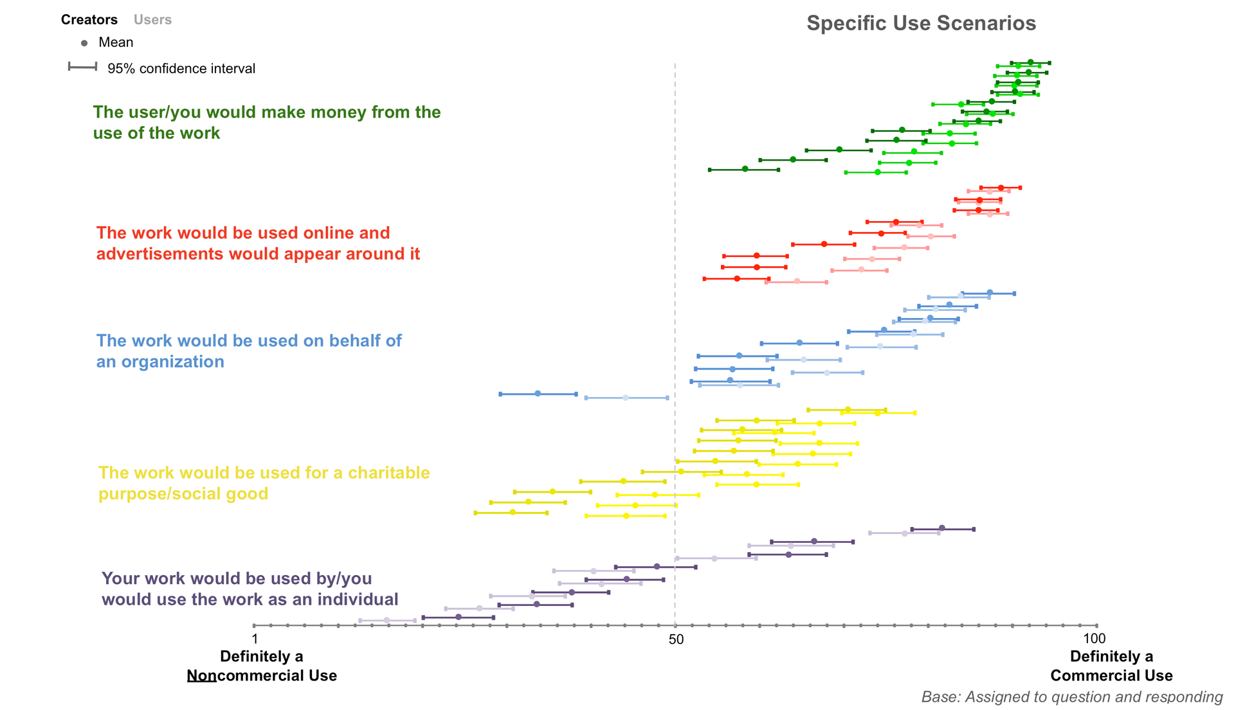
Figure 17: Ratings of Commercial Use by Creators and Users (Anchor Point Exercise) [Appendix 5.6, Slide 62]
As the graph illustrates, almost all of the uses that involve money, online advertising, and organizations are considered more commercial, while uses by individuals and those for charitable purposes fall in between, with approximately half rated more commercial and half rated more noncommercial. Creators and users evaluate many of the scenarios studied similarly, not only in terms of the “commerciality” of the use (how far to the left or right the icon appears) but also in terms of the strength of consensus on the rating (the width of the horizontal lines bisecting each mean). Users generally consider more of the uses studied slightly more commercial than creators, with the exception of uses by individuals. In these cases, creators tend to rate the uses more commercial and users less commercial.

Changes to Unaided Understandings
Immediately following the anchor point exercise, respondents were asked:

“Having completed this exercise, would you change your definitions of commercial use and/or noncommercial use?”

After having rated two different sets of specific use scenarios, most creators (73%) and users (75%) responded “no,” they would not change their initial, unaided definitions of commercial and noncommercial use; 13% of creators and 11% of users replied “yes”; 14% of creators and 14% of users replied “Don’t know/unsure.” Both groups answered “yes,” “no,” and “don’t know/not sure” in virtually identical ratio, suggesting creators and users feel similarly strongly about their initial definitions.

The responses to this open-ended question were coded using the same key used to code the answers to the initial question asking about the difference between commercial and noncommercial use. Creators and users who would change their definitions are most likely to add mentions of uses by an individual or organization as commercial. However, creators are also most likely to add mentions of uses by an organization as noncommercial (users add a few as well). Users are most likely to add mentions of uses for a charitable purpose or social good as noncommercial, but some also add mentions of these uses as commercial. Because the findings of the research overall are consistent, it is reasonable to believe that respondents’ changes to their initial definitions – which on gross may seem to cancel each other out somewhat – are a result of respondents having been presented with more complexity or nuance than they had in mind when giving their initial unaided definitions. Hence, these changes may be more in the nature of refinements than re-definitions.

However, even if some 1 in 10 respondents had completely rewritten their initial redefinitions, the most important takeaway from response to these two questions is that most respondents, creators and users alike, do not readily change their minds about what they believe is the difference between commercial and noncommercial use, at least on the basis of their experience working through an online survey.

Reaction to the Creative Commons NC Term

Of particular interest is respondents’ reaction to the verbatim language of the NC term, which was presented without identifying it as such. Following the anchor point exercise and the question asking whether respondents would then change their previous definitions of the difference between commercial use and noncommercial use, all respondents who provided a definition were asked:

“What if ‘noncommercial use’ meant any use that is not primarily intended for, or directed toward, commercial advantage or private monetary compensation? Do you think this definition is:

1. Essentially the same as your definition of noncommercial use
2. Different from but still compatible with your definition of noncommercial use
3. Different from and incompatible with your definition of noncommercial use
4. Don’t know/Not sure”

The majority of respondents (87% of creators, 85% of users) replied that the definition was “essentially the same as” (43% of creators, 42% of users), or “different from but still compatible with” (44% of creators, 43% of users), their definition. Only 7% of creators and 11% of users replied that the term was “different from and incompatible with” their definition. 6% or creators and 4% of users replied “don’t know/not sure.”

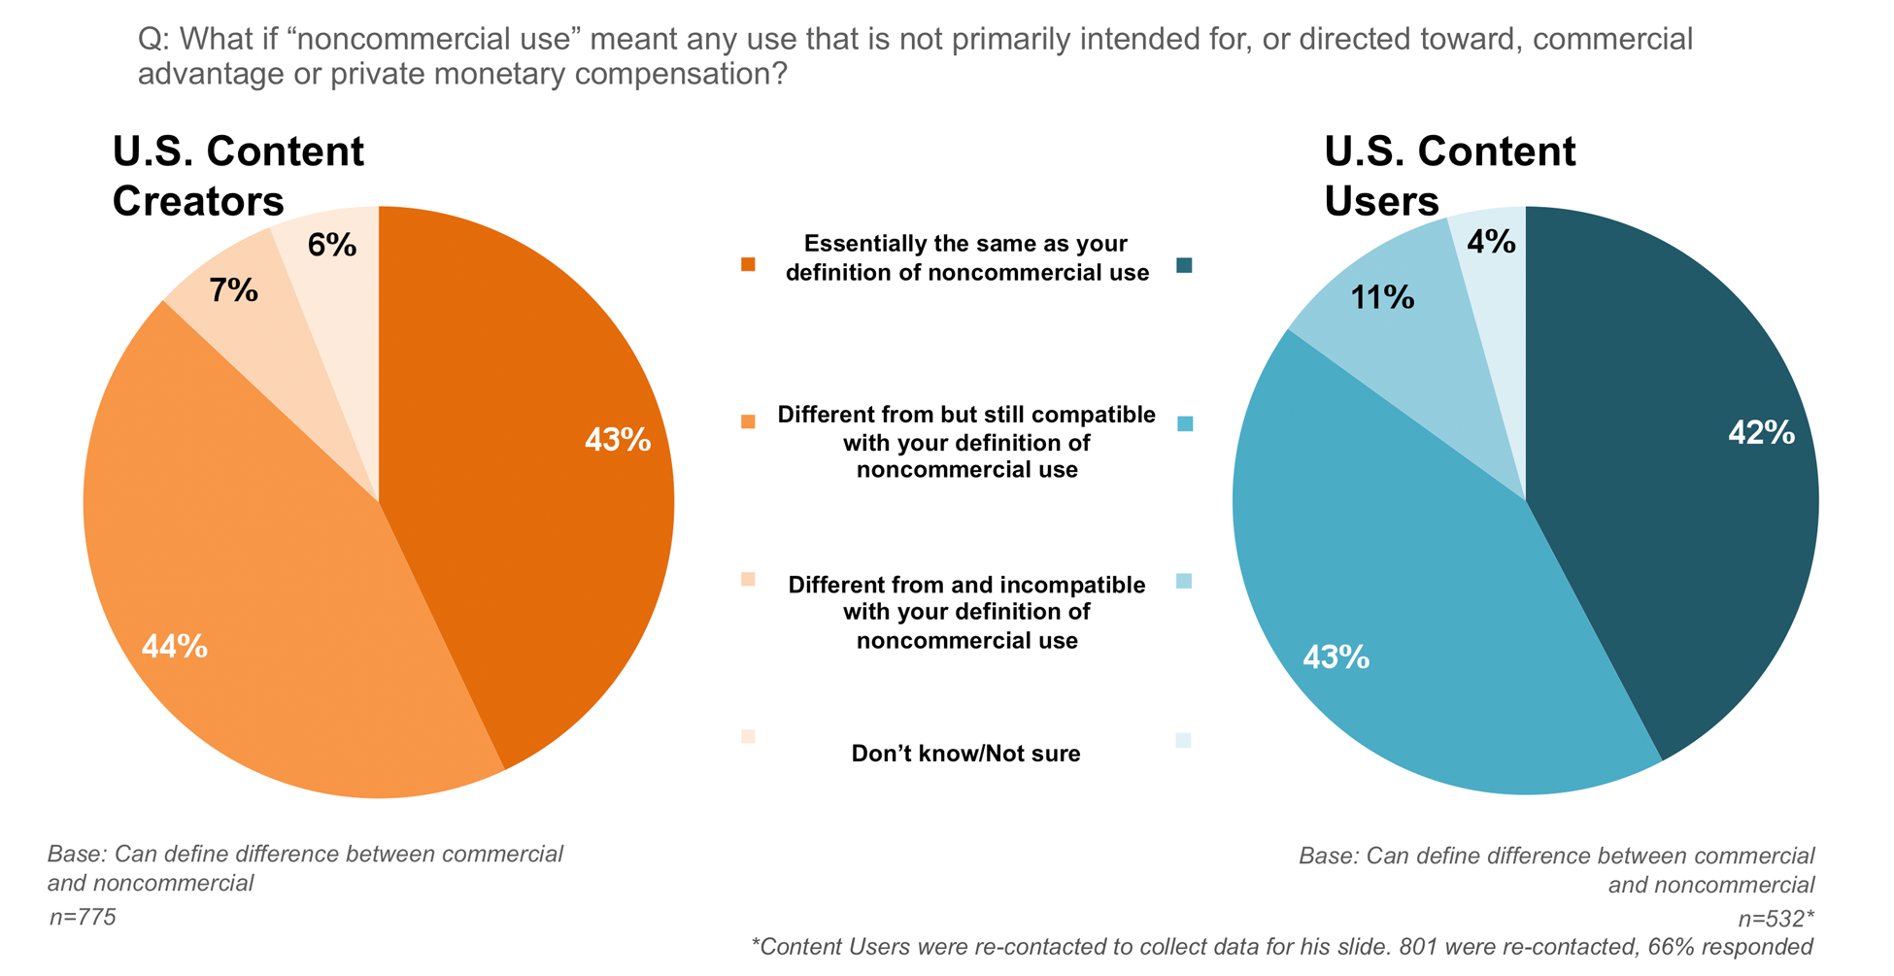
Figure 18: Changes in Definitions and Reactions to CC NC Term [Appendix 5.6, Slide 71]

In response to an open-ended question presented to those users who answered that the definition was “incompatible” with theirs, the overwhelming majority takes a hard line in defining commercial use as any monetary exchange, and thus objects to use of the word “primarily” Use of the word “intended” was also criticized as “too vague.” As noted above, these and other criticisms were also raised by respondents in qualitative research.

3.3 Quantitative Research: Creative Commons Friends and Family
This section summarizes some of the highlights of the findings from the open access polls of CCFF, described in Section 2.2 above. Again, the CCFF poll data cannot be considered scientific because of the self-selected nature of the samples, but they provide interesting counterpoints to the data collected from the U.S. online population and suggest several avenues for further research, as outlined in Section 4.3 below.

Unless called out, all comparisons below are made between CCFF creators and users, as a group, and U.S. online population creators and users, as a group. Much more data are available in the raw data referenced at the end of this Report in Section 5.2.

Comparison to U.S. Online Population
Almost half of the CCFF sample in both polls is from the United States; the next most represented countries include Germany, the United Kingdom, Canada, Australia and the Netherlands.

Compared to the U.S. online population, CCFF are much more likely to be familiar with copyright licensing and public copyright licenses, in particular. 74% of CCFF creators have licensed the works that they share online, compared to only 17% of U.S. creators. Of those who have licensed their works, 8 in 10 CCFF have used a free public license available online, compared to only 4 in 10 U.S. creators. CCFF users are also more likely than U.S. users to be aware of how the copyrighted works they use are licensed (9 in 10, compared to 7 in 10).

CCFF creators are far more likely than U.S. creators to allow greater access to the works they share online (86% CCFF “always” or “usually” share with anyone, as opposed to 39% of U.S. creators). Interestingly – though without assuming a causal relationship with their sharing habits – virtually all CCFF creators are at least somewhat familiar with the principles of the open source software movement, with 80% saying they embrace them.

Virtually all CCFF provided a definition of the difference between commercial use and noncommercial use, as opposed to about 7 in 10 of the U.S. online general population. While both groups define “commercial use” primarily as a use that makes money, CCFF have a somewhat different understanding of when some money may be made, in some cases.

When presented with the gatekeeping factors, CCFF consider uses in connection with online advertising and uses involving cost recovery less commercial than the U.S. online population. In particular, CCFF are much less likely to think use in connection with online advertising from which the user makes money is “definitely” commercial, compared to the U.S. online population. Only 3 in 10 CCFF think it is “definitely” commercial if a work is used on a website that is supported by advertising, compared to 6 in 10 of the U.S online population. By contrast, CCFF are much more likely to consider use in connection with splog advertising “definitely” commercial (85%, compared to 61%).

With respect to cost recovery generally, only 30% of CCFF creators and 36% of CCFF users say that making money by unspecified means from use of a work to cover cost distribution costs is “definitely” commercial, compared to 47% of U.S. online creators and 60% of U.S. users.

The results of the anchor point exercise confirm these differences, and reveal a few more. Ratings of CCFF and the U.S. online population are similar for all scenarios in which the user would make money, except that CCFF tend to rate uses less commercial where money is made for cost recovery or to support a not-for-profit organization. CCFF also rate uses involving online advertising less commercial, particularly if the money made goes to cost recovery or the support of a not-for-profit organization.

Uses by organizations also are rated less commercial by CCFF if the money is used to support a school or not-for-profit organization. CCFF tend to rate use by a government or state-run entity less commercial, as well.

Overall, CCFF also rate all uses studied by individuals less commercial, unless the user is a professional who makes money from the use. Like the U.S. online population, CCFF rate personal and private use the least commercial of all scenarios studied, and CCFF ratings are even lower than U.S. ratings, for both creators and users. Further, unlike the U.S. online population, CCFF creators and users are equally certain that personal or private use is “definitely” noncommercial – both rate this use an average of 8 on the 100-point scale (where 1 is “definitely” noncommercial, 100 is “definitely” commercial), compared to averages of 24 for U.S. creators, and 16 for U.S. users.

Perception of Creative Commons and Reaction to the NC Term
The additional data provided by CCFF in response to a number of questions specific to Creative Commons and its NC licenses show that the Creative Commons BY-NC-SA license is the most popular of all the CC licenses, among both CCFF creators and CCFF users. Almost half of CCFF creators have licensed a work under BY-NC-SA, while 6 in 10 CCFF users have used a work licensed BY-NC-SA.

CCFF creators say they choose to license their work for noncommercial use primarily because the NC term allows them to control the right to make money from the work (70%), and they do not want anyone else to make money or get a commercial advantage from the work (61%). Both CCFF creators and CCFF users say they trust that Creative Commons licenses are legally enforceable (63% of creators, 85% of users).

When they use others’ works, 77% of CCFF believe it is safer to use a Creative Commons NC-licensed work than an unlicensed one. 90% of CCFF users also say they like to use CC-licensed works, because they license their own works under CC licenses.

24% of CCFF creators and 27% of CCFF users say they have no dissatisfaction with or concerns about the NC licenses. However, half of all CCFF users are not sure that licensors understand the NC term the way they do, and over one-fourth of creators and over one-third of users think the term is not defined in enough detail and/or not defined clearly. 4 in 10 CCFF creators are concerned that licensees do not respect the NC term.

Half of CCFF creators have been contacted by someone who wanted to know if a certain use of one of their NC-licensed works would be acceptable to them. 1 in 4 CCFF who have used a Creative Commons NC licensed work have contacted the licensor to find out whether a certain use of the work would be acceptable.

CCFF creators are divided on whether they would support an effort to potentially refine or redefine the Creative Commons NC term: 38% say they would support an effort to consider a change; 36% say they would not support such an effort or that such an effort is not necessary or desirable; and 25% are not sure. CCFF users are also divided: 47% say they would support an effort to consider a potential change; 35% say such an effort is not necessary or not desirable; and 18% are not sure.

Only 13% of the CCFF creators and 20% of the CCFF users sample describe themselves as active members of the CC community; about one-third of each sample say they participate occasionally but do not consider themselves part of the community. CCFF who say they are involved with the CC community include newcomers as well as many people who have participated since the organization was founded.

3.4 Summary of Principal Findings

Empirical Study
Qualitative research suggests that creators and users take a similar approach when addressing the issues that surround the definition of noncommercial use.

Overall, quantitative research supports qualitative findings – online U.S. creators and users are more alike than different in their understanding of noncommercial use. Both creators and users consider uses that involve money or online advertising to be commercial in nature, and both groups are ambivalent, though largely deeming less commercial uses by organizations, by individuals, and for charitable purposes. Some differences are statistically significant between users and creators, primarily for uses that are harder to classify as either commercial or noncommercial. By contrast, uses that are decidedly commercial, such as uses that earn money or uses by for-profit companies, show no significant difference between creators and users. When statistically significant differences between use scenarios appear users almost always rate those uses more commercial than creators. The one exception is uses by individuals that are personal or private in nature. Here it is creators, not users, who consider the use more commercial, the opposite of the general pattern.

Few statistically significant differences exist among subgroups of creators within that sample of respondents, and virtually no statistically significant differences are found among subgroups of users, including users who also identify as creators. The most notable differences among subgroups are between creators who make money from their works and those who do not, and between users who make money from their uses of others’ works and those who do not. In both cases, those who make money generally rate uses less commercial than those who do not make money. The one exception to this pattern is with respect to personal or private uses by individuals: here, users who make money consider these uses more commercial than those who do not make money.

On an unaided basis, when asked to define the difference between commercial use and noncommercial use, both creators and users focus on the former. A commercial use is defined by 7 in 10 of all respondents as a use that makes money. On the same unaided basis, there is no majority consensus on the definition of noncommercial use in either group, although both creators and users include some use by an individual as the most common mention in their definitions (19% of creators, 33% of users).

The gatekeeping and anchor point exercises validate respondents’ unaided definitions while also providing some important qualifications and detail. Specifically, creators and users generally consider uses that earn users money or involve online advertising to be commercial in nature, while uses by organizations, by individuals, or for charitable purposes are less commercial (but not decidedly noncommercial) and harder to classify overall. Qualifiers, such as whether the user is by a not-for-profit organization or for cost-recovery purposes, bear an impact on how they are classified – in this case, typically making the use less commercial. But perceptions of the many use cases measured in this study suggests there is more uncertainty than clarity around whether uses of online content are commercial or noncommercial in nature.

Following these exercises, 7 in 10 of all respondents chose not to change their definitions of commercial and noncommercial use, a noteworthy fact given how much these exercises had the potential of prompting a shift in views. Moreover, when presented with the language of the Creative Commons NC term, the vast majority believe it is “essentially the same as” or “compatible with” their definition of noncommercial use. The Creative Commons NC prohibition on use of a work “in any manner that is not primarily intended for or directed towards commercial advantage or private monetary compensation” appears to resonate with a large majority of creators and users because, based on open-ended responses along with gatekeeping and anchor point exercises, most believe that no money can be made if a use is to be considered noncommercial. Reluctance to change their definitions and the appeal of the NC term may reflect a desire among creators and users to simplify and anchor the definition around an understanding that “no money” may be made.

Based on findings from the gatekeeping exercise (designed to establish whether respondents would identify certain possible uses as “definitely” commercial or “definitely” noncommercial), users and creators show strong agreement on most issues.

More than a three-quarter majority of both groups agrees that it is “definitely” a commercial use if money is made from the use of a work in some way, including directly from the sale of a copy of a work, or from online advertising around or in connection with the work, where the user makes money from the ads. Further, 6 in 10 of all respondents evaluate uses in connection with online advertising as “definitely” commercial, even if only enough money would be made to cover the cost of website hosting. More than 6 in 10 creators and users also consider use by a not-for-profit organization “definitely” commercial.

Approximately 6 in 10 of all respondents also agree that a use is “definitely” noncommercial when no money is made. The most significant difference between the groups is that while more than 6 in 10 users consider use by an individual to be “definitely” noncommercial, 5 in 10 creators think “it would depend” or “can’t say.” Creators and users also differ on the general question of cost recovery (not via means of online advertising), with more creators than users inclined to consider cost recovery by unspecified means a noncommercial use.

These findings are confirmed and refined in the anchor point exercise, which first asked respondents to rate five basic anchor points describing uses in very general terms, using a scale of 1 to 100, where 1 means “definitely a commercial use” and 100 means “definitely a noncommercial use.” Using the same scale, respondents were then asked to rate groups of more specific use scenarios based on or related to the anchor points.

With respect to two of the five basic anchor points, uses where the user makes money, and uses in connection with online advertising, the mean scores given by creators and users are high and remarkably close: both groups are in strong agreement that these are commercial uses. There is also a fairly high level of consensus within and between each group around the specific use cases related to these two anchor points. In fact, creators and users rate the studied uses that make money and occur in connection with online advertising on almost the same “curve” from most to least commercial.

Ratings for the other three anchor points remain closer to the middle of the scale, meaning most users do not find them strongly commercial, or strongly noncommercial. Uses that are less commercial, and also harder classify, also show less agreement between creators and users. In other words, the more commercial a use, the stronger the agreement; the less commercial the work the higher the more creators and users differ in views with creators typically rating uses even less commercial than users.

Creators and users are in general agreement that use by an organization tends to be commercial, though to a lesser extent than users that involve money or are in connection with advertising. When not-for-profit organizations are specified, however, both groups tend to consider uses noncommercial. Again, uses deemed less commercial also yield a greater difference between users and creators with creators typically rating uses even less commercial than users.

Creators and users also tend to agree that use for a charitable purpose or to promote a social or public good is noncommercial, unless the use is by a for-profit organization. However, of all the specific use scenarios measured in this study, both creators and users demonstrate the least amount of agreement on this one. Not even charitable use by a not-for-profit organization is rated “definitely” noncommercial by a majority of either group.

The single largest difference between creators and users is evidenced with respect to use by an individual. Both groups rate more such uses as noncommercial. However, users are much more likely than creators to rate personal or private uses as noncommercial, and there is strong consensus among users on this point. Thus this particular use scenario, at least as rated by users, stands out from all the others as being the most ‘definitively’ noncommercial (although it is not unanimously “definitely” noncommercial). Creators also agree that personal or private uses are the least commercial of all scenarios measured, but it is striking to have this one instance in which users believe the use is even less commercial than creators.

CCFF Survey
While findings from the open access poll of Creative Commons Friends and Family are not scientific, the results of the CCFF surveys provide valuable information about the attitudes and behaviors of the group.

CCFF are better versed with copyright licensing and public copyright licenses than the U.S. population; three-fourths have licensed their works online using a public license. CCFF allow broader access to the works they share online, as well.

CCFF and the U.S. online population share essentially the same definition, as one that makes the user of the work money, though with some differences. In particular, when presented with the gatekeeping factors, CCFF consider uses in connection with online advertising and uses involving costs recovery less commercial than the U.S. online population. Only 30% believe it is “definitely” commercial if a work is used on a website that is supported by advertising, half as much as the U.S online population.

Ratings of CCFF and the U.S. online population are similar for all scenarios in which the user would make money, except that CCFF tend to rate uses less commercial where money is made for cost recovery or to support a not-for-profit organization. CCFF also rate other specific uses where money is made as less commercial than the U.S. population, including support for not-for-profits, schools, and uses by a government or state-run entity.

Overall, CCFF also rate all uses studied by individuals less commercial unless the user is a professional who makes money from the use. CCFF also rate personal and private use the least commercial of all scenarios studied, although the CCFF ratings are even lower than the U.S. population. Additionally, unlike the U.S. online population, CCFF creators and users are equally certain that personal or private use is “definitely” noncommercial.

4 Next

This study is the first known empirical investigation of perception of the meaning of “noncommercial use.” As such it is best seen as a jumping off point for further research rather than the end of the inquiry.

Previous sections of this Report have focused on the empirical results of this study and the methodology used to obtain these results. This section takes a different tack and includes in Section 4.1 and Section 4.2 a preliminary analysis of what the study results mean for Creative Commons’ noncommercial licenses and recommendations on use of those licenses, informed in part by the study results. Finally, Section 4.3 provides some suggestions for further areas of inquiries and contributions to the discussion of “noncommercial use” by academic researchers and community members alike.

4.1 Import for Creative Commons Noncommercial Licenses
In the next years, possibly as soon as 2010, Creative Commons expects to formally launch a multi-year, international process for producing the next version (4.0) of the six main Creative Commons licenses. This process will include examination of whether the NC term should be usefully modified as a part of that effort, or if the better approach might be to adopt a “best practices” approach of articulating the commercial/noncommercial distinction for certain creator or user communities apart from the licenses themselves. Whichever the result, this study has highlighted that in order to meet the expectations of licensors using CC NC licenses it will be important to avoid any modification of the term, however manifested, that makes a use widely agreed to be commercial – or only agreed to be noncommercial with low consensus – explicitly noncommercial. There is an analogue in CC’s statement of intent for CC Attribution-ShareAlike, which provides assurances that CC will not break the expectations of licensors whose intent is to release works under copyleft terms.

While the costs of license proliferation are already widely appreciated and resisted by many, the study weighs against any lingering temptation to offer multiple flavors of NC licenses due to strong agreement on the commerciality of certain use cases that, in the past, may have been considered by some to be good candidates for splitting off into specialized versions of the NC term, such as online advertising. For even in those cases where strong agreement may appear to exist upon initial inquiry, such as with online advertising, nuances and sometimes strong differences of opinion are immediately revealed when more specific use cases are tested and facts presented – such as those involving cost recovery or support of nonprofit organizations.

The study results also advise against any concerted effort by CC to attempt appeasing all license users, all the time. The qualitative study results reported in Section 2.1 above support this conclusion. Participants are divided over the value of more or fewer specific “use cases” to delineate the commercial/noncommercial divide, some see the lack of specific uses as a strength and others as a weakness, and many others still disagree with the notion that a single definition of noncommercial use could be workable. Thus is the challenge, and opportunity, of public license stewards.

Aside from decisions about the NC licenses themselves, Creative Commons will be looking back to the study as it updates explanations of noncommercial licensing on CC’s license deeds, the license chooser and other materials. CC encourages ideas and feedback from the public (see Section 4.3, below).

4.2 Recommendations on Using CC Noncommercial Licenses
Overall, the CC NC licenses appear to be working rather well — they are the most popular Creative Commons licenses, and CC is not aware of a large number of disputes between licensors and licensees over the meaning of the NC term. The study hints at some of the potential reasons for this state of affairs, including that users are in some cases more conservative in their interpretation of what is noncommercial than are creators, and that in some cases creators who earn more money from their work (i.e., have more reason to dispute questionable uses) are more liberal in their interpretation of what is noncommercial than are those who earn less.

While it would take a more focused and exhaustive study to conclude that these seemingly fortunate attitudinal differences are correct, strong, and global, they do suggest rules of thumb for licensors releasing works under NC licenses and licensees using works released under NC licenses — that licensors should expect some uses of their works that would not meet the most stringently conservative definition of noncommercial, and licensees who are uncertain of whether their use is noncommercial should find a work to use that unambiguously allows commercial use (e.g., licensed under CC BY, CC BY-SA, or in the public domain), or ask the licensor for specific permission. Note that this rule of thumb has an analogue in network protocol design and implementation known as the robustness principle or Postel’s Law: “Be conservative in what you do; be liberal in what you accept from others.”

Relatedly, the study serves as a reminder to would-be users of the NC licenses the need for considering carefully the potential societal costs of a decision to restrict commercial use. One way to think about Creative Commons generally is as a provider of legal and technical tools that prevent (where desired) the failed sharing that results from copyright law’s default of “all rights reserved.” There exist certain uses that some creators would allow but that will not occur because they have not authorized them (maybe have not even thought of them), and the costs of finding the licensors and getting authorization are too high for the intended use. While this may sound overly hypothetical, if one considers the anti-network effects of failed sharing at a societal level, the costs are large indeed. Overuse of NC licenses suppresses some uses that a licensor who wants to share may wish to allow, at a cost to NC licensors and licensees and an even greater cost to communities and the broader free culture movement. Such situations represent failed sharing, though on a much smaller scale than the failed sharing engendered by default copyright. As another rule of thumb, licensors who are concerned about the costs of NC licensing – whether to themselves, the free culture movement, or society at large – ought review the arguments and consider “dropping -NC” from their licenses whenever the costs cannot be fairly justified.

The potential negative impact and corresponding lack of use of noncommercial licensing differs across fields. For example, noncommercial licenses do not exist at all in the free and open source software world (note that CC recommends using a free and open source software license for software). Science and education are two large fields in which Creative Commons believes that liberal licensing or the public domain are most critical. Unsurprisingly Wikipedia, which has strong relationships with the free software, open access (scientific publishing), and open education movements, mandates liberal licensing, and many other massively collaborative projects are following.

However, compelling use cases for NC licensing remain — most obviously when an existing significant revenue stream from a work would be compromised by release under liberal terms. Giving one’s audience legal certainty that they will not be prosecuted for doing what comes naturally from using digital networks — copying and remixing for no commercial gain or monetary exchange — while exploring the sharing economy and still protecting existing business — these are compelling reasons to start or continue releasing works under a NC license. It is little surprise that major music and book publishers’ use of CC licensing thus far has almost exclusively been of the NC variety.

In sum, although the results offer only the first views on a complex issue, the study provides immediately relevant guidance on several levels. For Creative Commons, the study affirms that the NC licenses are generally “on track” given the large percentage of people who understand the NC term to be defined as the same or consistent with their own understandings and definitions. Yet the study also makes clear there remains room for thoughtful evaluation and discussion about how CC might improve the definition yet further and/or forge and communicate a more fully shared understanding about its meaning – though never in a manner that risks breaking existing expectations of license users. For licensors and licensees, the study suggests rules of thumb for what licensors may expect when publishing under a noncommercial license, and how licensees ought consider behaving when using NC-licensed materials (including, at times, instead choosing a work that may be used commercially). Finally, the overall process of conducting the study and considering the points of view expressed in all phases point to a critical need for a richer understanding of the societal costs associated with choosing a noncommercial licensing option in the absence of a compelling justification to the contrary.

4.3 Further Research
The findings from this study suggest many possible areas for further research.

First, this study points out one use scenario that users consider less commercial than creators – that regarding the noncommerciality of personal or private use. Subsequent research could investigate the basis for this difference, including whether this difference is a cause or effect of the “copy fights,” beginning with Napster over file sharing in which no money changes hands.

Another area for additional research derives from the reality that the empirical research in this study was limited to the U.S. online population. This research project, or its relevant parts, could be replicated in other jurisdictions. It would be particularly interesting to know whether and how attitudes toward noncommercial use correlate with the variations in license adoption patterns observed across jurisdictions with “ported” licenses. Data from this study could also be used to inform models of license adoption and rules for economics laboratory experiments. Relatedly, the (non-random) qualitative research performed in both Phase 2 (creators) and Phase 3 (users) was used primarily to inform development of the questionnaires underlying the empirical analysis. That data, together with the (non-random) CCFF data, deserve further analysis in their own right. For example, the data could be analyzed for hints as to whether significant variations in understanding of noncommercial use exist across jurisdictions or regions.

Further research on the meaning of noncommercial could also be bounded not just by geography, but by specific communities and classes, e.g., collecting society members, lawyers, humanities scholars, remixers, and file sharers. As indicated in Section 2 of this Report, the original vision for the study included a more in-depth exploration of the different perceptions and understandings of various content communities. However, it was concluded that individual, separate studies devoted to particular content communities and industries should be conducted if the research were to provide meaningful results, which CC’s resources did not permit. Studies of the variations between and within different content communities could add valuably to the understandings of licensor and licensee expectations regarding noncommercial use of content found online.

Another potentially valuable area of research would be the gathering of field data on the use and impact of using NC licenses, non NC licenses, or no licenses, supported by further research into how understandings of and attitudes toward noncommercial use affect the use of each licensing strategy. This might include attempting to measure empirically the non monetary, societal benefits of allowing commercial, as opposed to noncommercial, uses of works, such as in the educational and scientific arenas, and conversely, the adverse consequences or missed opportunities that result from use of a NC license in those same arenas and others.

Finally, similar research could be conducted as to understandings of other key CC license terms – attribution, derivative use, and “share alike” derivative use – as well as other key legal and normative concepts that help shape the digital economy, including understandings of copyright, fair use, and the public domain.

4.4 How to Participate in the Discussion
In addition to using and citing this Report in academic contexts (see Section 5.1) there are a variety of ways those who are interested can participate in discussion of this study, the future of CC NC licenses and accompanying material, and future research on this and other topics related to voluntary sharing:
- Leave a comment on the blog post announcing the publication of this Report.
- Add to the “talk page” corresponding to the study’s home on the Creative Commons Wiki.
- Discuss on the CC Forum or cc-community mailing list.
- Subscribe to the very low volume cc-licenses mailing list to be alerted when the 4.0 process commences and contribute to the discussion.
- Join the commons-research list to connect with researchers studying free culture topics.
- Send a comment to noncommercial@creativecommons.org.

5 Appendix

5.1 Using and Citing the Report and Appendix
This appendix includes the supplementary materials referenced in the narrative above. As with the Report itself, Creative Commons has released these materials under a Creative Commons Attribution license. You are free to use them in any way, so long as you give attribution to Creative Commons with a link to http://wiki.creativecommons.org/Defining_Noncommercial, for any use beyond those permitted by fair use or other copyright exceptions and limitations.

If you want to cite to the Report or the appendix materials, below are some citation forms that may be useful:

Suggested citation for Report:
Creative Commons, Defining “Noncommercial”: A Study of How the Online Population Understands “Noncommercial Use” (September 2009), available at http://wiki.creativecommons.org/Defining_Noncommercial.

Suggested citation for appendix materials:
Creative Commons, Defining “Noncommercial”: A Study of How the Online Population Understands “Noncommercial Use” (September 2009), Appendix 5, available at http://wiki.creativecommons.org/Defining_Noncommercial.

5.2 Using and Citing the Data
To aid analysis of the quantitative data, “banner books” were created for each phase of research. These banner books provide a top-level analysis of certain key data points. Files containing the banner books and the raw data from which the banner books were created, excluding the answers to open-ended questions in order to protect individual’s privacy, are available at http://wiki.creativecommons.org/Defining_Noncommercial.

Other than the answers to the open-ended questions, Creative Commons has released all the quantitative data collected for the study under the CC0 copyright waiver, to ensure the data are known to be in the public domain and entirely free to all, for all uses, with no legal restrictions. There is no legal obligation to attribute the source of any data or content marked with CC0. However, since sourcing data are the research norm, below is a preferred citation form:

Suggested citation for data:
Creative Commons, Defining “Noncommercial” Study Data (September 2009), available at from http://wiki.creativecommons.org/Defining_Noncommercial.

5.3 Creative Commons BY-NC License and Commons Deed
The following pages contain the text of the BY-NC 3.0 Unported license, and an image of the associated Commons Deed.

Creative Commons Legal Code
Attribution-NonCommercial 3.0 Unported

CREATIVE COMMONS CORPORATION IS NOT A LAW FIRM AND DOES NOT PROVIDE LEGAL SERVICES. DISTRIBUTION OF THIS LICENSE DOES NOT CREATE AN ATTORNEY-CLIENT RELATIONSHIP. CREATIVE COMMONS PROVIDES THIS INFORMATION ON AN "AS-IS" BASIS. CREATIVE COMMONS MAKES NO WARRANTIES REGARDING THE INFORMATION PROVIDED, AND DISCLAIMS LIABILITY FOR DAMAGES RESULTING FROM ITS USE.

License

THE WORK (AS DEFINED BELOW) IS PROVIDED UNDER THE TERMS OF THIS CREATIVE COMMONS PUBLIC LICENSE ("CCPL" OR "LICENSE"). THE WORK IS PROTECTED BY COPYRIGHT AND/OR OTHER APPLICABLE LAW. ANY USE OF THE WORK OTHER THAN AS AUTHORIZED UNDER THIS LICENSE OR COPYRIGHT LAW IS PROHIBITED.

BY EXERCISING ANY RIGHTS TO THE WORK PROVIDED HERE, YOU ACCEPT AND AGREE TO BE BOUND BY THE TERMS OF THIS LICENSE. TO THE EXTENT THIS LICENSE MAY BE CONSIDERED TO BE A CONTRACT, THE LICENSOR GRANTS YOU THE RIGHTS CONTAINED HERE IN CONSIDERATION OF YOUR ACCEPTANCE OF SUCH TERMS AND CONDITIONS.

1. Definitions

a. "Adaptation" means a work based upon the Work, or upon the Work and other pre-existing works, such as a translation, adaptation, derivative work, arrangement of music or other alterations of a literary or artistic work, or phonogram or performance and includes cinematographic adaptations or any other form in which the Work may be recast, transformed, or adapted including in any form recognizably derived from the original, except that a work that constitutes a Collection will not be considered an Adaptation for the purpose of this License. For the avoidance of doubt, where the Work is a musical work, performance or phonogram, the synchronization of the Work in timed-relation with a moving image ("synching") will be considered an Adaptation for the purpose of this License.

b. "Collection" means a collection of literary or artistic works, such as encyclopedias and anthologies, or performances, phonograms or broadcasts, or other works or subject matter other than works listed in Section 1(f) below, which, by reason of the selection and arrangement of their contents, constitute intellectual creations, in which the Work is included in its entirety in unmodified form along with one or more other contributions, each constituting separate and independent works in themselves, which together are assembled into a collective whole. A work that constitutes a Collection will not be considered an Adaptation (as defined above) for the purposes of this License.

c. "Distribute" means to make available to the public the original and copies of the Work or Adaptation, as appropriate, through sale or other transfer of ownership.

d. "Licensor" means the individual, individuals, entity or entities that offer(s) the Work under the terms of this License.

e. "Original Author" means, in the case of a literary or artistic work, the individual, individuals, entity or entities who created the Work or if no individual or entity can be identified, the publisher; and in addition (i) in the case of a performance the actors, singers, musicians, dancers, and other persons who act, sing, deliver, declaim, play in, interpret or otherwise perform literary or artistic works or expressions of folklore; (ii) in the case of a phonogram the producer being the person or legal entity who first fixes the sounds of a performance or other sounds; and, (iii) in the case of broadcasts, the organization that transmits the broadcast.

f. "Work" means the literary and/or artistic work offered under the terms of this License including without limitation any production in the literary, scientific and artistic domain, whatever may be the mode or form of its expression including digital form, such as a book, pamphlet and other writing; a lecture, address, sermon or other work of the same nature; a dramatic or dramatico-musical work; a choreographic work or entertainment in dumb show; a musical composition with or without words; a cinematographic work to which are assimilated works expressed by a process analogous to cinematography; a work of drawing, painting, architecture, sculpture, engraving or lithography; a photographic work to which are assimilated works expressed by a process analogous to photography; a work of applied art; an illustration, map, plan, sketch or three-dimensional work relative to geography, topography, architecture or science; a performance; a broadcast; a phonogram; a compilation of data to the extent it is protected as a copyrightable work; or a work performed by a variety or circus performer to the extent it is not otherwise considered a literary or artistic work.

g. "You" means an individual or entity exercising rights under this License who has not previously violated the terms of this License with respect to the Work, or who has received express permission from the Licensor to exercise rights under this License despite a previous violation.

h. "Publicly Perform" means to perform public recitations of the Work and to communicate to the public those public recitations, by any means or process, including by wire or wireless means or public digital performances; to make available to the public Works in such a way that members of the public may access these Works from a place and at a place individually chosen by them; to perform the Work to the public by any means or process and the communication to the public of the performances of the Work, including by public digital performance; to broadcast and rebroadcast the Work by any means including signs, sounds or images.

i. "Reproduce" means to make copies of the Work by any means including without limitation by sound or visual recordings and the right of fixation and reproducing fixations of the Work, including storage of a protected performance or phonogram in digital form or other electronic medium.

2. Fair Dealing Rights. Nothing in this License is intended to reduce, limit, or restrict any uses free from copyright or rights arising from limitations or exceptions that are provided for in connection with the copyright protection under copyright law or other applicable laws.

3. License Grant. Subject to the terms and conditions of this License, Licensor hereby grants You a worldwide, royalty-free, non-exclusive, perpetual (for the duration of the applicable copyright) license to exercise the rights in the Work as stated below:

a. to Reproduce the Work, to incorporate the Work into one or more Collections, and to Reproduce the Work as incorporated in the Collections;

b. to create and Reproduce Adaptations provided that any such Adaptation, including any translation in any medium, takes reasonable steps to clearly label, demarcate or otherwise identify that changes were made to the original Work. For example, a translation could be marked "The original work was translated from English to Spanish," or a modification could indicate "The original work has been modified.";

c. to Distribute and Publicly Perform the Work including as incorporated in Collections; and,

d. to Distribute and Publicly Perform Adaptations.

The above rights may be exercised in all media and formats whether now known or hereafter devised. The above rights include the right to make such modifications as are technically necessary to exercise the rights in other media and formats. Subject to Section 8(f), all rights not expressly granted by Licensor are hereby reserved, including but not limited to the rights set forth in Section 4(d).

4. Restrictions. The license granted in Section 3 above is expressly made subject to and limited by the following restrictions:

a. You may Distribute or Publicly Perform the Work only under the terms of this License. You must include a copy of, or the Uniform Resource Identifier (URI) for, this License with every copy of the Work You Distribute or Publicly Perform. You may not offer or impose any terms on the Work that restrict the terms of this License or the ability of the recipient of the Work to exercise the rights granted to that recipient under the terms of the License. You may not sublicense the Work. You must keep intact all notices that refer to this License and to the disclaimer of warranties with every copy of the Work You Distribute or Publicly Perform. When You Distribute or Publicly Perform the Work, You may not impose any effective technological measures on the Work that restrict the ability of a recipient of the Work from You to exercise the rights granted to that recipient under the terms of the License. This Section 4(a) applies to the Work as incorporated in a Collection, but this does not require the Collection apart from the Work itself to be made subject to the terms of this License. If You create a Collection, upon notice from any Licensor You must, to the extent practicable, remove from the Collection any credit as required by Section 4(c), as requested. If You create an Adaptation, upon notice from any Licensor You must, to the extent practicable, remove from the Adaptation any credit as required by Section 4(c), as requested.

b. You may not exercise any of the rights granted to You in Section 3 above in any manner that is primarily intended for or directed toward commercial advantage or private monetary compensation. The exchange of the Work for other copyrighted works by means of digital file-sharing or otherwise shall not be considered to be intended for or directed toward commercial advantage or private monetary compensation, provided there is no payment of any monetary compensation in connection with the exchange of copyrighted works.

c. If You Distribute, or Publicly Perform the Work or any Adaptations or Collections, You must, unless a request has been made pursuant to Section 4(a), keep intact all copyright notices for the Work and provide, reasonable to the medium or means You are utilizing: (i) the name of the Original Author (or pseudonym, if applicable) if supplied, and/or if the Original Author and/or Licensor designate another party or parties (e.g., a sponsor institute, publishing entity, journal) for attribution ("Attribution Parties") in Licensor's copyright notice, terms of service or by other reasonable means, the name of such party or parties; (ii) the title of the Work if supplied; (iii) to the extent reasonably practicable, the URI, if any, that Licensor specifies to be associated with the Work, unless such URI does not refer to the copyright notice or licensing information for the Work; and, (iv) consistent with Section 3(b), in the case of an Adaptation, a credit identifying the use of the Work in the Adaptation (e.g., "French translation of the Work by Original Author," or "Screenplay based on original Work by Original Author"). The credit required by this Section 4(c) may be implemented in any reasonable manner; provided, however, that in the case of a Adaptation or Collection, at a minimum such credit will appear, if a credit for all contributing authors of the Adaptation or Collection appears, then as part of these credits and in a manner at least as prominent as the credits for the other contributing authors. For the avoidance of doubt, You may only use the credit required by this Section for the purpose of attribution in the manner set out above and, by exercising Your rights under this License, You may not implicitly or explicitly assert or imply any connection with, sponsorship or endorsement by the Original Author, Licensor and/or Attribution Parties, as appropriate, of You or Your use of the Work, without the separate, express prior written permission of the Original Author, Licensor and/or Attribution Parties.

d. For the avoidance of doubt:

i. Non-waivable Compulsory License Schemes. In those jurisdictions in which the right to collect royalties through any statutory or compulsory licensing scheme cannot be waived, the Licensor reserves the exclusive right to collect such royalties for any exercise by You of the rights granted under this License;

ii. Waivable Compulsory License Schemes. In those jurisdictions in which the right to collect royalties through any statutory or compulsory licensing scheme can be waived, the Licensor reserves the exclusive right to collect such royalties for any exercise by You of the rights granted under this License if Your exercise of such rights is for a purpose or use which is otherwise than noncommercial as permitted under Section 4(b) and otherwise waives the right to collect royalties through any statutory or compulsory licensing scheme; and,

iii. Voluntary License Schemes. The Licensor reserves the right to collect royalties, whether individually or, in the event that the Licensor is a member of a collecting society that administers voluntary licensing schemes, via that society, from any exercise by You of the rights granted under this License that is for a purpose or use which is otherwise than noncommercial as permitted under Section 4(c).

e. Except as otherwise agreed in writing by the Licensor or as may be otherwise permitted by applicable law, if You Reproduce, Distribute or Publicly Perform the Work either by itself or as part of any Adaptations or Collections, You must not distort, mutilate, modify or take other derogatory action in relation to the Work which would be prejudicial to the Original Author's honor or reputation. Licensor agrees that in those jurisdictions (e.g. Japan), in which any exercise of the right granted in Section 3(b) of this License (the right to make Adaptations) would be deemed to be a distortion, mutilation, modification or other derogatory action prejudicial to the Original Author's honor and reputation, the Licensor will waive or not assert, as appropriate, this Section, to the fullest extent permitted by the applicable national law, to enable You to reasonably exercise Your right under Section 3(b) of this License (right to make Adaptations) but not otherwise.

5. Representations, Warranties and Disclaimer

UNLESS OTHERWISE MUTUALLY AGREED TO BY THE PARTIES IN WRITING, LICENSOR OFFERS THE WORK AS-IS AND MAKES NO REPRESENTATIONS OR WARRANTIES OF ANY KIND CONCERNING THE WORK, EXPRESS, IMPLIED, STATUTORY OR OTHERWISE, INCLUDING, WITHOUT LIMITATION, WARRANTIES OF TITLE, MERCHANTIBILITY, FITNESS FOR A PARTICULAR PURPOSE, NONINFRINGEMENT, OR THE ABSENCE OF LATENT OR OTHER DEFECTS, ACCURACY, OR THE PRESENCE OF ABSENCE OF ERRORS, WHETHER OR NOT DISCOVERABLE. SOME JURISDICTIONS DO NOT ALLOW THE EXCLUSION OF IMPLIED WARRANTIES, SO SUCH EXCLUSION MAY NOT APPLY TO YOU.

6. Limitation on Liability. EXCEPT TO THE EXTENT REQUIRED BY APPLICABLE LAW, IN NO EVENT WILL LICENSOR BE LIABLE TO YOU ON ANY LEGAL THEORY FOR ANY SPECIAL, INCIDENTAL, CONSEQUENTIAL, PUNITIVE OR EXEMPLARY DAMAGES ARISING OUT OF THIS LICENSE OR THE USE OF THE WORK, EVEN IF LICENSOR HAS BEEN ADVISED OF THE POSSIBILITY OF SUCH DAMAGES.

7. Termination

a. This License and the rights granted hereunder will terminate automatically upon any breach by You of the terms of this License. Individuals or entities who have received Adaptations or Collections from You under this License, however, will not have their licenses terminated provided such individuals or entities remain in full compliance with those licenses. Sections 1, 2, 5, 6, 7, and 8 will survive any termination of this License.

b. Subject to the above terms and conditions, the license granted here is perpetual (for the duration of the applicable copyright in the Work). Notwithstanding the above, Licensor reserves the right to release the Work under different license terms or to stop distributing the Work at any time; provided, however that any such election will not serve to withdraw this License (or any other license that has been, or is required to be, granted under the terms of this License), and this License will continue in full force and effect unless terminated as stated above.

8. Miscellaneous

a. Each time You Distribute or Publicly Perform the Work or a Collection, the Licensor offers to the recipient a license to the Work on the same terms and conditions as the license granted to You under this License.

b. Each time You Distribute or Publicly Perform an Adaptation, Licensor offers to the recipient a license to the original Work on the same terms and conditions as the license granted to You under this License.

c. If any provision of this License is invalid or unenforceable under applicable law, it shall not affect the validity or enforceability of the remainder of the terms of this License, and without further action by the parties to this agreement, such provision shall be reformed to the minimum extent necessary to make such provision valid and enforceable.

d. No term or provision of this License shall be deemed waived and no breach consented to unless such waiver or consent shall be in writing and signed by the party to be charged with such waiver or consent.

e. This License constitutes the entire agreement between the parties with respect to the Work licensed here. There are no understandings, agreements or representations with respect to the Work not specified here. Licensor shall not be bound by any additional provisions that may appear in any communication from You. This License may not be modified without the mutual written agreement of the Licensor and You.

f. The rights granted under, and the subject matter referenced, in this License were drafted utilizing the terminology of the Berne Convention for the Protection of Literary and Artistic Works (as amended on September 28, 1979), the Rome Convention of 1961, the WIPO Copyright Treaty of 1996, the WIPO Performances and Phonograms Treaty of 1996 and the Universal Copyright Convention (as revised on July 24, 1971). These rights and subject matter take effect in the relevant jurisdiction in which the License terms are sought to be enforced according to the corresponding provisions of the implementation of those treaty provisions in the applicable national law. If the standard suite of rights granted under applicable copyright law includes additional rights not granted under this License, such additional rights are deemed to be included in the License; this License is not intended to restrict the license of any rights under applicable law.

Creative Commons Notice

Creative Commons is not a party to this License, and makes no warranty whatsoever in connection with the Work. Creative Commons will not be liable to You or any party on any legal theory for any damages whatsoever, including without limitation any general, special, incidental or consequential damages arising in connection to this license. Notwithstanding the foregoing two (2) sentences, if Creative Commons has expressly identified itself as the Licensor hereunder, it shall have all rights and obligations of Licensor.

Except for the limited purpose of indicating to the public that the Work is licensed under the CCPL, Creative Commons does not authorize the use by either party of the trademark "Creative Commons" or any related trademark or logo of Creative Commons without the prior written consent of Creative Commons. Any permitted use will be in compliance with Creative Commons' then-current trademark usage guidelines, as may be published on its website or otherwise made available upon request from time to time. For the avoidance of doubt, this trademark restriction does not form part of the License.

Creative Commons may be contacted at http://creativecommons.org/.

Creative Commons Attribution-Noncommercial 3.0 Unported Commons Deed

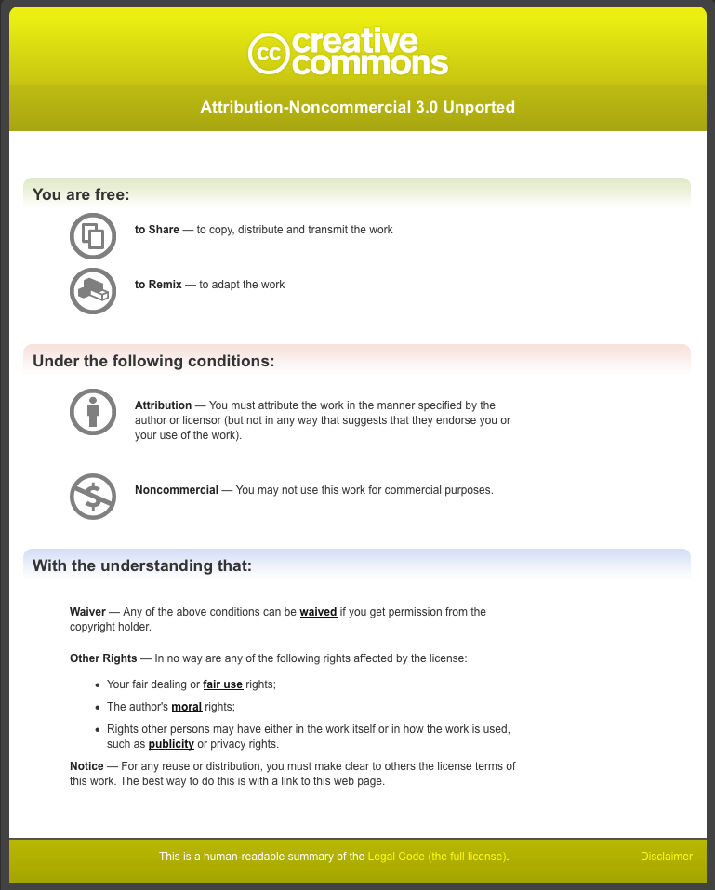

5.4 Defining “Noncommercial” Study Questionnaire for Creators

The following pages contain the master version of the study questionnaire fielded in Phase 2 (creators) of empirical research.

Defining “Noncommercial” Study Questionnaire for Creators

NOTE: This is the master version of the questionnaire prepared for the online quantitative survey of the general U.S. Internet population and the Creative Commons “Friends and Family” (“CCFF”) open access poll, both fielded in December 2008. Questionnaire headings, programming instructions and question numbers were not visible to respondents. Questions presented to CCFF only are indicated by ***. For ease of reading, most of the CCFF-only questions are grouped at the end of this document. As indicated, these questions appeared in slightly different order when the poll was fielded.

SCREENER QUESTIONS

INTRODUCTION: Thank you for taking this survey. We appreciate your time and consideration.
Please be aware that depending on your response, the survey could take anywhere from 15 - 25 minutes to complete. Also, please note that once you click the "continue" button on any page of the survey, you will not be able to return to previous pages

Q1. First, please indicate your age:

- Under 18
- 18-24
- 25-29
- 30-34
- 35-39
- 40-44
- 45-49
- 50-54
- 55+

TERMINATE CODE 1 AFTER Q2

Q2. Please indicate your gender:
- Male
- Female

TERMINATE IF CODE 1 AT S1

Q3. In the last 12 months, have you created any of the following types of works or content? Please select all that apply.

RANDOMIZE
- Videos or films
- Songs or instrumental music
- Photos
- Texts or writings (for example, stories, poems, articles)
- Images (for example, paintings, drawings, flash animations)
- Podcasts
- Blogs, online journals or blog postings
- Mash-ups or remixes (works that are created by combining other pre-existing works)
- Online ratings or reviews of others’ works (for example, movie or music reviews)
- Games
- Other, please specify
- None of the above

TERMINATE IF CODE 11 (NONE OF THE ABOVE) AT Q3, OR ONLY CODE 10 (“OTHER”)

BASE: All Respondents

SCREEN-OUT MESSAGE: Thank you for participating in our survey today. Unfortunately, your profile does not correspond to the one we were looking for in this study.
Thanks again!

GENERAL ATTITUDES AND BEHAVIORS REGARDING SHARING ONLINE

BASE: All Respondents
Q4. Do you generally consider yourself an amateur or professional creator?

Select one.

DO NOT RANDOMIZE
- Amateur
- Professional
- Both or neither, please explain

ERROR MESSAGE: “Please explain your answer.”

BASE: Created non-web-native works (Codes 1-5, 10) at Q3
Q5. From this point forward, we will use “work” and “works” to refer to any works or content you have created.

Have you shared any of the following works online? That is, have you distributed any of the following works using the Internet, by posting to a website, blog, or microblog, or using email, IM, or a peer-to-peer (P2P) network?

Select all that apply.

PIPE THOSE FROM Q1 THAT ARE NOT WEB-NATIVE (CODES 1-5, 10)
COLUMN HEADER: “SHARED ONLINE”
SHOW IN SAME ORDER AS PRESENTED IN Q3
INCLUDE NONE OF THE ABOVE
DO NOT PIPE “OTHER SPECIFIES”

BASE: Share Works Online (Codes 6-9 at Q3 or at least one at Q5)
Q6. Approximately how often do you share each type of work online?
Please select one in each row.

 | Daily or several times a day | 2 to 3 times a week | About once a week | About once a month | About once every 3 to 5 months | ABOUT ONCE EVERY 6 MONTHS TO A YEAR
PIPE ALL SELECTS AT Q5 AND ANY CODES 6-9 AT Q3
SHOW IN SAME ORDER AS Q3

BASE: Share Works Online (Codes 6-9 at Q3 or at least one at Q5)
Q7. When you share your works online, how do you typically do that?

Please think of all the different types of works you create when answering this question.
Select all that apply.

RANDOMIZE
- Post to my own blog or website
- Post to a blog or website run by someone else
- Post to a website that hosts a variety of user-generated content, such as Flickr or YouTube
- Post to a social networking website, such as Facebook or MySpace
- Share via a peer-to-peer (P2P) network
- Send via email, in the email itself, or as an attachment or in a link
- Send via an email group or listserv, in the email itself, or as an attachment, or in a link
- Send via an instant message or "chat" message, in the message itself, or as a link
- Send via micro-blog, such as Twitter
- Other, please specify

BASE: Share Works Online (Codes 6-9 at Q3 or at least one at Q5)

Q8. When you share your works online, approximately how many people do you typically reach?

Select one.

DO NOT RANDOMIZE
- Less than 5 people
- 5 to 9
- 10-29
- 30-49
- 50-99
- 100-199
- 200-499
- 500-999
- 1000 or more people

BASE: Share Works Online (Codes 6-9 at Q3 or at least one at Q5)

Q9. Which of the following best describes how, if at all, you control who can access your works when you share them online?

DO NOT RANDOMIZE

- Always control who can access my works (for example, only family and friends)
- Usually control who can access
- Usually share with anyone (that is, allow public access)
- Always share with anyone

BASE: Share Works Online (Codes 6-9 at Q3 or at least one at Q5)
Q10. Why do you share the works you create online?
Rate each of the following reasons on the 7-point scale below where “7” means “Strongly Agree” and “1” means “Strongly Disagree.”
If you can’t say or a reason does not apply to your works, select the last column (“Can’t Say/Not Applicable”).
Select one in each row.

RANDOMIZE | STRONGLY AGREE |  |  |  |  |  | STRONGLY DISAGREE | CAN’T SAY/ NOT APPLICABLE
 | 7 | 6 | 5 | 4 | 3 | 2 | 1
- I want to generate awareness and interest in my works
- It may increase the value of my work(s)
- I want to influence others’ opinions
- I want to share my knowledge or expertise on certain subjects
- I enjoy sharing my works with others
- I want to engage with a community of colleagues or others interested in my works or the subject of my works
- I take pride in my works and want others to use them
- I want to expand my network of friends and/or social contacts
- I want to expand my network of professional contacts
- I want to boost my reputation
- I need a place to store them
- I want to reciprocate with others who share their works online
- I am experimenting, and curious to see what happens

BASE: All respondents
Q11. [IF SHARE WORKS ONLINE (CODES 6-9 AT Q3 OR AT LEAST ONE AT Q5)] Do you have any concerns about sharing your works online? Rate each of the following potential concerns on the 7-point scale below where “7” means “Strongly Agree” and “1” means “Strongly Disagree.”
Select one in each row.
If you can’t say or a reason does not apply to your works, select the last column (“Can’t Say/Not Applicable”).

[IF DO NOT SHARE ONLINE (NO CODES 6-9 AT Q3 AND NO SELECTS AT Q5)] You indicated that you do not share your works online. Why don’t you share online? Rate each of the following reasons on the 7-point scale below where “7” means “Strongly Agree” and “1” means “Strongly Disagree.”
Select one in each row.
If you can’t say or a reason does not apply to your works, select the last column (“Can’t Say/Not Applicable”).

RANDOMIZE | STRONGLY AGREE |  |  |  |  |  | STRONGLY DISAGREE | CAN’T SAY/ NOT APPLICABLE
 | 7 | 6 | 5 | 4 | 3 | 2 | 1
- My works could be used for some purpose I find objectionable (for example, pornography or political propaganda)

- Someone may disapprove or criticize of my works
- I consider public sharing a violation of my privacy
- An individual or organization could derive financial gain from my work without sharing the profits with me
- It may cause the value of my other works to decline
- My competitors might find out what I am producing
- The overall market for the kinds of works I produce could decline
- It takes too much time/effort to share my works online
- I don’t know how to share my works online

COMMERCIAL USE V. NONCOMMERCIAL USE

BASE: All respondents
Q12. Imagine someone approached you about using one of your works, and asked if you would allow both commercial use and noncommercial use of your work. Would you understand the question? We would like to know how you would define the difference between a “commercial use” of your work and a “noncommercial use” of your work. Please type your definition in the space provided.

Please do not consult other sources to answer this question! We want to know what you think the difference is between commercial use and noncommercial use – in your own words, at this moment.

If you cannot define the difference, check the box labeled “Don’t Know” below.

OPEN END TEXT FIELD LABELED “Type in your definition”
INCLUDE CHECK BOX: “DON’T KNOW”

BASE: Can define difference (Box NOT checked at Q12)
Q13. Do you think other people understand the difference between commercial use and noncommercial use in the same way you do?

Select one.

DO NOT RANDOMIZE
- Yes
- Yes, most do
- Yes, many do
- Yes, some do
- No, many do not
- No, most do not
- No
- Not sure

BASE: Can define difference (Box NOT checked at Q12)
Q14. Are you aware of any law that defines a difference between commercial use and noncommercial use?

Select one.

DO NOT RANDOMIZE
- Yes
- No
- Not sure

BASE: Aware of law (Code 1 at Q14)
Q15. Please describe, in your own words, the law that defines commercial use and noncommercial use.

OPEN TEXT FIELD LABELED “Be as specific as possible”

BASE: All CCFF respondents
***Q15A. Please select your legal jurisdiction from the drop-down list of countries below.
DROP-DOWN MENU OF ALL COUNTRIES

GATEKEEPING EXERCISE

BASE: All respondents
Q16. Continue to imagine someone approaching you about using one of your works. Each of the statements below describes a potential type of user or use of your work.

For each statement, please indicate whether you think the statement means the proposed use would be definitely a commercial use or definitely a noncommercial use.
If it would depend or can’t say, select the third column for that row.

If you don’t know, select the last column for that row.

Please complete the exercise to the best of your ability, based on what you think the difference is between commercial use and noncommercial use. Again, please do not consult other sources.

Some statements refer to a “not-for-profit organization”. By “not-for-profit organization”, we mean any organization that exists primarily for some reason other than to make a profit. A religious organization, school or hospital might be an example of a not-for-profit organization.

Select one in each row.

PIPE RANDOM GROUP OF EIGHT STATEMENTS PER EACH RESPONDENTS FROM THE LIST BELOW (TOTAL N=~500 FOR EACH RESPONDENT)

RANDOMIZE  SHOW TOTAL OF EIGHT (8) STATEMENTS | DEFINITELY A COMMERCIAL USE | DEFINITELY A NONCOMMERCIAL USE | IT WOULD DEPEND/  CAN’T SAY | DON’T KNOW
- Money would be made directly from the sale of a copy of your work
- Money would be made from the use of your work in some way
- Money would be made from the use of your work, but only enough to cover costs of copying and distributing the work
- No money would be made from the use of your work
- Your work would be used online and advertising would appear around or in connection with it – and the user would make money from the ads
- Your work would be used online and advertising would appear around or in connection with it – and the user would make money from the ads, but only enough to cover the cost of hosting the website
- Your work would be used on a splog or “zombie website” that exists only to artificially generate traffic and revenues from pay-per-click advertising
- Your work would be used by an individual
- Your work would be used by a not-for-profit organization
- Your work would be used by a for-profit company
- "Your work would be used by the government or a state-run entity"
- Your work would be used by a for-profit company, but no money would be made from the use of your work
- Your work would be used for a charitable purpose, or to promote a public or social good
- Your work would be used for a purpose you find objectionable
- Only a small part of your work would be used
- Your entire work or “the heart” of your work would be used

ANCHOR POINT ALLOCATION EXERCISE

BASE: All respondents
Q17. Now we’d like to ask you to evaluate some similar statements about how, or by whom, one of your works might be used. This time, we would like you to enter a number on a scale of 100 to 1, where:

100 means you think the proposed use would be “Definitely A Commercial Use”

and

1 means you think the proposed use would be “Definitely A Noncommercial Use”.

Please read each statement and then enter a number in the space provided. Assume this is all the information available. (In the next phase of this exercise, you will be presented with more information.)

Please complete the exercise to the best of your ability, based on what you think the difference is between commercial use and noncommercial use.

If you cannot enter a number based on the information provided, check the box in the column labeled “Don’t Know/Can’t Say.”

Enter a whole number.

GRID WITH 2 COLUMNS:

COLUMN ONE (SEE BELOW): OPEN NUMERIC FIELDS, WHOLE NUMBERS ONLY BETWEEN 1 AND 100

COLUMN TWO (SEE BELOW): CHECK BOXES.

FOR EACH ANSWER CHOICE, RESPONDENTS MUST ENTER WHOLE NUMBER IN COLUMN ONE OR CHECK BOX IN COLUMN 2

RANDOMIZE | ENTER A WHOLE NUMBER FROM 100 = “DEFINITELY A COMMERCIAL USE” TO 1 = “DEFINITELY A NONCOMMERCIAL USE” | DON’T KNOW/ CAN’T SAY
- The user would make money from the use of your work
- Your work would be used online and advertisements would appear around or in connection with it
- Your work would be used by an individual
- Your work would be used by an organization
- Your work would be used for a charitable purpose or to promote a social or public good

EVERY RESPONDENT WILL RATE TWO DRILL-DOWNS:

HALF OF RESPONDENTS WILL RATE Q18A (MAKE MONEY FROM USE OF WORK)

OTHER HALF WILL RATE Q18B (USED ONLINE WITH ADVERTISING)

OTHERS (Q18C, Q18D AND Q18E WILL BE DISTRIBUTED RANDOMLY)

GIVE PREFERENCE TO DRILL-DOWN STATEMENTS THAT RECEIVE A SCORE IN COLUMN 1 OVER “DON’T KNOW/CAN’T SAY”, SEND TO LOWEST INCIDENCE GROUP

ANCHOR POINT PIPES FOR Q18A-E:

PIPE FOR Q17, Code 1: if the user would make money from the use of your work
PIPE FOR Q17, Code 2: if your work would be used online and advertisements would appear around or in connection with it
PIPE FOR Q17, Code 3: if your work would be used by an individual
PIPE FOR Q17, Code 4: if your work would be used by an organization
PIPE FOR Q17, Code 5: if your work would be used for a charitable purpose or to promote a social or public good

BASE: All Respondents

Q18A-E. [IF NUMBER GIVEN IN COL. 1 AT CODE X OF Q17] You indicated that, if your work would be [PIPE], your score would be [INSERT SCORE FROM CODE X OF Q17] on a 100-point scale where 100 means “Definitely A Commercial Use”, and 1 means “Definitely A Noncommercial Use”.

Below is another group of statements, each of which includes some additional information describing the proposed use of your work. Please read each statement carefully.

For each statement, in the space provided, please enter a number on a scale of 100 to 1, where:

100 = "Definitely A Commercial Use"

and

1 = "Definitely A Noncommercial Use"

If you cannot enter a number based on the information provided, check the box in the column labeled "Don't Know/Can't Say."

Please enter a whole number.

[IF NUMBER NOT GIVEN IN COL. 1 AT CODE X OF Q17 (“DON’T KNOW” IS CHECKED):]
Below is another group of statements, each of which includes some additional information describing the proposed use of your work. Please read each statement carefully.

For each statement, in the space provided, please enter a number on a scale of 100 to 1, where:

100 = “Definitely A Commercial Use”

and

1 = “Definitely A Noncommercial Use”.

If you cannot enter a number based on the information provided, check the box in the column labeled “Don’t Know/Can’t Say.”

Enter a whole number.

GRID WITH 2 COLUMNS:

COLUMN ONE (SEE BELOW): OPEN NUMERIC FIELDS
IF RESPONDENT GAVE NUMBER AT CODE 1 AT Q17, INCLUDE NUMBER IN FIELDS AS DEFAULT, IF RESPONDENT DID NOT GIVE NUMBER, LEAVE FIELDS BLANK TO BEGIN.
WHOLE NUMBERS ONLY BETWEEN 1 AND 100

COLUMN TWO (SEE BELOW): CHECK BOXES

FOR EACH ANSWER CHOICE, RESPONDENTS MUST ENTER WHOLE NUMBER IN COLUMN ONE OR CHECK BOX IN COLUMN 2

RANDOMIZE | ENTER A WHOLE NUMBER FROM 100 = "DEFINITELY A COMMERCIAL USE" TO 1 = "DEFINITELY A NONCOMMERCIAL USE" | DON’T KNOW/CAN’T SAY
INSERT APPROPRIATE SET OF ANSWER CHOICES (SEE BELOW)

Q18A – IF CODE 1 AT Q17 (MAKES MONEY FROM WORK), INSERT AT Q18A-E:

- The user intends to make money from selling a copy of your work
- The user would make money from selling a copy of your work
- The user would make money by selling something that includes your work (for example, the user sells a video that includes one of your songs on the soundtrack)
- The work would be used in a profit-making venture, and your entire work or “the heart” of your work would be used
- The work would be used in a profit-making venture, and only a small part of your work would be used
- The work is used in a profit-making venture, and your work would be changed or altered to a considerable degree
- A not-for-profit organization would make money from the use of your work, but only enough to cover the costs of copying and distributing the work (for example, a not-for-profit uses your work in a manual about emergency medical care, which it sells for just enough to cover the costs of copying and distributing the manual)
- A for-profit company would make money from the use of your work, but only enough to cover the costs of copying and distributing the work (for example, a private school that charges tuition uses your work in course materials, but only charges students the cost of copying and distributing the course materials)
- A not-for-profit organization would make money from the use of your work, enough to cover the costs of copying and distributing the work, and also some operating costs (for example, a not-for-profit uses your work in a manual about emergency medical care, which it sells for enough to cover the costs of copying and distributing the manual, and pay some staff salaries)
- A not-for-profit organization would make money from the use of your work, enough to contribute to its endowment fund
- A for-profit company would make money from the use of your work, and would donate all the money it makes to a not-for-profit organization
- The user would not make money directly from the use of your work, but your work would be used to promote the user or the user’s work (for example, your photograph appears on posters promoting the user’s concert or the cover of a CD containing the user’s music)

Q18B – IF CODE 2 AT Q17 (ONLINE WITH ADVERTISING), INSERT AT Q18A-E:

- Your work would be used on a blog or webpage that is supported by advertising, and the user would not make any money directly from the advertising
- Your work would be used on a blog or webpage with advertising, and the user would make money from the advertising – just enough to cover the user’s costs of putting your work online (for example, the cost of hosting a website)
- Your work would be used on a blog or webpage with advertising, and the user would makes money from the advertising – enough to turn a profit
- Your work would be used on a splog or “zombie” website – websites that exist only to artificially generate traffic and revenues from pay-per-click advertising
- Your work would be posted on an aggregator website which hosts millions of works (such as YouTube or MySpace), and which makes money from the advertising because of the high volume of traffic it attracts
- A not-for-profit organization would use your work on its website, and the organization would make enough money from advertising to cover the costs of hosting the website
- A not-for-profit organization would use your work on its website, and the organization would make enough money from advertising on the website to help cover the organization’s operating costs
- A for-profit company would use your work on its website, and would donate all the money it makes from advertising on the website to a not-for-profit organization
- The user would use your work to advertise another product for sale (for example, your photograph of people playing sports would be used to advertise an energy drink)

Q18C – IF CODE 3 AT Q17 (AN INDIVIDUAL), INSERT AT Q18A-E:

- The user would be an individual, and the use would be personal or private (for example, your work would be used at home, or in the company of a few friends)
- The user would be an individual, and your work would be shared on a website that restricts access (visitors are required to log-in)
- The user would be an individual, and your work would be shared on a website with anyone the user specifically allows (for example, the user’s friends on a social networking site)
- The user would be an individual, and your work would be shared on a blog or on a website that anyone can access
- The user would be an individual who is an amateur known for the kind of product or activity for which your work is used, but the user does not make a living from that activity (for example, your photograph would be used to illustrate a personal blog about the user’s hobbies)
- The user would be an individual who is a professional who makes a living from the product or activity for which your work is used, but the user does not make money directly from use of your work (for example, the user is a filmmaker who includes your video in a film distributed for free)
- The user would be an individual who is a professional who makes a living from the product or activity for which your work is used (for example, your video is used in a documentary film the user sells)
- The user would be someone you view as a competitor

Q18D – IF CODE 4 AT Q17 (AN ORGANIZATION), INSERT AT Q18A-E:

- The user would be a small for-profit company, that has yet to turn a profit
- The user would be a large for-profit company
- The user would be a for-profit company, and your work would be shared with a small group of employees
- The user would be a for-profit company, and your work would be shared with the entire company
- Your work would be used for course materials in a school – a not-for-profit organization that does not charge tuition
- Your work would be used for course materials in a school – a not-for-profit organization that charges tuition
- Your work would be used by a not-for-profit organization to raise money to sustain its operations
- Your work would be used by a not-for-profit organization to raise money for its endowment fund
- Your work would be used by the government or a state-run entity

Q18E – IF CODE 5 AT Q17 (CHARITABLE, SOCIAL GOOD), INSERT AT Q18A-E:

- Your work would be used by a not-for-profit organization.
- Your work would be used by a for-profit company for a charitable purpose (for example, to raise money to donate to a disaster relief fund)
- Your work would be used by a not-for-profit organization for a charitable purpose that you strongly support
- Your work would be used by a for-profit company for a charitable purpose that you strongly support
- Your work would be used by a not-for-profit organization for a purpose that you find objectionable
- Your work would be used by a for-profit company for a purpose that you find objectionable
- Your work would be used by a private for-profit school, for a fundraiser
- Your work would be used by a public not-for-profit school, for a fundraiser
- Your work would be used in free educational materials distributed to the public by a for-profit company, which would receive favorable publicity from this activity
- Your work would be used in free educational materials distributed to the public by a for-profit company, which would receive a tax deduction from this activity
- Your work would be used by the government or a state-run entity

BASE: Can define difference (Box NOT checked at Q12)
Q19. Thank you for completing this exercise. Earlier, you described the difference between a commercial use and a noncommercial use of your work as:

PIPE ANSWER FROM Q12

Having completed this exercise, would you change your definitions of commercial use and/or noncommercial use? Or would they stay the same? Select one.

DO NOT RANDOMIZE
- Yes, I would change my definitions
- No, I would not change my definitions
- Don’t know/Not sure

BASE: Definition changed (Code 1 at 19)
Q20. How would you define the difference between commercial use and noncommercial use now? Please describe.

OPEN-END TEXT FIELD

BASE: Can define difference (Box NOT checked at Q12) – GEN POP SURVEY ONLY. HIDE FOR CCFF
Q21. What if “noncommercial use” meant any use that is not primarily intended for, or directed toward, commercial advantage or private monetary compensation?

Do you think this definition is:

DO NOT RANDOMIZE
- Essentially the same as your definition of noncommercial use
- Different from but still compatible with your definition of noncommercial use
- Different from and incompatible with your definition of noncommercial use
- Don’t know/Not sure

COPYRIGHT AND LICENSING QUESTIONS

BASE: All Respondents
Q22. Are any of the works you created in the last 12 months copyrighted? Select one answer.

DO NOT RANDOMIZE
- Yes, some or all of them are copyrighted
- No, none of them are copyrighted
- Not sure

BASE: All Respondents
Q23. Have you ever been involved with licensing copyrighted works? Select the one answer that best describes your experience.

DO NOT RANDOMIZE
- Yes, I have licensed my own copyrighted work to others
- Yes, I have licensed copyrighted work from others
- Yes, I have licensed my own copyrighted work to others, and
I have licensed copyrighted work from others
- No, I have not been involved with licensing any copyrighted work or content
- Don’t know/Not sure
- Other, please specify

BASE: Share works online (Codes 6-9 at Q3 or any selects at Q5)
Q24. Do you ever license the works that you share online? If so, how do you license these works? Please select all that apply.
If you have never licensed your works, select the final answer choice below.

RANDOMIZE
LAST ANSWER CHOICE SHOULD REMAIN AT THE BOTTOM

- I have used a free public license available online
- I have used a standard license that I prefer to use for all my works when possible
- I have used a license written specifically for use of a specific work, or for a specific use of that work
- A lawyer has helped me license a work
- I have used a license provided by the party to whom I licensed the work
- I have never licensed a work that I have shared online

BASE: License works (NOT Codes 6 at Q24)
***Q25. Thinking of all the works that you have shared online and licensed as 100%, what percent have you licensed in each of the following ways?
Enter a percent for each approach listed below. Your answers must total 100%.

Enter a whole number.

TOTAL SUM CALCULATOR
PIPE SELECTS AT Q24:
(FOR CODE 1): Free public license available online
(FOR CODE 2): Standard license that I prefer to use for all my works
(FOR CODE 3): License drafted specifically for that work or use
(FOR CODE 4): Helped by a lawyer
(FOR CODE 5): Licensed provided by the licensee

SHOW IN SAME ORDER AS Q24
DEFAULT = 0%
IF ONLY ONE ANSWER SELECTED AT Q24, AUTO-PUNCH 100%

PROFILING VARIABLES

BASE: All respondents
Q26. Thinking of all the works you create as 100%, approximately what percent of these works generate revenue – that is, what percent of your works earn you money?

Enter the percents in the spaces provided. Your answers must total 100%.

Enter a whole number.

DO NOT RANDOMIZE
TOTAL SUM CALCULATOR
% SIGNS BESIDE OPEN NUMERIC FIELDS
DEFAULT = 0%

1. Percent of works that generate revenue
2. Percent of works that do not generate any revenue

BASE: At least 1% of works generate revenues (>0% at code 1 at Q26)
Q27. You indicated that some or all of your works generate revenue. How do you earn money from these works?

Select all that apply.

DO NOT RANDOMIZE
- I earn money from my works directly (for example, from the sale of products, downloads, or merchandise, or by displaying or performing my work at events)
- I earn money from my works indirectly, from advertising that appears online around or in connection with my works
- I earn money from my works indirectly in ways other than online advertising (for example, through speaking fees)
- Other, please specify

BASE: At least 1% of works generate revenues (>0% at code 1 at Q26)
Q28. Approximately how much money do you earn from your works on an annual basis, whether directly, indirectly or a combination of both?

Select one.

DO NOT RANDOMIZE
- Less than $500 annually
- $500 - $999
- $999 - $1,999
- $2,000 - $4,999
- $5,000 - $9,999
- $10,000 - $24,999
- $25,000 - $49,999
- $50,000 - $74,999
- $75,000 - $99,999
- $100,000 - $199,999
- $200,000 -$299,999
- $300,000 - $499,999
- $500,000 or more annually
- I prefer not to answer

BASE: All respondents
Q29. If you were to categorize your works, which one of the following categories would best describe the majority of them?

Select one.

RANDOMIZE
- Education
- Science
- Music
- Visual art
- Filmmaking/video
- Entertainment
- Literature
- Journalism
- Marketing
- Other, please specify

BASE: All Respondents
Q30. Which of the following best describes your familiarity with and attitude toward the principles of “open source” – that is, the principles associated with the open source software movement? Select one.

If you are not at all familiar with open source principles, please select the last answer choice below.

DO NOT RANDOMIZE
- I am familiar with and embrace open source principles
- I am familiar with but do not necessarily embrace open source principles
- I am familiar with open source principles and do not agree with them
- I am somewhat familiar with but have no opinion of open source principles
- I am not at all familiar with open source principles

BASE: All Respondents
Q31. Finally, are you a lawyer or have you had any formal legal training?

Select one.

- Yes, I am a lawyer or have had some formal legal training
- No, I am not a lawyer and have had no formal legal training

USE AND PERCEPTION OF CC-NC LICENSES

BASE: Have licensed works using CC licenses (Codes 1 or 3 at Q23)
***Q32. You indicated that you have licensed your own copyrighted work to others. Which, if any, of the following Creative Commons licenses have you used to license your work?

Select all that apply.

If you cannot recall the license(s) you used, select the last answer choice below.

DO NOT RANDOMIZE
LAST TWO ANSWER CHOICES SHOULD BE SINGLE SELECTS
- Attribution (BY)
- Attribution Share Alike (BY-SA)
- Attribution No Derivatives (BY-ND)
- Attribution Noncommercial (BY-NC)
- Attribution Noncommercial Share Alike (BY-NC-SA)
- Attribution Noncommercial No Derivatives (BY-NC-ND)
- I do not recall which CC licenses I have used
- None of the above

BASE: Have used CC-NC license (Codes 4-6 at Q32)
***Q33. You indicated that you have used a Creative Commons license that includes the “Noncommercial” or “NC” term to license your work. Why did you choose to license your work for noncommercial use?

Select all that apply.

RANDOMIZE
- Licensing under the NC term is useful for promoting me and my work
- The NC term allows me to control the right to make money from my works
- Creative Commons is a respected “brand”
- I trust that Creative Commons licenses are legally enforceable
- Association with Creative Commons enhances my image/reputation
- I don’t want anyone else to want make money or get a commercial advantage from using my work
- Other, please specify

BASE: Have used CC-NC license (Codes 4-6 at Q32)
***Q34. Approximately how many works have you licensed using the Creative Commons Noncommercial or NC license term?

Select one.

- Less than 10
- 10 – 49
- 50 – 99
- 100 – 499
- 500 or more

BASE: Have used CC-NC license (Codes 4-6 at Q32)
***Q35. As a licensor, do you have any dissatisfaction with or concerns about the Creative Commons Noncommercial licenses?

Select all that apply.

If you do not have any dissatisfaction or concerns, select “none of the above” below.

RANDOMIZE
- The term is not defined clearly
- The term is not defined in enough detail
- The term does not capture differences in industries
- The term does not capture differences in types of works
- The term does not match my personal definition of “noncommercial use”
- I am not sure that licensees understand the term the way I do
- I am concerned that licensees do not respect the term
- None of the above (do not have any dissatisfaction or concerns)
- Other, please specify

BASE: Have used CC-NC license (Codes 4-6 at Q32)
***Q36. Have you ever been contacted by someone who wanted to know if a certain use of one of your CC-NC-licensed works would be acceptable to you?

1. Yes, I have been contacted to see if a use would be acceptable
2. No, I have never been contacted
3. Don’t know/not sure

BASE: All Respondents
*** Q37. Creative Commons licenses define a noncommercial use as any use that is not “primarily intended for, or directed toward, commercial advantage or private monetary compensation”.

Would you support an effort to potentially refine or redefine the CC-NC term? Select one.

- Yes, I would support a change
- No, change is not necessary
- No, change is not desirable
- Not sure

BASE: All Respondents
***Q38. We welcome any additional thoughts or comments you might have on the CC-NC term – including any that relate directly to potential refinements or redefinitions – in the space provided below.

OPEN TEXT FIELD LABELED “Be as specific as possible”

CREATIVE COMMONS COMMUNITY

BASE: All Respondents
***Q39. Which of the following best describes your involvement, if any, in the “Creative Commons community”?

Select one.

DO NOT RANDOMIZE
- I am very involved with Creative Commons and consider myself to be a very active member of the Creative Commons community
- I consider myself an active member of the Creative Commons community, but I am not as active as some others
- I occasionally participate in discussions, activities or events associated with Creative Commons, but I do not consider myself a member of the Creative Commons community
- I have no involvement with the Creative Commons community
- I do not think there is a “Creative Commons community”
- Not sure/Don’t know how to answer

BASE: Involved in CC Community (Codes 1-3) at Q39
***Q40. In what year did your involvement with the Creative Commons community begin? Select one.
- 2001
- 2002
- 2003
- 2004
- 2005
- 2006
- 2007
- 2008

BASE: All Respondents
CLOSING MESSAGE: That is all the questions we have for you. Thank you for your time and consideration.

5.5 Defining “Noncommercial” Study Questionnaire for Users
The following pages contain the master version of the study questionnaire fielded in Phase 3 (users) of empirical research.

Defining “Noncommercial” Study Questionnaire for Users

NOTE: This is the master version of the questionnaire prepared for the online quantitative survey of the general U.S. Internet population and the Creative Commons “Friends and Family” (“CCFF”) open access poll, both fielded in April 2009. Questionnaire headings, programming instructions and question numbers were not visible to respondents. Questions presented to CCFF only are indicated by ***. For ease of reading, most of the CCFF-only questions are grouped at the end of this document. As indicated, these questions appeared in slightly different order when the poll was fielded.

SCREENER QUESTIONS

INTRODUCTION: Thank you for taking this survey. We appreciate your time and consideration.

Please be aware that depending on your response, the survey could take anywhere from 15 to 25 minutes to complete. Also, please note that once you click the "continue" button on any page of the survey, you will not be able to return to previous pages.

Q1. First, please indicate your age:

- Under 18
- 18-24
- 25-29
- 30-34
- 35-39
- 40-44
- 45-49
- 50-54
- 55+

TERMINATE CODE 1 AFTER Q2

Q2. Please indicate your gender:

- Male
- Female

TERMINATE IF CODE 1 AT Q1

Q3. In the last 12 months, have you used any online content in any of the following ways?

By “online content” we mean any type of content or creative work that you found online, such as a video, song, photograph, blog posting, podcast, article or image.

Please think only of online content created by someone else, not any content that you may have created.

Have you: (Select all that apply)

RANDOMIZE
- Accessed any online content (for example, have you viewed, read or listened to any online content)
- Downloaded any online content just for yourself
- Downloaded and shared any online content with others
- Remixed or mashed up any online content (that is, made something by combining two or more works created by someone else, for example, adding an existing song to existing video footage)
- Made a new work incorporating any online content (for example, adding a song or photograph made by someone else to a new work that you created)
- Made a new work by changing or altering any online content (for example, making a new work by changing the lyrics of a song, or re-editing video footage)
- Posted or uploaded any online content to a blog, social networking or other type of website
- None of the above
- Other, please specify

TERMINATE IF CODE 8 OR ONLY CODE 9

Q4. You indicated that you have accessed, shared or used online content in some way.

Which of the following types of online content have you accessed, shared or used?

Select all that apply.

RANDOMIZE
- Video or film
- Songs or instrumental music
- Photographs
- Texts or writings (for example, stories, poems, articles)
- Images (for example, paintings, drawings, flash animations)
- Podcasts
- Blogs, online journals or blog postings
- Online ratings or reviews of others’ works (for example, movie or music reviews)
- Games
- Remixes or mash-ups
- None of the above
- Other, please specify

TERMINATE IF CODE 11 OR ONLY CODE 12

BASE: All Respondents

SCREEN-OUT MESSAGE: Thank you for participating in our survey today. Unfortunately, your profile does not correspond to the one we were looking for in this study.
Thanks again!

USERS AS CREATORS

BASE: All respondents
INSTRUCTIONS: Going forward, we will use “content” and “work” or “works” interchangeably.
Unless otherwise indicated, please think only of content created by someone else that you find online, not content that you create yourself.

BASE: All respondents
Q5. If you were to categorize the works you find online that you access, share or use, which one of the following categories would best describe the majority of them?

Select one.

RANDOMIZE
- Education
- Science
- Music
- Visual art
- Filmmaking/video
- Entertainment
- Literature
- Journalism
- Marketing
- Other, please specify

BASE: All respondents
Q6. [IF NOT CODES 4, 5 OR 6 AT Q3, ASK] In the last 12 months, have you created any of the following types of content or works using content created by someone else?

Select all that apply.

If you never create content or works using content created by someone else, select “none of the above” below.

[IF CODES 4, 5 OR 6 AT Q3, ASK] You indicated that you have remixed, incorporated or altered content created by someone else. When you perform those activities, which of the following types of works do you ultimately create?

Select all that apply.

If you never create content or works, select “none of the above” below.

RANDOMIZE
- Videos or films
- Songs or instrumental music
- Photographs
- Texts or writings (for example, stories, poems, articles)
- Images (for example, paintings, drawings, flash animations)
- Podcasts
- Blogs, online journals or blog postings
- Online ratings or reviews of others’ works (for example, movie or music reviews)
- Games
- Remixes or mash-ups
- Other, please specify
- None of the above (do not create content or works)

BASE: Remixers, Incorporators, Alterers of Content (Codes 4, 5 or 6 at Q3)
Q7. Which of the following best describes when, if ever, you give attribution or credit to the original creators of the content you remix, incorporate and/or alter?

Select one.

DO NOT RANDOMIZE
- Always give attribution, even when not required or requested
- Usually give attribution, even when not required or requested
- Give attribution only when required or requested
- Rarely give attribution
- Never give attribution

BASE: Shared or Reused Content (Codes 3-7 at Q3)
Q8. Do you think users should give attribution or credit to the original creator when they share or use another’s work?

Select one.

- Yes, attribution should always be given, even when not required or requested
- Yes, attribution should be given when required or requested
- No, attribution should never be required
- Don’t know/Not sure

BASE: Creators (not “none of the above” at Q6)
Q9. If you were to categorize the works that you create, which one of the following categories would best describe the majority of them?

Select one.

RANDOMIZE
- Education
- Science
- Music
- Visual art
- Filmmaking/video
- Entertainment
- Literature
- Journalism
- Marketing
- Other, please specify

BASE: Creators (not “none of the above” at Q6)
Q10. How, if at all, do you share online the works that you create? Please think of all the different types of works you create when answering this question.

If you never share online the works you create, select “None of the above.”

Select all that apply.

RANDOMIZE
- Post to my own blog or website
- Post to a blog or website run by someone else
- Post to a website that hosts a variety of user-generated content, such as Flickr or YouTube
- Post to a social networking website, such as Facebook or MySpace
- Share via a peer-to-peer (P2P) network
- Send via email, in the email itself, or as an attachment or in a link
- Send via an email group or listserv, in the email itself, or as an attachment, or in a link
- Send via an instant message or "chat" message, in the message itself, or as a link
- Send via micro-blog, such as Twitter
- None of the above (do not share works I create online)
- Other, please specify

BASE: All respondents
Q11. Now, please think of all the works you find online that you access, share or use, and all of the works that you create (if any, and regardless whether you share them online). Do you consider yourself:

- Exclusively a user of works
- Primarily a user of works
- Equally a user and creator of works
- Primarily a creator of works, but also a user
- Other, please specify

BASE: All respondents
Q12. You indicated that you consider yourself [PIPE RESPONSE IN UC5]. Do you generally consider yourself an amateur or professional in this role?

Select one.

DO NOT RANDOMIZE
- Amateur
- Professional
- Both or neither, please explain

ERROR MESSAGE: “Please explain your answer.”

BASE: All respondents
Q13. Would you use any of these terms to help describe your involvement with the content you use and/or create?

Select all that apply.

If none of these terms characterize your involvement, select “none of the above.”

RANDOMIZE
- Remixer
- Sampler
- Mediator
- Intermediary
- Curator
- Repurposer
- Contributor
- None of the above
- Other, please specify

BASE: All respondents
Q14. Do you have any concerns about accessing, sharing or using works created by other people?

Rate each of the following potential concerns on the 7-point scale below where “7” means “Strongly Agree” and “1” means “Strongly Disagree.”
Select one in each row.

If you “can’t say,” or a reason does not apply to the online content you use, select the last column (“Can’t Say/Not Applicable”).

RANDOMIZE | STRONGLY AGREE |  |  |  |  |  | STRONGLY DISAGREE | CAN’T SAY/NOT APPLICABLE
 | 7 | 6 | 5 | 4 | 3 | 2 | 1
- Someone may not want me to download and keep a copy of their work
- Someone may not want me to further distribute their work or share it with anyone else
- I may use someone’s works for a purpose they would find objectionable
- Someone may object to my making money from my use of their work
- Someone may not want me to change or alter their work in any way
- Someone may not want me to include their work in a collection or aggregation of other content
- The creator of a work I use may want some form of credit or attribution, and I may not want to do that, or may not know how to do that

COMMERCIAL USE V. NONCOMMERCIAL USE

BASE: All respondents
Q15. Imagine you were interested in using someone else’s work, and the creator of that work would allow you to do so, but not for commercial use, only for noncommercial use. Would you understand what you were allowed to do with the work?

We are interested in how you would define the difference between a “commercial use” of someone’s work and a “noncommercial use” of someone’s work. Please type your definition in the space provided.

Please do not consult other sources to answer this question! We want to know what you think the difference is between commercial use and noncommercial use — in your own words, at this moment.

If you cannot define the difference, check the box labeled “Don’t Know” below.

OPEN END TEXT FIELD LABELLED “Type in your definition”
INCLUDE CHECK BOX: “DON’T KNOW”

BASE: Can define difference (Box NOT checked at Q15)
Q16. Do you think other people understand the difference between commercial use and noncommercial use in the same way you do?

Select one.

DO NOT RANDOMIZE
- Yes
- Yes, most do
- Yes, many do
- Yes, some do
- No, many do not
- No, most do not
- No
- Not sure

BASE: Can define difference (Box NOT checked at Q15)
Q17. Are you aware of any law that defines a difference between commercial use and noncommercial use?

Select one.

DO NOT RANDOMIZE
- Yes
- No
- Not sure

BASE: Aware of law (Code 1 at Q17)
Q18. Please describe, in your own words, the law that defines commercial use and noncommercial use.

OPEN TEXT FIELD LABELLED “Be as specific as possible”

BASE: All CCFF respondents
***Q18A. Please select your legal jurisdiction from the drop-down list of countries below.

DROP-DOWN MENU OF ALL COUNTRIES

GATEKEEPING EXERCISE

BASE: All respondents
Q19. Continue to imagine you were interested in using someone else’s works. Each of the statements below describes a possible scenario.

For each statement, please indicate whether you think the statement means the proposed use would be definitely a commercial use or definitely a noncommercial use.

If it would depend or you can’t say, select the third column for that row.

If you don’t know, select the last column for that row.

Please complete the exercise to the best of your ability, based on what you think the difference is between commercial use and noncommercial use. Again, please do not consult other sources.

Some statements refer to a “not-for-profit organization”. By “not-for-profit organization”, we mean any organization that exists primarily for some reason other than to make a profit. A religious organization, school or hospital might be an example of a not-for-profit organization.

Select one in each row.

PIPE RANDOM GROUP OF EIGHT STATEMENTS PER EACH RESPONDENTS FROM THE LIST BELOW (TOTAL N=~500 FOR EACH RESPONDENT)

RANDOMIZE  SHOW TOTAL OF EIGHT (8) STATEMENTS | DEFINITELY A COMMERCIAL USE | DEFINITELY A NONCOMMERCIAL USE | IT WOULD DEPEND/  CAN’T SAY | DON’T KNOW
- You would make money from the sale of a copy of the work
- You would make money from the use of the work in some way
- You would make money from the use of the work, but only enough to cover costs of copying and distributing the work
- You would not make any money from the use of the work
- You would use the work online and advertising would appear around or in connection with it — and you would make money from the ads
- You would use the work online and advertising would appear around or in connection with it — and you would make money from the ads, but only enough to cover the cost of hosting the website
- You would use the work on a splog or “zombie website” that exists only to artificially generate traffic and revenues from pay-per-click advertising
- You would use the work as an individual
- You would use the work on behalf of a not-for-profit organization
- You would use the work on behalf of a for-profit company
- The work would be used on behalf of the government or a state-run entity
- You would use the work on behalf of a for-profit company, but no money would be made from the use of the work
- You would use the work for a charitable purpose, or to promote a public or social good
- You would use the work for a purpose the creator would find objectionable
- You would only use a small part of the work
- You would use the entire work or “the heart” of the work

ANCHOR POINT ALLOCATION EXERCISE

BASE: All respondents
Q20. Now we’d like to ask you to evaluate some similar statements about how you might use a work created by someone else. This time, we would like you to enter a number on a scale of 100 to 1, where:

100 means you think the proposed use would be “Definitely A Commercial Use”

and

1 means you think the proposed use would be “Definitely A Noncommercial Use”.
Please read each statement and then enter a number in the space provided. Assume this is all the information available. (In the next phase of this exercise, you will be presented with more information.)

Please complete the exercise to the best of your ability, based on what you think the difference is between commercial use and noncommercial use.

If you cannot enter a number based on the information provided, check the box in the column labeled “Don’t Know/Can’t Say.”

Enter a whole number.

GRID WITH 2 COLUMNS:

COLUMN ONE (SEE BELOW): OPEN NUMERIC FIELDS. WHOLE NUMBERS ONLY BETWEEN 1 AND 100

COLUMN TWO (SEE BELOW): CHECK BOXES

FOR EACH ANSWER CHOICE, RESPONDENTS MUST ENTER WHOLE NUMBER IN COLUMN ONE OR CHECK BOX IN COLUMN 2

RANDOMIZE | ENTER A WHOLE NUMBER FROM 100 = “DEFINITELY A COMMERCIAL USE” TO 1 = “DEFINITELY A NONCOMMERCIAL USE” | DON’T KNOW/ CAN’T SAY
- You would make money from the use of the work
- You would use the work online and advertisements would appear around or in connection with it
- You would use the work as an individual
- You would use the work on behalf of an organization
- You would use the work for a charitable purpose or to promote a social or public good

EVERY RESPONDENT WILL RATE TWO DRILL-DOWNS:

HALF OF RESPONDENTS WILL RATE Q21A (MAKE MONEY FROM USE OF WORK)

OTHER HALF WILL RATE Q21B (USED ONLINE WITH ADVERTISING)

OTHERS (Q21C, Q21D, AND Q21E WILL BE DISTRIBUTED RANDOMLY)

GIVE PREFERENCE TO DRILL-DOWN STATEMENTS THAT RECEIVE A SCORE IN COLUMN 1 OVER “DON’T KNOW/CAN’T SAY”, SEND TO LOWEST INCIDENCE GROUP

ANCHOR POINT PIPES FOR Q21A-E:

PIPE FOR Q20, Code 1: if you would make money from the use of the work
PIPE FOR Q20, Code 2: if you would use the work online and advertisements would appear around or in connection with it
PIPE FOR Q20, Code 3: if you, as an individual, would use the work
PIPE FOR Q20, Code 4: if you would use the work on behalf of an organization
PIPE FOR Q20, Code 5: if you would use the work for a charitable purpose or to promote a social or public good

BASE: All Respondents
Q21A-E. [IF NUMBER GIVEN IN COL. 1 AT CODE X OF Q20] You indicated that, [PIPE], your score would be [INSERT SCORE FROM CODE X OF Q20] on a 100-point scale where 100 means “Definitely A Commercial Use”, and 1 means “Definitely A Noncommercial Use”.

Below is another group of statements, each of which includes some additional information describing the proposed use of the work. Please read each statement carefully.

For each statement, in the space provided, please enter a number on a scale of 100 to 1, where:

100 = "Definitely A Commercial Use"

and

1 = "Definitely A Noncommercial Use"

If you cannot enter a number based on the information provided, check the box in the column labeled "Don't Know/Can't Say."

Please enter a whole number.

[IF NUMBER NOT GIVEN IN COL. 1 AT CODE X OF Q20 (“DON’T KNOW” IS CHECKED)] Below is another group of statements, each of which includes some additional information describing the proposed use of someone else’s work. Please read each statement carefully.

For each statement, in the space provided, please enter a number on a scale of 100 to 1, where:

100 = “Definitely A Commercial Use”

and
1 = “Definitely A Noncommercial Use”.

If you cannot enter a number based on the information provided, check the box in the column labeled “Don’t Know/Can’t Say.”

Enter a whole number.

GRID WITH 2 COLUMNS:

COLUMN ONE (SEE BELOW): OPEN NUMERIC FIELDS
IF RESPONDENT GAVE NUMBER AT CODE 1 AT Q20, INCLUDE NUMBER IN FIELDS AS DEFAULT, IF RESPONDENT DID NOT GIVE NUMBER, LEAVE FIELDS BLANK TO BEGIN, WHOLE NUMBERS ONLY BETWEEN 1 AND 100

COLUMN TWO (SEE BELOW): CHECK BOXES

FOR EACH ANSWER CHOICE, RESPONDENTS MUST ENTER WHOLE NUMBER IN COLUMN ONE OR CHECK BOX IN COLUMN 2

RANDOMIZE | ENTER A WHOLE NUMBER FROM 100 = "DEFINITELY A COMMERCIAL USE" TO 1 = "DEFINITELY A NONCOMMERCIAL USE" | DON’T KNOW/CAN’T SAY
INSERT APPROPRIATE SET OF ANSWER CHOICES (SEE BELOW)

Q21A – IF CODE 1 AT Q20 (MAKES MONEY FROM WORK), INSERT AT Q21A-E:

- You intend to make money from selling a copy of someone else’s work
- You would make money from selling a copy of someone else’s work
- You would make money by selling something that includes someone else’s work (for example, you sell a video that includes music created by someone else)
- You would use someone else’s work in a profit-making venture, and the entire work or “the heart” of the work would be used
- You would use someone else’s work in a profit-making venture, and only a small part of the work would be used
- You would use someone else’s work in a profit-making venture, and the work would be changed or altered to a considerable degree
- You would use someone else’s work on behalf of a not-for-profit organization that would make money from the use of the work, but only enough to cover the costs of copying and distributing the work (for example, you would use someone else’s work in a manual about emergency medical care, which the not-for-profit organization sells for just enough to cover the costs of copying and distributing the manual)
- You would use someone else’s work on behalf of a for-profit company that would make money from the use of the work, but only enough to cover the costs of copying and distributing the work (for example, you would use someone else’s work in course materials for a for-profit school that charges tuition, but the students are charged only the cost of copying and distributing the course materials)
- You would use someone else’s work on behalf of a not-for-profit organization that would make money from the use of the work, enough to cover the costs of copying and distributing the work, and also some operating costs (for example, you would use someone else’s work in a manual about emergency medical care, which a not-for-profit organization sells for enough to cover the costs of copying and distributing the manual, and pay some staff salaries)
- You would use someone else’s work on behalf of a not-for-profit organization that would make money from the use of the work, enough to contribute to its endowment fund
- You would use someone else’s work on behalf of a for-profit company that would make money from the use of the work, and would donate all the money it makes to a not-for-profit organization
- You would not make money directly from the use of the work, but you would use the work to promote you or your own work (for example, you use a photograph on posters to promote your own concert or on the cover of a CD containing your music)

Q21B – IF CODE 2 AT Q20 (ONLINE WITH ADVERTISING), INSERT AT Q21A-E:

- You would use someone else’s work on a blog or webpage that is supported by advertising, and you would not make any money directly from the advertising
- You would use someone else’s work on a blog or webpage with advertising, and you would make money from the advertising — just enough to cover your costs of putting the work online (for example, the cost of hosting a website)
- You would use someone else’s work on a blog or webpage with advertising, and you would makes money from the advertising — enough to turn a profit
- You would use someone else’s work on a splog or “zombie” website — websites that exist only to artificially generate traffic and revenues from pay-per-click advertising
- You would post someone else’s work on an aggregator website which hosts millions of works (such as YouTube or MySpace), and which makes money from the advertising because of the high volume of traffic it attracts
- You would use someone else’s work on behalf of a not-for-profit organization for the organization’s website, and the organization would make enough money from advertising to cover the costs of hosting the website
- You would use someone else’s work on behalf of a not-for-profit organization for the organization’s website, and the organization would make enough money from advertising on the website to help cover the organization’s operating costs
- You would use someone else’s work on behalf of a for-profit company for the company’s website that would donate all the money it makes from advertising on the website to a not-for-profit organization
- You would use someone else’s work to advertise another product for sale (for example, you would use someone else’s photograph of people playing sports would be used to advertise your energy drink)

Q21C – IF CODE 3 AT Q20 (AN INDIVIDUAL), INSERT AT Q21A-E:

- You, as an individual, would use someone else’s work for personal or private purposes (for example, you would use the work at home, or in the company of a few friends)
- You, as an individual, would share the work on a website that restricts access (visitors are required to log-in)
- You, as an individual, would share the work on a website with anyone you specifically allow (for example, your friends on a social networking site)
- You, as an individual, would share the work on a blog or on a website that anyone can access
- You would use someone else’s work as an individual who is an amateur who does not make a living from the product or activity (for example, you would use someone else’s photograph to illustrate a personal blog about your hobbies)
- You would use someone else’s work as an individual who is a professional who makes a living from the product or activity, but you do not make money directly from use of the work (for example, you are a filmmaker who includes someone else’s video in a film you distribute for free)
- You would use someone else’s work as an individual who is a professional who makes a living from the product or activity for which someone else’s work is used (for example, you use the video in a documentary film that you sell)
- You are a competitor to the creator of the work you use

Q21D – IF CODE 4 AT Q20 (AN ORGANIZATION), INSERT AT Q21A-E:

- You use someone else’s work on behalf of a small for-profit company that has yet to turn a profit
- You use someone else’s work on behalf of a large for-profit company
- You use someone else’s work on behalf of a for-profit company, and the work would be shared with a small group of employees
- You use someone else’s work on behalf of a for-profit company, and the work would be shared with the entire company
- You would use the work for course materials in a school — a not-for-profit organization that does not charge tuition
- You would use the work for course materials in a school — a not-for-profit organization that charges tuition
- You use someone else’s work on behalf of a not-for-profit organization which uses the work to raise money to sustain its operations
- You use someone else’s work on behalf of a not-for-profit organization to raise money for its endowment fund
- You use someone else’s work on behalf of a government or state-run entity

Q21E – IF CODE 5 AT Q20 (CHARITABLE, SOCIAL GOOD), INSERT AT Q21A-E:

- You would use someone else’s work on behalf of a not-for-profit organization
- You would use someone else’s work on behalf of a for-profit company for a charitable purpose (for example, to raise money to donate to a disaster relief fund)
- You would use someone else’s work on behalf of a not-for-profit organization for a charitable purpose that you strongly support
- You would use someone else’s work on behalf of a for-profit company for a charitable purpose that you strongly support
- You would use someone else’s work on behalf of a not-for-profit organization for a purpose that the creator would find objectionable
- You would use someone else’s work on behalf of a for-profit company for a purpose that the creator would find objectionable
- You would use someone else’s work on behalf of a private for-profit school, for a fundraiser
- You would use someone else’s work on behalf of a public not-for-profit school, for a fundraiser
- You would use someone else’s work in free educational materials distributed to the public by a for-profit company, which would receive favorable publicity from this activity
- You would use someone else’s work in free educational materials distributed to the public by a for-profit company, which would receive a tax deduction from this activity
- You would use someone else’s work on behalf of a government or a state-run entity

BASE: Can define difference (Box NOT checked at Q15)
Q22. Thank you for completing this exercise. Earlier, you described the difference between a commercial use and a noncommercial use of someone else’s work as:

PIPE ANSWER FROM Q15

Having completed this exercise, would you change your definitions of commercial use and/or noncommercial use? Or would they stay the same? Select one.

DO NOT RANDOMIZE
- Yes, I would change my definitions
- No, I would not change my definitions
- Don’t know/Not sure

BASE: Definition changed (Code 1 at Q22)
Q23. How would you define the difference between commercial use and noncommercial use now? Please describe.

OPEN-END TEXT FIELD

BASE: Can define difference (Box NOT checked at Q15)
Q24. What if “noncommercial use” meant any use that is not primarily intended for, or directed toward, commercial advantage or private monetary compensation?

Do you think this definition is:

DO NOT RANDOMIZE
- Essentially the same as your definition of noncommercial use
- Different from but still compatible with your definition of noncommercial use
- Different from and incompatible with your definition of noncommercial use
- Don’t know/Not sure

BASE: Say definition is different and incompatible (Code 3 at Q24)
Q25. You indicated that your definition of noncommercial use is different from and incompatible with “any use that is not primarily intended for, or directed toward, commercial advantage or private monetary compensation”.

Why is your definition different from and incompatible with this one? Please explain.

OPEN-END TEXT FIELD

COPYRIGHT and LICENSING QUESTIONS

BASE: All Respondents
Q26. Are any of the works you used in the last 12 months copyrighted? Select one answer.

DO NOT RANDOMIZE
- Yes, some or all of them are copyrighted
- No, none of them are copyrighted
- Don’t know/Not sure

BASE: All Respondents
Q27. Have you ever been involved with licensing copyrighted works or content?

Select the one answer that best describes your experience.

DO NOT RANDOMIZE
- Yes, I have licensed my own copyrighted work to others
- Yes, I have licensed copyrighted work from others
- Yes, I have licensed my own copyrighted work to others, and I have licensed copyrighted work from others
- No, I have not been involved with licensing any copyrighted work or content
- Don’t know/Not sure
- Other, please specify

BASE: Used works are copyrighted (Code 1 at Q26)
Q28. How have the copyrighted works of others that you have used been licensed? Please select all that apply.

RANDOMIZE
LAST ANSWER CHOICE SHOULD REMAIN AT THE BOTTOM
- Works were licensed under a free public license available online
- Works were licensed with a standard license that the creator prefers to use for all his/her works
- I have used a license written specifically for use of a specific work, or for a specific use of that work
- A lawyer helped me get a license to use works
- I have provided a license form to the creator whose work I used
- Works were not licensed
- I did not seek or acquire a license to use the works
- Don’t know/Not sure

BASE: License works (NOT Codes 6 or 7 or 8 at Q28)
***Q29. Thinking of all the works that you have shared online and licensed as 100%, what percent have you licensed in each of the following ways?
Enter a percent for each approach listed below. Your answers must total 100%.

TOTAL SUM CALCULATOR
PIPE SELECTS AT Q28:
(FOR CODE 1): Free public license available online
(FOR CODE 2): Standard license preferred by creator
(FOR CODE 3): License drafted specifically for that work or use
(FOR CODE 4): Helped by a lawyer
(FOR CODE 5): License provided by me (the licensee)

SHOW IN SAME ORDER AS Q28
DEFAULT = 0%
IF ONLY ONE ANSWER SELECTED AT Q28, AUTO-PUNCH 100%

[***Q35-Q45 APPEARED HERE]

PROFILING VARIABLES

BASE: All respondents
Q30. Thinking of all your uses of others’ works as 100%, approximately what percent of these uses generate revenue — that is, what percent of the uses you make of others’ works earn you money?

Enter the percents in the spaces provided. Your answers must total 100%.

Enter a whole number.

DO NOT RANDOMIZE
TOTAL SUM CALCULATOR
% SIGNS BESIDE OPEN NUMERIC FIELDS
DEFAULT = 0%

- Percent of works that generate revenue
- Percent of works that do not generate any revenue

BASE: At least 1% of works generate revenues (>0% at code 1 at Q30)
Q31. You indicated that some or all of the uses you make of others’ works generate revenue. How do you earn money from these uses of others’ works?

Select all that apply.

DO NOT RANDOMIZE
- I earn money from the use of others’ works directly (for example, from the sale of products, downloads, or merchandise, or by displaying or performing those works work at events)
- I earn money from the use of others’ works indirectly, from advertising that appears online around or in connection with those work
- I earn money from the use of others' works by aggregating those works online
- Other, please specify

BASE: At least 1% of works generate revenues (>0% at code 1 at Q30)
Q32. Approximately how much money do you earn from the works on an annual basis, whether directly, indirectly or a combination of both?

Select one.

DO NOT RANDOMIZE
- Less than $500 annually
- $500 - $999
- $1,000 - $1,999
- $2,000 - $4,999
- $5,000 - $9,999
- $10,000 - $24,999
- $25,000 - $49,999
- $50,000 - $74,999
- $75,000 - $99,999
- $100,000 - $199,999
- $200,000 -$299,999
- $300,000 - $499,999
- $500,000 or more annually
- I prefer not to answer

BASE: All Respondents
Q33. Which of the following best describes your familiarity with and attitude toward the principles of “open source” — that is, the principles associated with the open source software movement? Select one.

If you are not at all familiar with open source principles, please select the last answer choice below.

DO NOT RANDOMIZE
- I am familiar with and embrace open source principles
- I am familiar with but do not necessarily embrace open source principles
- I am familiar with open source principles and do not agree with them
- I am somewhat familiar with but have no opinion of open source principles
- I am not at all familiar with open source principles

BASE: All Respondents
Q34. Finally, are you a lawyer or have you had any formal legal training?

Select one.

- Yes, I am a lawyer or have had some formal legal training
- No, I am not a lawyer and have had no formal legal training

USE AND PERCEPTION OF CC-NC LICENSES

***INTRODUCTION [SHOW CCFF SAMPLE ONLY]: Last fall, we conducted a related survey for Creative Commons that examined perceptions among creators of content. A few of the following questions are identical to questions asked in that earlier survey. Please answer the questions again, even if you answered them last time.

BASE: Have licensed works using CC licenses (Codes 1 at Q28)
***Q35. Which, if any, of the following Creative Commons licenses have been associated with the works you have accessed, shared or used?

Select all that apply.

If you cannot recall the license(s) that were used, select the last answer choice below.

DO NOT RANDOMIZE
LAST TWO ANSWER CHOICES SHOULD BE SINGLE SELECTS
- Attribution (BY)
- Attribution Share Alike (BY-SA)
- Attribution No Derivatives (BY-ND)
- Attribution Noncommercial (BY-NC)
- Attribution Noncommercial Share Alike (BY-NC-SA)
- Attribution Noncommercial No Derivatives (BY-NC-ND)
- None of the above/I do not recall which CC licenses were used

BASE: Have used CC-NC licensed works (Codes 4-6 at Q35)
***Q36. You indicated that you have accessed, shared or used works licensed with a Creative Commons license that includes the “Noncommercial” or “NC” term.

Below is a list of statements about Creative Commons, the noncommercial license or your use of others’ works.

Do you generally agree or disagree with each of the following statements? Select one in each row.

RANDOMIZE | GENERALLY AGREE | GENERALLY DISAGREE | DON’T KNOW/NOT SURE
- Creators who license their works for noncommercial use allow almost any use that promotes them or their work
- Creators who license their works for noncommercial use don’t want anyone else to make money from the works
- Creative Commons is a respected “brand”
- I trust that Creative Commons licenses are legally enforceable
- Using works with Creative Commons licenses enhances my image/reputation
- I don’t want to make money or get a commercial advantage from using someone else’s work
- I use Creative Commons licenses on works I create, so I like to use others’ CC-licensed works
- It is safer to use a work with a CC-NC license than to use an unlicensed work
- I wasn’t sure if my use would be considered a fair use, but because the work had an NC license, I didn’t worry about it
- It doesn’t make any difference if a work is licensed for noncommercial use, I feel free to use any CC-licensed work I want to for any purpose, including commercial purposes

BASE: Have used CC-NC licensed works (Codes 4-6 at Q35)
***Q37. Approximately how many works have you used that are licensed using the Creative Commons Noncommercial or NC license term?

Select one.

- Less than 10
- 10 - 49
- 50 - 99
- 100 - 499
- 500 or more

BASE: Have used CC-NC licensed works (Codes 4-6 at Q35)
***Q38. As a licensee, do you have any dissatisfaction with or concerns about the Creative Commons Noncommercial licenses?

Select all that apply.

If you do not have any dissatisfaction or concerns, select “none of the above” below.

RANDOMIZE
- The term is not defined clearly
- The term is not defined in enough detail
- The term does not capture differences in industries
- The term does not capture differences in types of works
- The term does not match my personal definition of “noncommercial use”
- I am not sure that licensors (creators) understand the term the way I do
- None of the above (do not have any dissatisfaction or concerns)
- Other, please specify

BASE: Have used CC-NC license (Codes 4-6 at Q35)
***Q39. Have you ever contacted a creator of a CC-NC-licensed work to find out whether a certain use of the work would be acceptable?

- Yes, I have contacted a creator of a CC-NC-licensed work to find out whether a certain use would be acceptable
- No, I have never contacted a creator of a CC-NC-licensed work to find out whether a certain use would be acceptable
- Don’t know/not sure

BASE: Has contacted creator (Code 1 at P6)
***Q40. You indicated that you have contacted a creator of a CC-NC licensed work to find out whether a certain use would be acceptable.

What did the use(s) entail and why did you feel it necessary to contact the creator? Please describe.

OPEN-END TEXT FIELD

BASE: All Respondents
*** Q41. Creative Commons licenses define a noncommercial use as any use that is not “primarily intended for, or directed toward, commercial advantage or private monetary compensation”.

Would you support an effort to potentially refine or redefine the CC-NC term?

Select one.

- Yes, I would support a change
- No, change is not necessary
- No, change is not desirable
- Not sure

BASE: Would support change in CC-NC term (Code 1 at Q41)
***Q42. You indicated that you would support an effort to potentially refine or redefine the CC-NC term. Can you suggest specific ways to refine or redefine the term itself? If so, please describe.
If you do not have ideas on how to refine or redefine the term, check the box labeled “Don’t Know.”

OPEN END TEXT FIELD
INCLUDE CHECK BOX “DON’T KNOW”

BASE: All Respondents
***Q43. We welcome any additional thoughts or comments you might have on the CC-NC term — including any that relate directly to potential refinements or redefinitions — in the space provided below.

OPEN TEXT FIELD LABELED “Please be as specific as possible”.
ADD CHECK BOX: No additional comment

CREATIVE COMMONS COMMUNITY

BASE: All Respondents
***Q44. Which of the following best describes your involvement, if any, in the “Creative Commons community”?

Select one.

DO NOT RANDOMIZE

- I am very involved with Creative Commons and consider myself to be a very active member of the Creative Commons community
- I consider myself an active member of the Creative Commons community, but I am not as active as some others
- I occasionally participate in discussions, activities or events associated with Creative Commons, but I do not consider myself a member of the Creative Commons community
- I have no involvement with the Creative Commons community
- I do not think there is a “Creative Commons community”
- Not sure/Don’t know how to answer

BASE: Involved in CC Community (Codes 1-3) at CC1
***Q45. In what year did your involvement with the Creative Commons community begin? Select one.
- 2001
- 2002
- 2003
- 2004
- 2005
- 2006
- 2007
- 2008

BASE: All Respondents
CLOSING MESSAGE: That is all the questions we have for you. Thank you for your time and consideration.

5.6 Defining “Noncommercial” Study Data Graphs
The following pages contain data graphs produced for this study that are reproduced or referenced in the narrative of the Report.

Due to resource constraints, the scope of the empirical research was limited to the U.S. online population, as discussed in more detail in Section 2.1, below.
See, e.g., R. Hobbs, P. Jaszi, and P. Aufderheide, The Cost of Copyright Confusion for Media Literacy, September 2007, http://www.centerforsocialmedia.org/files/pdf/Final_CSM_copyright_report.pdf.
The qualitative research findings were not designed to be limited in scope and applicable to either the U.S. online population of creators and users, or the broader worldwide CCFF sample, but to instead inform the development of the questionnaires for both.
This is the general rule for countries that are party to the Berne Convention for the Protection of Literary and Artistic Works and have enacted national legislation implementing its provisions.
A brief video explaining Creative Commons is available at http://creativecommons.org/videos/a-shared-culture/.
Creators can license only what they own or have the authority to license. All CC licenses expressly pertain only to copyright, and do not cover other rights such as those of publicity or privacy, trademarks or patents. Creative Commons is not a party to any of the licenses it provides. Also, the organization is not a law firm and does not give legal advice. Users of Creative Commons licenses are encouraged to consult a lawyer if they are unsure in any way about whether a CC license is appropriate for their work.
The Creative Commons licensing model was inspired in large part by the work of Richard Stallman, who is founder of the Free Software Foundation and responsible for the development of the GNU General Public License for free software. More information on the FSF is available at http://www.fsf.org. The validity of public licenses was recently noted by a U.S. court in Jacobsen v. Katzer, reported at 535 F.3d 1373 (Fed.Cir. (Cal.) Aug 13, 2008), on remand, Jacobsen v. Katzer, 609 F.Supp.2d 925 (N.D.Cal. Jan 5, 2009).
Information on all the Creative Commons licenses may be found at http://creativecommons.org/about/licenses/. From its founding, the organization has been working to provide licenses that work for as many creators and users as possible while avoiding the proliferation of licenses that in turn could undermine standardization and interoperability.
Information on Creative Commons jurisdiction project affiliates is available at http://creativecommons.org/international/. Courts in the Netherlands and Spain have upheld the validity of Creative Commons licenses. See Curry v. Audax Publishing B.V., Netherlands LJN: AV4204, Rechtbank Amsterdam, 334492 / KG 06-176 SR, March 9, 2006, available at http://zoeken.rechtspraak.nl/resultpage.aspx?snelzoeken=true&searchtype=ljn&ljn=AV4204 (Dutch only), and Sociedad General de Autores y Editores v. Ricardo Andres Utrera Fernandez, Juzgado de Primera Instancia Numero Seis de Badajoz, 761/2005, available at http://www.internautas.org/archivos/sentencia_metropoli.pdf (Spanish only). No court has found a CC license to be invalid.
250 million is a conservative estimate of the number of web pages containing CC-licensed works and other creative works licensed using CC licenses. This estimate is based on Yahoo! Site Explorer counts of web pages linking to a CC license, and data from the photo-sharing website Flickr, which as of March 2009 alone contained 100 million CC-licensed works. See http://wiki.creativecommons.org/Metrics. This estimate does not capture offline uses of CC licenses, nor does it measure precisely the number of objects under CC licenses. The Case Studies project documents Creative Commons license implementations from around the world. Learn more at http://wiki.creativecommons.org/Case_Studies.
The Creative Commons website facilitates search for CC-licensed works via the “Find” link on its homepage. From the search page, users can find content using CC-enabled search services at Google, Yahoo!, Flickr and elsewhere. See http://search.creativecommons.org. These services and others have also built Creative Commons licensing options into their content publishing tools. Additionally, a list of descriptions of and links to CC-licensed audio, video, image and text content directories is available at http://wiki.creativecommons.org/Content_Curators.
Section 107 of the U.S. Copyright Act of 1976 (as amended) provides, for example, that the first factor for courts to consider in a fair use defense is “the purpose and character of the use, including whether such use is of a commercial nature or is for nonprofit educational purposes.” 17 U.S.C. § 107.
For example, Section 111 of the U.S. Copyright Act of 1976 (as amended) exempts secondary transmissions by a “nonprofit organization, without any purpose of direct or indirect commercial advantage,” and Section 114 provides a scheme for licensing “noncommercial webcasters,” which are defined as those that are, or have in good faith applied to be tax-exempt under Internal Revenue Code Section 501. See 17 U.S.C. § 111(a)(5) and 17 U.S.C. § 114(f)(5)(E), respectively.
Because the study conducted focused on how the U.S. online population understands “noncommercial use” due to resource constraints, a review of whether or how other countries’ laws may define such a use and the relevance of any such definitions in the licensing context is beyond the scope of this Report.
See paragraph 4(b) of the CC BY-NC license at Appendix 5.3. Every CC license, including those with the NC term, also expressly provides that fair use rights are not affected. See paragraph 2 of the CC BY-NC license at Appendix 5.3.
The decision by CC to exclude this specific use case in its noncommercial licenses was driven in part by the Napster court decision, in which the court concluded that the trading of music online was commercial in nature even though no money exchanged hands. A&M Records, Inc. v. Napster, Inc., 239 F.3d 1004 (9th Cir. 2001).
This estimate is based on Yahoo! Site Explorer counts of web pages linking to a CC noncommercial license, as well as data from the photo-sharing website Flickr. See http://wiki.creativecommons.org/Metrics.
These categories seem to have been reasonable choices, as only 17% of creators selected “Other” when asked to categorize their works, and only 5% of users did so. See Figure 4, reproduced in Appendix 5.6, Slide 6.
When asked about the most common type of online content respondents created or used, only 2% of creators and 3% of users selected “Other,” rather than the available choices. See Figure 3 reproduced in Appendix 5.6, Slide 4.
While “sampling” and “remixing” in their most specific definitions may be 20th and 21st century aesthetic strategies and forms, there are antecedents and similar impulses in culture, worldwide and over many centuries.
See Acknowledgements, above, for a list of project personnel, advisors and others who contributed to this Report.
This effort was led by Creative Commons community member Evan Prodromou. See http://lists.ibiblio.org/pipermail/cc-licenses/2005-April/002215.html.
The existence of this understanding is distinct from the question of whether conduct separate from its commerciality, such as illegal downloading/sharing of content, can take place in private. That question is not addressed by this study.
For more information about the Greenfield Online panel, see: http://www.greenfield-ciaosurveys.com/html/home.htm and http://www.qualitydataprogram.com/qdp.html.
See Creative Commons, Defining “Noncommercial” Study Questionnaire for Creators (September 2009), (“Creators Questionnaire”) at Appendix 5.4, Question 3.
The study was not limited to creators who put their content online, because although much content continues to be created and live offline, in theory any work can be published on the Internet as a copy or in the form of documentation.
See Creative Commons, Defining “Noncommercial” Study Questionnaire for Users (September 2009), (“Users Questionnaire”) at Appendix 5.5, Question 3.
Here, respondents were sought who definitely use content online, because the Internet is the primary means for distributing publicly licensed works.
Open access polls should not be confused with the “open access” movement, in which many Creative Commons community members are involved. As used here, open access refers to the fact that anybody who became aware of the poll and so desired could participate.
Some consideration factors identified in the qualitative research were hypothetical in nature, such as perceived economic value of the content and potential impact on the market. These factors were not included in the quantitative stages of the study.
The following few examples of each factor, raised by focus group participants and expressed in the form of questions or scenarios that might be put to a creator considering whether to license content for noncommercial use, may help illustrate the complex nature of some of the decision-making involved. Economic value: Might the work itself be worth substantially more in the future? Does allowing noncommercial use of the work build demand for commercial use of the work, or depress it? Status of the user: Individual or organization Can an individual use music licensed for noncommercial use in a podcast? What if that individual is a world-renowned celebrity and the podcast has been downloaded over 100 million times, albeit for free? Can a small “mom and pop” organization create a presentation that includes content licensed for noncommercial use and distribute it internally to a few employees? What if the organization is a highly profitable multinational? For-profit or not-for-profit Can a large for-profit company use an image licensed for noncommercial use in free educational materials they distribute to schools? Can a not-for-profit entity such as a big public university sell in its gift shop a notebook whose cover includes an image licensed for noncommercial use? Amateur or professional Can an amateur blogger use images licensed for noncommercial use? What if the blog includes advertising and generates $50 per month? What if the advertising generates $50,000 per month? Can an individual who relies on blogging as a primary source of income use images licensed for noncommercial use? Monetary compensation and cost recovery: Can a not-for-profit organization sell educational materials licensed for noncommercial use to a less-developed country? What if the organization only generates enough revenues from the sale of these materials to cover the costs of production and distribution? What if the organization earns one cent beyond cost recovery that they reinvest in the organization to help sustain its humanitarian operations? If a website redistributes music licensed for noncommercial use, is that website allowed to charge an access fee solely for the purposes of maintaining itself as a means of distribution for noncommercial music? What if this process unintentionally results in a profit for the site? Promotional value: What if a music website does an entire promotional campaign around distributing an artist’s noncommercially-licensed work, greatly increasing traffic and therefore advertising revenues generated from other sections of their site? What if the campaign pushes the artist’s new music to the top of the charts? Does it matter whether the website or the artist benefits more from the campaign? Personal or private use: What if the user posts a work licensed for noncommercial use to a personal blog? What if the blog has thousands of regular readers? What if the blog promotes the user’s own work? What if the work goes viral, and the blogger is credited as the source of the work? Charitable purpose or social good: Can a not-for-profit sell copies of a work to raise money to donate to disaster relief? What if an elementary school shows a video of a popular movie at a fundraiser for which they collect $10 per attendee? Does it matter if the school is public or private? What if an otherwise charitable use is underwritten by a corporate sponsorship? Advertising: Can a blogger use material licensed for noncommercial use if the blog is hosted by a company that places ads around the licensed content and does not share advertising revenues with the blogger? Does it matter if the blogger makes some minimal amount of money from the advertising? What if there are paid search ads or “sponsored links” on the blog? What about content licensed for noncommercial use posted to an ad-supported site that gets traffic because of the volume of works it aggregates, and which does not share revenues with posters? Use in part or whole: Is only part of the work being used, so that the rest is still available for commercial exploitation? Does use of the part build or depress demand for the whole? Does use of the entire work benefit the creator by providing greater exposure? Impact on the market or use by competitor: Does making content available for noncommercial use diminish the economic value of related or similar content? Conversely, might this help build a market? Could noncommercial uses of content eventually be perceived as commercial, as markets are developed? What if a creator licenses an image for noncommercial use, and another creator in the same market space uses that image in a demo or proposal?
The Creative Commons NC term restricts use in “any manner that is primarily intended for or directed towards commercial advantage or private monetary compensation.”
Those more familiar with Internet culture also point to other challenges in connection with advancing public copyright licensing generally, including establishing attribution standards, increasing indexability and search functionality for locating works, and concerns about enforcement.
A few participants were aware that copyright in organizational schemas may exist in the United States, and that the copyrightability of metadata has been raised as a question by some. Some also were aware that data and databases are protected by copyright in some jurisdictions outside of the United States. These participants expressed wariness about the impact of copyright in data and metadata, seeming to believe it would stifle rather than promote the development of web-based products and services.
Users came up with many of the same (or very similar) examples to illustrate the difficulty of making the commercial/noncommercial distinction that creators did, as reported in footnote 31, above.
Some individual users openly admitted to sometimes using content without permission and without being sure it was fair use (or with some expectation that it was not fair use), because they judged it too complicated or costly to find out what the creator would allow. Many of these users feel that if such uses are noncommercial, and/or if they offer some promotional advantage to the creator, they are more likely to be tolerated. Some also feel that so long as such uses are not highly visible or profitable, even if they are commercial uses, at worst their risk of getting into trouble is low. Many other individual users stated they try to “operate under the radar,” working within largely self-prescribed parameters, with some acknowledging a certain struggle to balance their own conflicting ethical and opportunistic impulses. It is worth noting that a number of participants in both Phase 2 (creators) and Phase 3 (users) focus groups agreed that some users behave differently online, specifically that they “start doing things with other people’s stuff” that they wouldn’t normally do.
It was not clear whether in a public copyright licensing scheme “community support” could be something other than a special-interest carve-out, or whether facilitating any commercial restriction on “promotion of public discourse” was in the greatest public interest.
Analysis of the quantitative data for the U.S. online population for this study included a comparison of creators to users across all variables measured as well as subgroup analyses within each sample of creators and users of: - Age and gender - Community/industry category of works created or used (for example, education or entertainment) - Media or content type created or used (for example, music or photos) - Amateurs versus professionals - Those who say they create or use copyrighted works, versus those who do not - Users who also identify as creators - Those who share their works online (including users who identify as creators) - Those who make money from works they create (including users who identify as creators) or use, versus those who do not - Creators who make <$2000 annually from their works, versus those who make more/users who make <$500 annually from use of others’ works, versus those who make more - Those who have legal training, versus those who do not (for creators only) Although the sample size for those who have legal training is quite small, this analysis was run in case any consistent patterns could be noted, even if they are statistically insignificant. Little of note was found.
See Appendix 5.6, Slide 5.
See Appendix 5.6, Slide 7.
See Appendix 5.6, Slide 8.
See Appendix 5.6, Slide 7.
See Appendix 5.6, Slide 9.
Id. Due to the high rate of adoption of microblogging, this percentage likely has grown since the survey was fielded. In response to the survey fielded about 4 months later, users who also identify as creators say they share their work in almost exactly the same way, though the percentage microblogging is greater (15%). See Appendix 5.6, Slide 10.
See Appendix 5.6, Slide 9.
See Appendix 5.6, Slide 11.
See Appendix 5.6, Slide 12.
Id.
See Appendix 5.5, Users Questionnaire, Q3. Respondents were asked if they had “used any online content in any of the following ways,” and instructed to select all that applied from a list of answer choices including “Accessed any online content (for example, have you viewed, read or listened to any online content).” The fact that only 85% of respondents selected this answer suggests that even though examples were provided, respondents may not have understood the use of “accessed” in this context.
See Appendix 5.6, Slide 13.
Id.
Id.
Id. It is unknown what respondents are including in their definitions of “remix” or “mash-up” since other independent categories were presented specifying use of others’ content to make a new work. See Appendix 5.5, Users Questionnaire, Q3. As discussed below, of those users who also identify themselves as creators of content, or works using content created by someone else, 9% say they have created mash-ups or remixes. See Appendix 5.5, Users Questionnaire, Q6, and Appendix 5.6, Slide 14.
See Appendix 5.6, Slide 15.
See Appendix 5.4, Creators Questionnaire, Q3.
See Appendix 5.6, Slide 16. Younger users (ages 18-29), and those who use podcasts and remixes/mash-ups are more likely to think the works they use are copyrighted.
See Appendix 5.6, Slide 15.
See Appendix 5.6, Slide 18.
See Appendix 5.5, Users Questionnaire, Q28, and Appendix 5.6, Slide 19.
See Appendix 5.6, Slide 19.
See Appendix 5.6, Slide 20.
See Appendix 5.6, Slide 21.
See Appendix 5.6, Slides 22 and 23. While the question as framed for users in Phase 3, Q31, was clear in its reference to money made from the use of others’ works (and this question followed Q30, also framing the subject as use of others’ works), as fielded two of the answer choices presented to users for Q31 referred to money made from “my work” rather than from “the use of others’ works.” In this context, there is little reason to believe this minor design error caused confusion for respondents. See Appendix 5.5, Users Questionnaire, Q30 and Q31.
See Appendix 5.6, Slide 24. Respondents were asked how much money they earned on an annual basis from works they created or used, whether the money was earned directly (for example, from the sale of products, downloads, or merchandise, or by displaying or performing works at events); indirectly, either from advertising that appears online around or in connection with works, or in other ways (for example, through speaking fees); or a combination of both. See Appendix 5.4, Creators Questionnaire, Q27, and Appendix 5.5, Users Questionnaire, Q31.
See Appendix 5.6, Slides 25 and 26.
See Appendix 5.6, Slide 27.
See Appendix 5.6, Slide 28.
See Appendix 5.6, Slide 14.
See Appendix 5.6, Slide 27.
See Appendix 5.6, Slide 30.
The set of graphs representing the data drawn from the survey questions designed to elicit respondents’ unaided understandings of the difference between commercial and noncommercial use may be found at Appendix 5.6, Slides 31, 32, 33, 34, 35.
See Appendix 5.4, Creators Questionnaire, Q12, and Appendix 5.5, Users Questionnaire, Q15.
Coding of the answers to the open-ended question was necessarily a subjective process. Although care was exercised, these results cannot be considered scientific, and they are not represented as an attempt to be exhaustive. The first step in the process of coding was to create a list of key words and themes. The list included words and themes related to the anchor points tested in quantitative research, as well as words and themes that seemed to recur with some frequency upon an initial review of the answers. The answers were then searched for word matches and reviewed for expression of themes, and the results tabulated.
See Appendix 5.6, Slide 37.
In their answers, both creators and users focus on commercial rather than noncommercial use. While it is not known with certainty, some respondents may have thought that having given some definition of a commercial use the inverse of that definition would be understood as noncommercial. For example, if a respondent defined a commercial use as one that makes the user money, it may have been thought implicit that a noncommercial use is one that does not make the user money.
See Appendix 5.6, Slide 38. Coding of the answers to open-ended questions was, again, necessarily a subjective process. In this instance, coding combined instances where respondent actually used word “individual,” and others where the wording was more in opposition to “wide distribution,” i.e. “limited distribution,” in which case it was given that code. The two-part working of the question made coding of responses to this particular question challenging.
See Appendix 5.6, Slide 39. By contrast, most focus groups participants came to the groups already aware of some debate or uncertainty about the definition of noncommercial use. It is believed that everyone left with that awareness.
See Appendix 5.6, Slides 40 and 41.
Id. Fewer than 1 in 10 creators or users have any formal legal training. See Appendix 5.6, Slide 42.
See Appendix 5.4, Creators Questionnaire, Q16, and Appendix 5.5, Users Questionnaire, Q19. The scenarios were worded slightly differently for creators and users, and have been combined and condensed here.
The questions included this explanation: “By ‘not-for-profit organization’, we mean any organization that exists primarily for some reason other than to make a profit. A religious organization, school or hospital might be an example of a not-for-profit organization.”
Data for the other anchor point exercises in the study also show variations from the initial ratings: user ratings for Anchor Point I (use by individual) include the most range of variation, for users. Creators’ ratings for Anchor Point I show more variation on either side of their initial mean rating.
See Appendix 5.6, Slide 47.
See Appendix 5.6, Slide 48.
See Appendix 5.6, Slide 47.
See Appendix 5.6, Slide 49 and Slide 50.
See Appendix 5.4, Creators Questionnaire, Q18A, and Appendix 5.5, Users Questionnaire, Q21A.
See Appendix 5.6, Slide 52 and Slide 53.
See Appendix 5.4, Creators Questionnaire, Q18B, and Appendix 5.5, Users Questionnaire, Q21B.
See Appendix 5.6, Slides 55 and 56, and Slides 57 and 58. Creators who make more money are even more inclined to rate these studied uses less commercial.
See Appendix 5.4, Creators Questionnaire, Q18D, and Appendix 5.5, Users Questionnaire, Q21D.
See Appendix 5.6, Slide 60.
See Appendix 5.4, Creators Questionnaire, Q19, and Appendix 5.5, Users Questionnaire, Q22.
See Appendix 5.6, Slides 63 and 64.
See Appendix 5.6, Slides 65, 66, and 67.
See Appendix 5.6, Slides 66 and 68.
See Appendix 5.6, Slides 67 and 68.
See Appendix 5.4, Creators Questionnaire, Q21, and Appendix 5.5, Users Questionnaire, Q24. As a result of a programming error, the base of 801 content users who replied to the question asking for a definition of commercial/noncommercial use was re-contacted. 66% responded and yielded the sample n=532.
See Appendix 5.6, Slides 69 and 70.
See Appendix 5.6, Slide 70, and Appendix 5.5, Users Questionnaire, Q25. This question was not asked of creators in Phase 2.
See Appendix 5.6, Slide 70.
See Appendix 5.6, Slides 72 and 73.
See Appendix 5.6, Slide 74. More CCFF creators identified themselves as professionals. See Appendix 5.6, Slide 75.
See Appendix 5.6, Slide 74.
See Appendix 5.6, Slides 19 and 77.
See Appendix 5.6, Slides 11 and 78.
See Appendix 5.6, Slide 79.
See Appendix 5.6, Slides 80 and 81.
See Appendix 5.6, Slides 82 and 83.
See Appendix 5.6, Slides 84 and 85.
Id.
Id.
Id.
Id.
See Appendix 5.6, Slides 86 and 87.
See Appendix 5.6, Slides 88 and 89.
See Appendix 5.6, Slides 90 and 91.
Id.
See Appendix 5.6, Slides 92 and 93.
Id. Ratings are 8.2 and 7.8 for CCFF creators and users, respectively – 24.3 for U.S. creators, and 16 for U.S. users.
See Appendix 5.6, Slides 94 and 95.
See Appendix 5.6, Slide 96.
See Appendix 5.6, Slides 96 and 97.
See Appendix 5.6, Slide 97.
Id.
See Appendix 5.6, Slides 98 and 99.
Id.
See Appendix 5.6, Slide 98.
See Appendix 5.6, Slide 100.
See Appendix 5.6, Slide 101.
See Appendix 5.6, Slide 102.
See Appendix 5.6, Slide 103.
See Appendix 5.6, Slides 104 and 105.
See Appendix 5.6, Slides 106 and 107.
See http://wiki.creativecommons.org/License_versions for information on the development of previous and future versions of the Creative Commons licenses.
See http://creativecommons.org/licenses/ for a list of the six main Creative Commons licenses.
For example, most creators and users agree that online advertising is “definitely commercial” with a high degree of consensus. See Appendix 5.6, Slides 108, 109, 110, 111, 112, 113, 114, and 115, and Figure 14, above.
The study results indicate, for example, that most uses for charitable purposes are rated noncommercial, but with low consensus. See Figure 16, above.
Creative Commons Statement of Intent for Attribution-ShareAlike Licenses released, 2008, available at http://creativecommons.org/weblog/entry/8213.
See Appendix 5.6, Slide 54. See also Appendix 5.6, Slide 51 on cost recovery but in the context of “making money.”
Public license stewardship is addressed in Wikipedia licensing Q&A posted, 2008, available at http://creativecommons.org/weblog/entry/11544.
See e.g., the deed for the Creative Commons Attribution-NonCommercial 3.0 Unported license, available at http://creativecommons.org/licenses/by-nc/3.0/.
The Creative Commons license chooser is available at http://creativecommons.org/choose.
See http://wiki.creativecommons.org/License_statistics for breakdowns of license adoption.
See Appendix 5.6, Slides 44, 45, 46, 59, 61, and 62.
See Appendix 5.6, Slides 47, 48, 52, 55, 56, 116, 117, 118, and 119.
Interestingly, about half of respondents to the Creative Commons Friends and Family questionnaire who had licensed works under a NC license indicated that they had been contacted for specific permission. See Appendix 5.6, Slide 100. Approximately 25% of CCFF sampled who use NC-licensed works say they have contacted a licensor to see if a use was permissible. See Appendix 5.6, Slide 101.
See Internet Experiment Note 111, Internet Protocol, 1979, available at http://www.postel.org/ien/txt/ien111.txt and further discussion at http://en.wikipedia.org/wiki/Robustness_principle.
James Boyle. The Public Domain: Enclosing the Commons of the Mind, page 182. Yale University Press, 2008.
Or perhaps the creator is dead and even scholarly use of the work is suppressed by the creator’s estate. See, e.g., D.T. Max. The Injustice Collector: Is James Joyce’s grandson suppressing scholarship?, The New Yorker, 2006, available at http://www.newyorker.com/archive/2006/06/19/060619fa_fact.
The Definition of Free Cultural Works website includes an article summarizing reasons to avoid NC licenses, available at http://freedomdefined.org/Licenses/NC. See also Approved for Free Cultural Works, 2008, available at http://creativecommons.org/weblog/entry/8051, concerning the relationship of CC’s less restrictive licenses to the Definition.
The Free Software Foundation addresses the non-role of noncommercial licensing for free software in Categories of Free and Non-Free Software available at http://www.gnu.org/philosophy/categories.html#semi-freeSoftware.
See e.g., the Budapest Open Access Initiative available at http://www.soros.org/openaccess/read.shtml, which states “The only constraint on reproduction and distribution, and the only role for copyright in this domain, should be to give authors control over the integrity of their work and the right to be properly acknowledged and cited.”
Creative Commons addresses the need for less restrictive licensing in the context of education in Increase Funding Impact Recommendations for Organizations that Fund the Production of Open Educational Resources (OER) available at http://learn.creativecommons.org/wp-content/uploads/2009/07/cclearn-recommendations-increase-funding-impact-05-apr-09.pdf.
Wikipedia + CC BY-SA = Free Culture Win!, 2009, available at http://creativecommons.org/weblog/entry/15411.
The Napster decision is discussed briefly in Section 1.2, above.
Giorgos Cheliotis, Warren Chik, Ankit Guglani and Giri. Tayi, Taking Stock of the Creative Commons Experiment: Monitoring the Use of Creative Commons Licenses and Evaluating Its Implications for the Future of Creative Commons and for Copyright Law, 35th Research Conference on Communication, Information and Internet Policy (TPRC), at the National Center for Technology & Law, George Mason University School of Law, Sep 28-30 2007, http://web.si.umich.edu/tprc/papers/2007/805/CreateCommExp.pdf.
Zachary Katz, Pitfalls of open licensing: An analysis of Creative Commons licensing, IDEA: The Intellectual Property Law Review, 46, 391–413 (2006), http://www.piercelaw.edu/assets/pdf/idea-vol46-no3-katz.pdf.
Defining Noncommercial report published, 2009, available at http://creativecommons.org/weblog/entry/17127.
Find the Defining Noncommercial home page at http://wiki.creativecommons.org/Defining_Noncommercial.
Find the CC Forum at http://forum.creativecommons.org.
Find the CC Community email list at http://lists.ibiblio.org/mailman/listinfo/cc-community.
Find the CC Licenses email list at http://lists.ibiblio.org/mailman/listinfo/cc-licenses.
Find the Commons Research email list at http://lists.ibiblio.org/mailman/listinfo/commons-research.
For further explanation of CC0, visit http://creativecommons.org/about/cc0.

